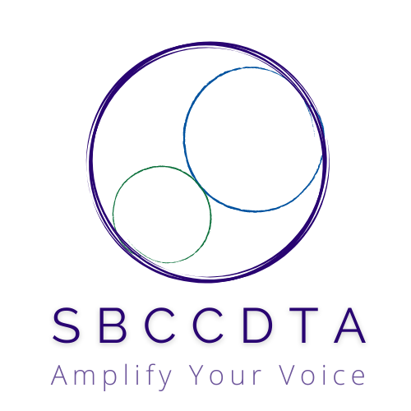**September 20, 2024**

**12:00-2:30pm [Zoom]**

horizontal line

# SBCCDTA

Amplifying the voices of fellow faculty to advocate for themselves by organizing and horizontal linementoring and defending and negotiating the contract.

horizontal line Action and Work Items

The following items need action from the executive board.

|  |  |
| --- | --- |
|  | Action Item |
| President | * Discuss Chapter Bylaws Edits * Outline Agenda for 10/2 General Membership meeting |
| Elections/PAC | * Mechanics of Bylaws Vote * ABC Grant Status |
| Secretary | * Alert General Membership about October 2nd meeting * Prepare Meeting Minutes (9/6 and 9/20) |
| Treasurer/Negotiations | * PAC Contribution Status * PT Software License Access * Negotiations Update |
| VP (CHC/SBVC) | * Reserve General Membership meeting space (CHC) * Publicize General Membership meeting |
| FT Reps (CHC/SBVC) | * Publicize General Membership meeting * Allied Health Associate Dean (SBVC) |
| PT Reps (CHC/SBVC) | * Publicize General Membership meeting * PT Recognition Activities/Outreach |