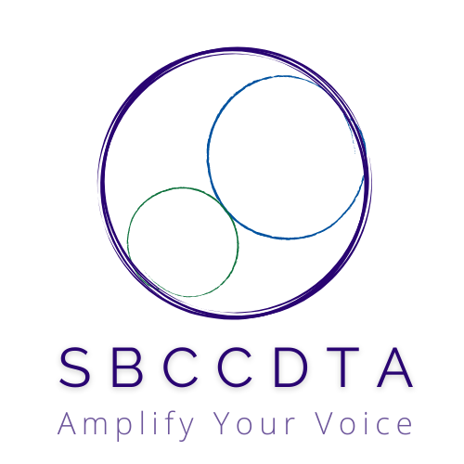**April 4, 2025**

**12:00-2:30pm [SBTA Offices]**

horizontal line

# SBCCDTA

Amplifying the voices of fellow faculty to advocate for themselves by organizing and horizontal linementoring and defending and negotiating the contract.

horizontal linehorizontal line Preliminary Items

**12-12:20 pm**

* Call to Order: noon
* Approval of Prior Minutes
* Approval of the Agenda
* CTA Report

horizontal line

## Written Reports

**12:20-12:25 pm**

This is a report of all of your work completed between union meetings as well as information for the entire board.

Except in cases of last-minute updates, reports will not be given during the meeting; the time for written reports will be spent on any questions regarding the written reports on this document.

|  |  |  |
| --- | --- | --- |
| Position | Name and Release | Written Report |
| President | Jeff Demsky | Communications with Chancellor Rodriguez  Communications with Vice Chancellor Hannon  Communications with HR Director Bonnet  Communications with Board of Trustees  Meetings with SBVC President and Interim VPI  Meetings with CHC President and VPs  Communications with CTA staff  Communications with CSEA E-Board  Picnic Planning Meeting with CSEA/POA  Addressed March Board of Trustees Meeting  Accompanied Board of Trustees on SBVC Campus Tour  Attended/Addressed SBVC Luncheon  Answered members’ emails and questions  Supported Executive Board members  Attended SBVC College Council  Prepared General Membership Meeting Agenda  Led General Membership Meeting  Prepared March E-Board Agenda  Led March Executive Board Meeting |
| Secretary | Maria Ortiz |  |
| Treasurer | Jamie Salyer |  |
| Negotiations | Jamie Salyer |  |
| 1st Vice President Crafton | Nick Reichert | Some Bylaws work  Voter Preference form for E-board Review  CHC VP Nominee form for E-board review  Met with PRT in Feb as Union Rep, wasn't on report for March meeting I missed  Crafton Councils, Chancelor Councils, DBAC Meetings  Successful Luncheon with happy peeps 4-2  Simply Voting work  Created rosters for current members using both colleges' work emails (it doesn't exist in CTA, I had to find each member)  Monitored Email |
| 2nd Vice President Valley | Denise Knight |  |
| Full-time Rep #1 Valley | Sheri Lillard |  |
| Full-time Rep #2 Valley | Jessy Lemieux | Communicated with CTE faculty (Aeronautics, Automotive, Machining, Welding) regarding management and safety issues and met with VPI to discuss  Communicated on a leave pay issue with member  Worked with negotiations team to complete wage negotiations  Serving as CTA State Council Rep April 4 |
| Full-time Rep #1 Crafton | Meridyth McClaren |  |
| Full-time Rep #2 Crafton | Robert McAtee | Attended General Meeting at Escape.  Attended Standing Rules & Bylaws meeting  Attended March's Union luncheon.  Attended Picnic planning meeting.  Gather raffle prizes for the picnic.  Identified faculty union representatives to sit on both the music faculty & and associate dean of the HWC hiring committee.  Met with Counseling faculty to discuss new Academic Compressed Calendar.  Met with union President and Crafton representatives to discuss possible faculty investigation by the district.  Attended March's union Eboard mtg. |
| Part-time Rep Valley | Sam Valle | - answered members emails  -participated in exec meeting (March 7)  - participated in SBVC member lunch (March 26)  - participated in Institutional Effectiveness committee meeting (March 27)  -participated in Health Benefits committee meeting (March 28)  - participated in special Standing rules meeting (March 28) |
| Part-time Rep Crafton | Karol McCool | Oct 2 Monthly Union Meeng  Karol McCool  •       • !"#"  • $%       • &' (  • )*+,-  • -./01(2"1-  232  •  45+  #  • (#6  Oct 2 Monthly Union Meeng  Karol McCool  •       • !"#"  • $%       • &' (  • )*+,-  • -./01(2"1-  232  •  45+  #  • (#6  Oct 2 Monthly Union Meeng  Karol McCool  •       • !"#"  • $%       • &' (  • )*+,-  • -./01(2"1-  232  •  45+  #  • (#6  Feb 7, 2025 Monthly Union Meeng  Karol McCool  •         • !"#$  • %&'(  • !$)  • &*+$  • !,-.    • &,%          • !"#$  • %&'(  • !$)  • &*+$  • !,-.    • &,% |
| Grievance (SBVC) | Leonard Lopez |  |
| Grievance (CHC) | VACANT |  |
| Negotiations | Danielle Bell |  |
| Negotiations | Suzi Mattson |  |
| Elections/PAC | Micah Martin |  |

## Tracking Itemshorizontal line

**12:25-12:30 pm**



The following are items that we need to track for their potential relation to union work.

|  |  |  |
| --- | --- | --- |
| **Item** | **Relevance** | **Timeline** |
| CTA-Ethnic Minority Early Identification and Development (EMEID) Program | Enables our chapter to increase future leaders and staff of color. | Application(s) are submitted. Decision by May 2025. |
| CTA-Institute for Teaching. Biology Grant (SBVC) | $20K grant opportunity from CTA. Enhances faculty footprint across community. Helps offset District costs. Provides template for related faculty applications. | Application is submitted. Decision upcoming. |

Action and Work Items

**12:30-2:30 pm**

The following items need action from the executive board.

- Anticipated TA Approval Timeline

- Special SBCCDTA E-Board Election (VP, CHC)

- Elections Manual and Online Voting Processes

- Treasury/UniServ Update

- PT Seniority Rights

- SBTA Meeting (4/23)

- Stacked Classes (SBVC) Update

- Luncheons (Costs)

- CCA Spring Conference Delegates

- Tri-Union Picnic (5/10)

- Supporting Proposition 55 Strategies

## **Membership**

### **District-Wide**

|  |  |  |
| --- | --- | --- |
| **Position** | **Name** | **In Attendance** |
| President | Jeff Demsky |  |
| Treasurer/Negotiations Lead | Jamie Salyer |  |
| Secretary | Maria Ortiz |  |
| PAC/Elections Chair | Micah Martin |  |
|  |  |  |

### 

### **Crafton Hills College**

|  |  |  |
| --- | --- | --- |
| **Position** | **Name** | **In Attendance** |
| 1st Vice President | Nick Reichert |  |
| Full-time Rep #1 | Meridyth McClaren |  |
| Full-time Rep #2 | Robert McAtee |  |
| Part-time Rep | Karol McCool |  |
| Grievance | VACANT |  |
| Negotiations | Danielle Bell |  |

### 

### **Valley College**

|  |  |  |
| --- | --- | --- |
| **Position** | **Name** | **In Attendance** |
| 2nd Vice President | Denise Knight |  |
| Full-time Rep #1 | Sheri Lillard |  |
| Full-time Rep #2/Negotiations | Jessy Lemieux |  |
| Part-time Rep | Sam Valle |  |
| Negotiations | Suzi Mattson |  |
| Grievance | Leonard Lopez |  |

Guests:

CTA Staff

_____________ ____________