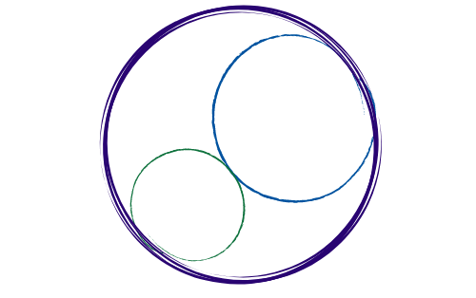April 3, 2026
12:00-3:00 pm [SBTA Offices]

SBCCDTA
Amplifying the voices of fellow faculty to advocate for themselves by organizing and mentoring and defending and negotiating the collective bargaining agreement.
Preliminary Items
12-12:20 pm
- Call to Order: noon

- Approval of Prior Minutes

- Approval of the Agenda

- CTA Executive Director Report

Discussion and Action Items
12:20-2:30 pm
The following items need discussion or action from the executive board.

- CBA Compliant Evaluations (Tiffany, HR)

- Executive Board Elections (Micah)

- Standing Rules (Meridyth)

- PAC Activities (Maria/Jeff)

- Board of Trustees Endorsement (Gonzales)

- Negotiations/TA Update (Jamie)
- Treasurer’s Report (Jamie)

- PAC Treasurer’s Report (Jamie)

- Grievance Report (Leonard)

- CCA SP ’26 Conference (Delegates)

- Valley Shared Governance Manual (SBCCDTA)

- Election Transition Dinner, 5/7 (Karol)

- PT Equity Event (Karol/Sam)

- Membership Update (Jeff)

- CTA IFT Grant Applications (SBVC, Geography and Music)

- Luncheons (CHC/SBVC)

