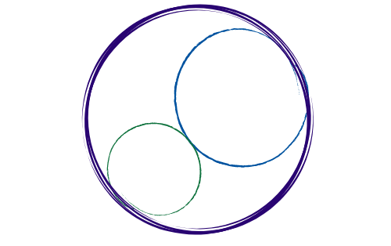February 6, 2026
12:00-3:00 pm [SBTA Offices]

SBCCDTA
Amplifying the voices of fellow faculty to advocate for themselves by organizing and mentoring and defending and negotiating the collective bargaining agreement.
Preliminary Items
12-12:20 pm
- Call to Order: noon

- Approval of Prior Minutes

- Approval of the Agenda

- CTA Executive Director Report

Action and Work Items
12:20-2:30 pm
The following items need discussion or action from the executive board.

- SBTA Inter-Union Meeting (Debrief)

- Maria Health Care Remarks (Debrief)

- Presidential Elections Update

- Proposition 55 Update

- Negotiations Update (Committee Work and Evaluation Language/FACCC Membership)

- Treasurer’s Report

- PAC Treasurer’s Report (Adding Funds)

- Board of Trustees Endorsements

- Grievance Update/Deans’ Training (Evaluations)

- Standing Rules Development (Release Time)

- General Membership Meeting (2/25)

- Membership Update

- Bowling Event/CSEA (3/7)

- Election Transition Dinner (May ’26)

- Luncheons (CHC/SBVC)

- Swag Inventory/Distribution

