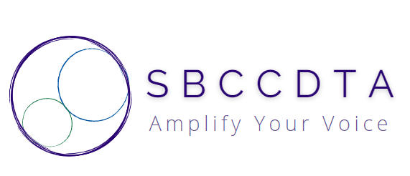

horizontal line

Amplifying the voices of fellow faculty to advocate for themselves by organizing and mentoring and defending and negotiating the contract.

**Executive Board Meeting (9 am-12:30pm)**

1. Treasury Report (Jamie)
2. Grievances (Leonard)
3. Calendaring
   1. Executive Board Meetings (Lunch Order/Pickup)
   2. Adjunct Orientation Recruitment (CHC/SBVC)
   3. SP 25 General Membership Meeting (SBVC)
   4. Luncheons (CHC/SBVC)
   5. Joint Meeting with CSEA
   6. Joint Meeting with SBTA (4/23, 4:30pm, Offices)
   7. CCA Winter Conference (2/7-2/9)
   8. “Spring Fling”
   9. PT Equity Dinner
4. Swag
   1. Order Swag
   2. Receive Swag
   3. Inventory Swag
   4. Distribute Swag
   5. Completion Metrics
   6. Create Swag Subcommittee
5. Communications
   1. Purposes/Potentials/Pitfalls
   2. Communications Shop Stipend
   3. Streamline Outputs
   4. Streamline Inputs
   5. Website/Discord Operations (SP 25)
   6. Recording/Uploading Minutes
   7. Communications Manual
6. SB 553
   1. Define/Discuss Law
   2. Anticipate Union Exposure
   3. Plan E-Board Protocols
   4. Outreach to DSO
   5. Outreach to Members
7. E-Board Officers’ Written Reports
   1. Compile/Submit to President