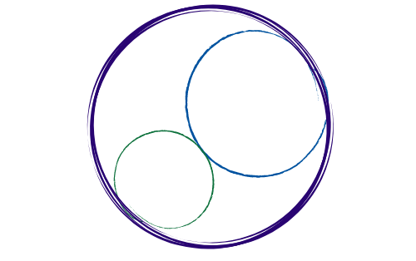March 6, 2026
12:00-3:00 pm [SBTA Offices]

SBCCDTA
Amplifying the voices of fellow faculty to advocate for themselves by organizing and mentoring and defending and negotiating the collective bargaining agreement.
Preliminary Items
12-12:20 pm
- Call to Order: noon

- Approval of Prior Minutes

- Approval of the Agenda

- CTA Executive Director Report

- CCA Conference (Debrief)

- Presidential Elections Results

Action and Work Items
12:20-2:30 pm
The following items need discussion or action from the executive board.

- PAC Activities (Ongoing and Future)

- E-Board Officer Elections (Timeline)

- Chapter’s Standing Rules (Release Time)

- Proposition 55 Update
- Negotiations Update

- Treasurer’s Report

- Grievance Update

- Double Evaluations (Instructional/Non-Instructional)

- Bowling Party

- Election Transition Dinner (May ’26)

- PT Equity (Karol)

- Luncheons (CHC/SBVC)

- Swag Inventory/Distribution

