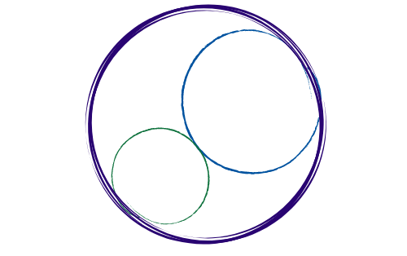May 1, 2026
12:00-3:00 pm [SBTA Offices]

SBCCDTA
Amplifying the voices of fellow faculty to advocate for themselves by organizing and mentoring and defending and negotiating the collective bargaining agreement.
Preliminary Items
12-12:20 pm
- Call to Order: noon

- Approval of Prior Minutes

- Approval of the Agenda

- CTA Executive Director Report

- CCA Conference (Debrief)

- Executive Board Elections Results

Action and Work Items
12:20-2:30 pm
The following items need discussion or action from the executive board.

- Standing Rules Package (Release Time/Appointments)

- RSI Training

- SBCCDTA Dual Programs Panel Discussion (5/7)

- Negotiations Update/TA Ratification
- Treasurer’s (PAC) Report

- PAC Update (Disbursements)

- Stipend Disbursements (Secretary/PAC/Elections)

- CHC Professional Dev’p Committee (Employee Appreciation Week Gift Cards)

- Grievance Update(s)

- Administration Transition Dinner (5/7, Falconer of Redlands)

- Board of Trustees Remarks (5/14)

- Summer Plenary Planning

