**SBCCD Counter Proposal 3**

**By and Between**

**San Bernardino Community College District Teachers Association**

**And San Bernardino Community College District**

**March 14, 2025**

**Article 10: Wages**

WHEREAS: The District is mindful of Appendix A, Objective #1 of the Agreement and will continue efforts to move the full-time faculty salary schedule to the median salary of the agreed upon comparative community college districts by the end of the fiscal year 2021 – 2022 using current (2021 or the most current) comparison college districts’ data. If at any time, the District determines it is fiscally unable to fulfill this commitment based on state budget, enrollment and other factors, it will demand to bargain,

WHEREAS; it is reasonable to expect that fair compensation comparisons can be made using current salary schedules from each district,

WHEREAS; San Bernardino Community College District full time faculty are on average 17.42% below the median based on the agreed upon cells,

WHEREAS; part time faculty are behind the median by 11.10% for instructional faculty and 5.42% for non-instructional faculty,

WHEREAS: Parity for part-time instructors has been a concern for both the Association and the District as described in Appendix A1 Objective #4, Restructure the part-time faculty salary schedule to enhance the overall competitiveness of the part-time faculty salaries and move toward parity, and

WHEREAS, To attract and retain the most qualified candidates we need to offer wages for both full and part-time faculty to be competitive with our comparison colleges.

IT IS THEREFORE AGREED THAT:

1. A multi-year proposal will be implemented to bring faculty to median.
   1. Full-time Faculty
      1. Year 1 - ~~5%~~ 1% increase effective July 1, 2024
      2. Year 2 - ~~5%~~ ~~3%~~ ~~4% increase~~ ~~and adjust the percentage between rows~~, 2% and Adjust the percentages between rows (rows 1 - 10 to 3.5%, row 11 to 3%, row 12 to 2.5%, and rows 11 -21 to 1%)~~, plus any Additional Ongoing Unrestricted General Fund Revenues Received~~ effective July 1, 2025.
      3. Year 3 - ~~bring faculty to median based on the most recent comparable college contracts~~ negotiate adjustments to various areas using the value of a ~~3%~~ ~~4%~~ 3% increase effective July 1, 2026



* 1. Part-time Faculty
     1. Year 1 - part-time bargaining unit members shall be compensated at the non-instructional rate for district mandated training effective July 1, 2024
     2. Year 2 - ~~5% 3% 4%~~ 3% increase, ~~plus additional compensation for instructional faculty prep and grading equal to ⅓ contact hours plus any Additional Ongoing Unrestricted General Fund Revenues Received~~ effective July 1, 2025



* + 1. Year 3 - ~~bring faculty to median based on the most recent comparable college contracts and increase steps to 7~~ negotiate adjustments to various areas using the value of a ~~3% 4%~~ 3% increase effective July 1, 2026



1. ~~Moving forward (year 4 and beyond) - the District and the Association agree to use an mutually agreed funding formula. every 1st and 2nd year after reaching median, and remain/get to median every 3rd year The District will conduct a Compensation Study every 3~~~~rd~~ ~~year to assess if salaries are within the median. If the assessment reflects salaries are below median, the Parties will negotiate a plan to achieve median.~~ The District and SBCCDTA acknowledge the need for a comprehensive plan to bring faculty salaries to the median. Both parties have agreed to continue working on wages throughout the duration of the agreement. The goal is to develop a plan that addresses bringing faculty salaries up to the median and to create a unified salary schedule for both full-time and part-time faculty.

~~Year 1 - 5% increase effective July 1, 2024~~

~~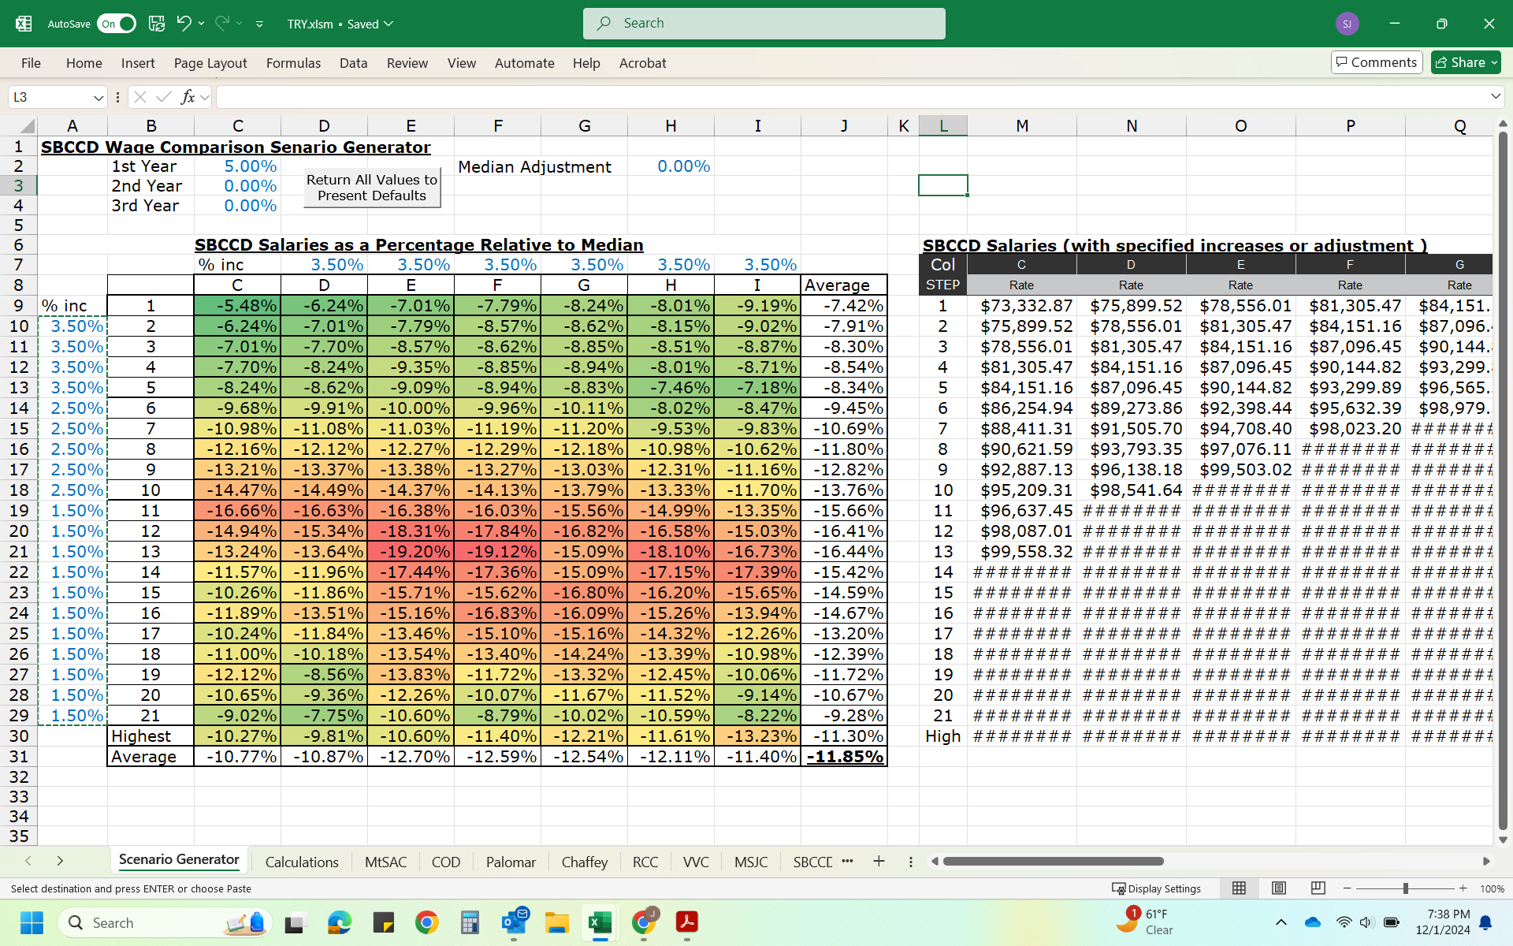~~



~~Year 2 - 5% increase and adjustments to the percentage increase between rows effective July 1, 2025~~ Year 2 - 4% increase and adjustments to the percentage increase between rows effective July 1, 2025

~~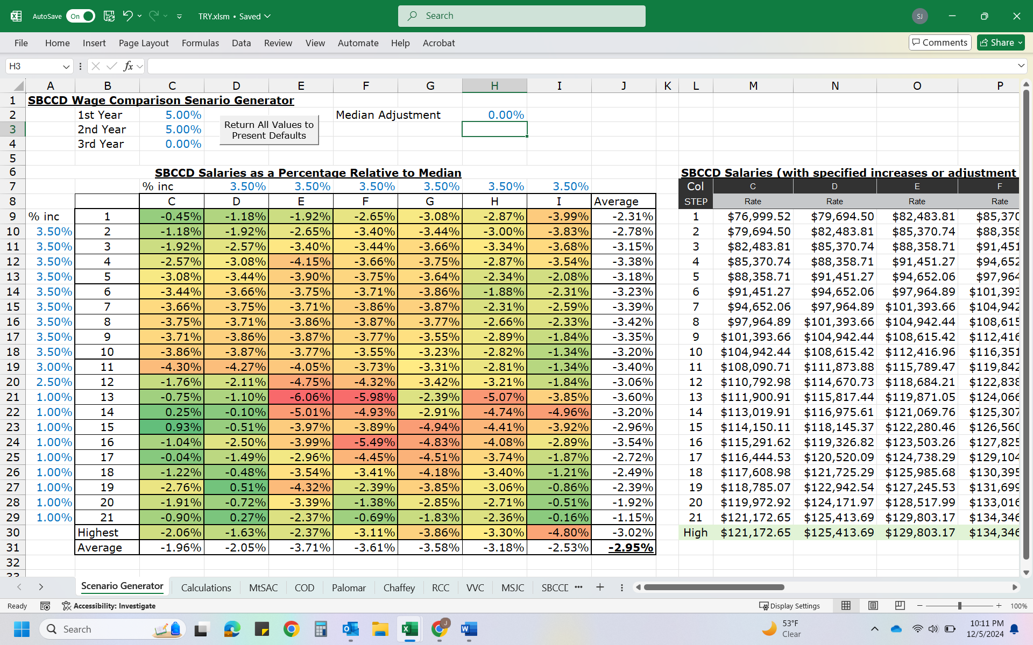~~

~~Year 3 - bring faculty to median based on the most recent comparable college contracts effective July 1, 2026 (example if median was an additional 5%)~~

~~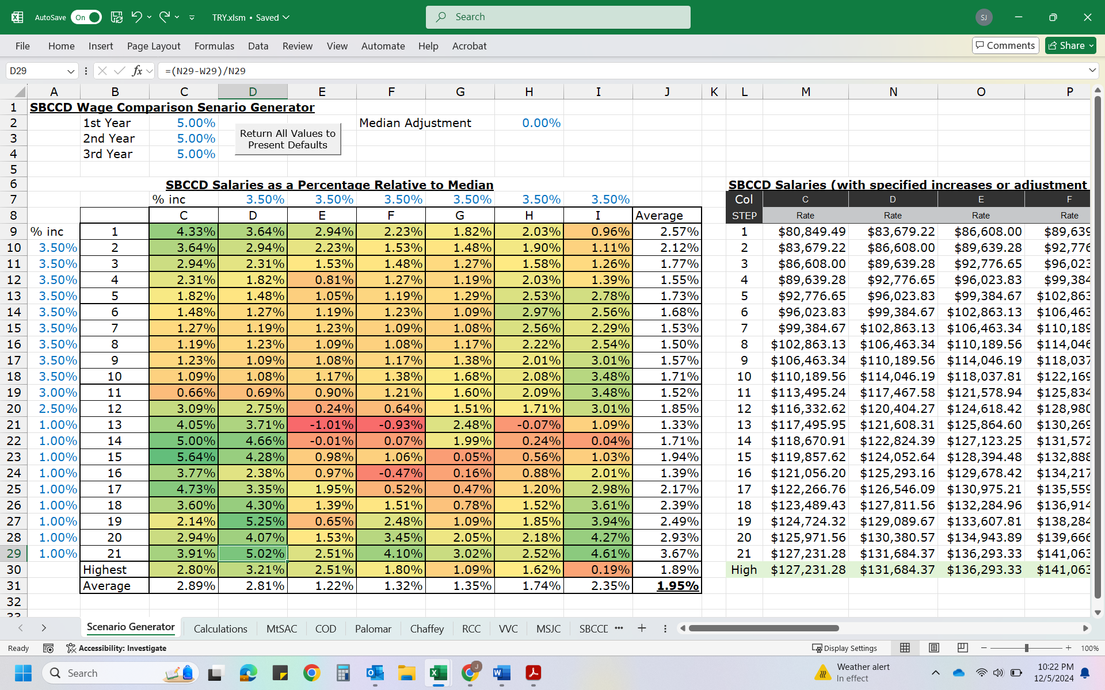~~

~~Progress Towards Parity Example, Year 2 - additional compensation for instructional faculty prep and grading equal to ⅓ teaching hours~~

|  |  |  |  |
| --- | --- | --- | --- |
| ~~Load~~ | ~~Contact Hours~~ | ~~Prep and Grading (⅓)~~ | ~~Total Pay Hours~~ |
| ~~.067~~ | ~~1~~ | ~~.33~~ | ~~1.33~~ |
| ~~.2~~ | ~~3~~ | ~~1~~ | ~~4~~ |
| ~~.267~~ | ~~4~~ | ~~1.33~~ | ~~5.33~~ |

~~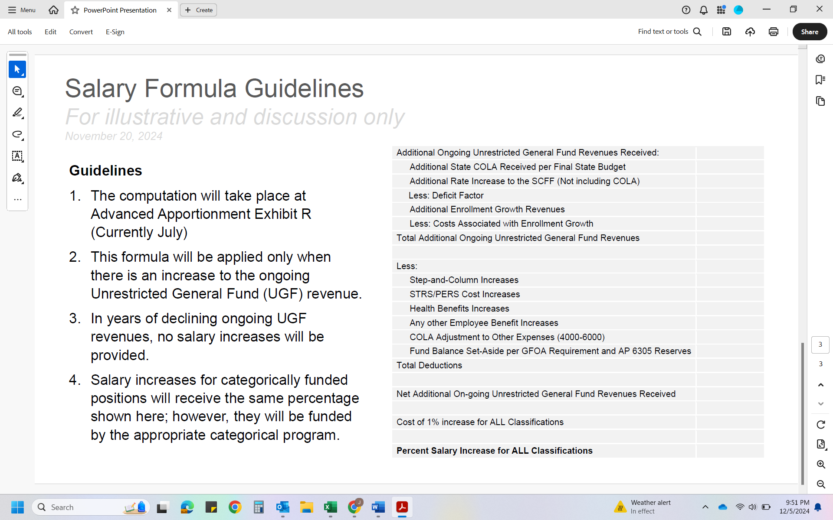~~

~~*** add to number 3, and no salaries will be reduced.~~

Presented by SBCCD:

Kristina Hannon Date: 3/13/2025

Kristina Hannon

Vice Chancellor, Human Resources & Police Services,

SBCCD Lead Negotiator

Received by SBCCDTA:

Jamie Salyer Date: 3/13/2025

Jamie Salyer

SBCCDTA Lead Negotiator