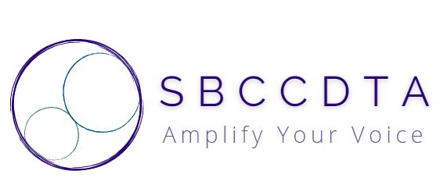
Saturday January 10, 2026 noon-3:30pm
Hotel Zessa, Anaheim, CA
Ballroom A

Refreshments Served

SBCCDTA January Executive Board Meeting

Discussion Items
- Welcome Officers/Guests
- Chapter Bylaws Approved
- Standing Rules Needed
- Grievances Process
- Negotiations Update
- Treasurer’s Report (Chapter and Uniserv)
- PAC Bank Account
- Requesting Reimbursements https://docs.google.com/forms/d/e/1FAIpQLScJ59keHYUFNu3twmwB6cE5I_t9m9PJb0yXVOt26qa7jilX9w/viewform
https://forms.gle/3yuJ5GWu2TA86j669 [PAC]

- H.I.L. Committee Report
- Preparing for SP 26 Presidential Election
- Preparing for SP 26 E-Board Election
- Setting Release Time/Stipends (SP 26 and thereafter)
- Membership Drives/Coordinator
- New Swag

Action Items
- Approve SP 26 Release Time/Stipends
- Approve SP 26 CHC “Welcome Breakfast” Budget ($700)
- Approve SP 26 PAC Budget ($1000)
- Set SP 26 Presidential Election Timeline
- Set SP 26 E-Board Election Timeline (TA Ratification)
- Set SP 26 E-Board Meeting Dates
- Set SP 26 General Membership Meeting Date
- Set SP 26 Inter-Union (SBTA) Meeting Date
- Set SP 26 Campus Luncheon Dates (CHC/SBVC)
- SP 26 Social Events [Happy Hour/Bowling/Top Golf/Banquet]
- Calendar Events via Outlook
- Calendar Events via Website
- Communicate Events via Email
- Board of Trustee Speakers (1/22, 2/12, 3/12, 4/9, 5/14) *1/22 at Museum of Redlands
5PM DINNER: Hotel Zessa, Citra Bar & Kitchen (https://hotelzessa.com/citra-bar-kitchen)

Sunday January 11, 2026 12:30-3:30pm
Hotel Zessa, Anaheim, CA
Ballroom A

Winter Plenary

BREAKFAST: On your own…please save/submit receipts

Discussion Items
- CTA Staff Presentation (Proposition 55 and more]
- Union/Senate (Shared Authorities/Interests)
- Dual Enrollment
- Academic Calendars
- CSEA/CTA (Shared Authorities/Interests)
- Distance Education (Workload/Evaluations)
- Membership Drives/Grants
- Identifying EMEID Candidates

Action Items
- Delegates to CCA Winter Conference, Hilton Orange County/Costa Mesa (2/27-3/1)
- Delegates to CTA Region IV Leadership Conference Hyatt Regency, La Jolla (3/6-3/8)
- Delegates to CTA Region IV Organizing Summit, Hyatt Regency Orange County (3/13)
- Delegates to CCA Spring Conference, Irvine Marriott (4/24-4/26)
- Set SP 26 PAC Activities
- Perform Website Updates
4PM DINNER: Hotel Zessa, Citra Bar & Kitchen (https://hotelzessa.com/citra-bar-kitchen)
💥Don’t forget to complete and submit this form to Jamie for your mileage reimbursement. https://cca4us.org/wp-content/uploads/2025/01/2025-CCA-MES.xlsx

