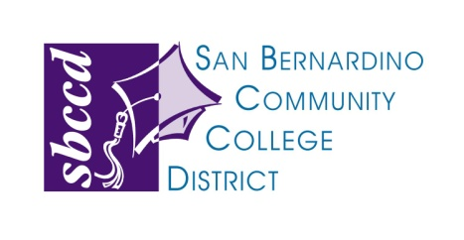

114 South Del Rosa Drive • San Bernardino, CA 92408 • Phone (909) 382-4000

ADDENDUM

BOARD MEETING – April 9, 2015

ACTION AGENDA
DELETE: Item 12.c.iv
Consideration of Approval of Proposal - Interior Office Solutions (p.186)

