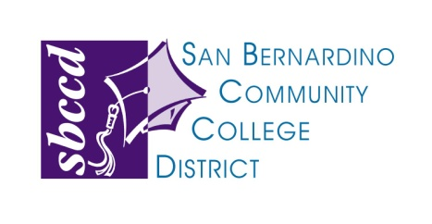

114 South Del Rosa Drive • San Bernardino, CA 92408 • Phone (909) 382-4000

SPECIAL BOARD MEETING NOTICE

April 23, 2015

The Board of Trustees of the San Bernardino Community College District (hereafter referred to as "governing body") will be holding a Special Meeting on Thursday, April 23, 2015 at 2:00pm. The meeting will be held in the District Board Room at 114 S. Del Rosa Dr., San Bernardino, CA 92408. At the time this notice is being prepared, the governing body expects the closed session agenda of its meeting to include the following topic:

Public Employee Performance Evaluation, Government Code 54957, Title: Chancellor

