The August 26, 2015 DAWG meeting began at 2:00 pm in the Annex Training Room with the following discussions and individuals in attendance (* = via CCC Confer):

Present: Michael Aquino, Larry Aycock, *Corrina Baber, *Veada Benjamin, Joyce Bond,
*Jason Brady, Joe Cabrales, Kirsten Colvey, April Dale-Carter, Amber Gallagher,
Cyndi Gundersen, Kristina Heilgeist, Robert McAtee, Robert Scudder, *Steven Silva,
DyAnn Walter, and Dianna Jones

I. Colleague as a “Hosted” environment (Andy Chang)
Andy Chang was absent – No Discussion.

- Financial Aid Processing 2012 blank ‘CS’ records (Cory Brady)
Cory Brady did not attend the meeting – No Discussion.

III. Residency Codes & AB540 (Cory Brady)
Cory Brady did not attend the meeting – No Discussion.

IV. DREG Automation “prerequisite not met” – XPRR, RQMM Status (Special Project-Joyce Bond)
Joyce Bond provided detailed information on the status of the project (see attachment). Larry Aycock stated that he had begun testing the changes and so far it appears that everything is working as it should be. Corrina Baber asked if the Academic Senates and Faculty has been made aware of these changes to automating prerequisites and co-requisites. Larry gave a brief historical overview of the topic and advised that when the original request was discussed SBVC’s academic senate passed a resolution approving the request and was fully onboard with the automation of pre/co-requisite drops.

Kirsten Colvey stated that Assessment also plays a part in this automated drop process. Larry Aycock stated that there must be date coordination between (1) stopping pre/co-requisite drops for current term, (2) invalidation of test scores, and (3) starting the pre/co-requisite drops for the next term. Larry stated that the three steps above pretty much has to occur on the same date, and as late as possible before registration for the next term; and that instructors still have the option to drop students who have not met the pre/co-requisite.

V. WebAdvisor Surveys (Special Project-Michael Aquino/Jason Brady)
Michael Aquino stated that they are still in the process of coding, and that there will be a status meeting this Friday to review the code. Jason Brady stated that he is working on ensuring a single sign-on method for those students who take the survey. Michael Aquino stated that they would continue to provide updates to the Committee.

VI. EPI Steering Committee (Ben Mudgett/Ailsa Aguilar-Kitibutr/Andy Chang)
Ben Mudgett is on vacation and did not attend the meeting – No Discussion.

VII. DAWG-PUP Discussions – Degree Audit (Ben Mudgett)
Ben Mudgett is on vacation and did not attend the meeting – No Discussion.

Miscellaneous
- Auditing Courses – Larry Aycock stated that the issue of auditing courses has not yet been submitted as a project because they are waiting on the Academic Senate to answer some additional questions regarding when registration to audit a class should occur. Larry stated that they have a meeting tomorrow with Denise and that, hopefully, these questions can be answered and they can come to an agreement so a project request can be submitted and prioritized.

- Adding Nickname to Class Roster – Joe Cabrales stated that he received a copy of a University of Redlands class roster that had a ‘preferred (or nickname)’ name within parenthesis in the same column as the student name. See sample below: 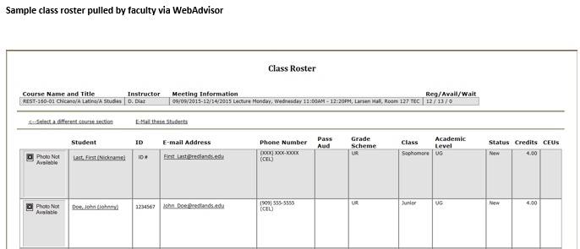
Joe Cabrales stated that they are reviewing available options, such as maintaining just the legal name on the class rosters; and recommending that students who want a different name get a legal name change to maintain the ‘legal’ integrity of the class roster. Robert McAtee stated that having a different name on the orientation and/or assessment record would create mismatched data that could prevent the orientation and/or assessment record from being imported. This would further hinder the student’s registration process.

- Course Not Available for Ed Plan – Robert McAtee stated that it has been reported to him that ASL-105 and ASL-205 courses are not available for counselors to select to put on a student’s education plan. Corrina Baber advised that CHC confirm that subject ‘ASL’ is listed on the Web Search Parameters (WSRP) screen and that the courses (ASL-105 & ASL-205) are actually created and setup in Colleague. Kristina Heilgeist stated that she would follow-up on this issue.

The meeting adjourned at 2:37pm.

The next regularly scheduled DAWG Committee meeting is scheduled for Wednesday, September 9th, 2015 at 2:00pm at the District Annex in the TESS Training Room.

