The July 20, 2016 DAWG meeting was held in the Annex Training Room with the following discussions and individuals in attendance (* = via CCC Confer):
Attendance:
Valley | *Corrina Baber, *Veada Benjamin, *Steven Silva
Crafton | Larry Aycock, Joe Cabrales, Kristina Heilgeist
District | Michael Aquino, *Jason Brady, Andy Chang, Joanna Crisostomo, Cyndi Gundersen,  Robert Scudder, DyAnn Walter, and Joyce Bond

I. Registration Time Line (Joe Cabrales/Larry Aycock)
- Longer open registration period
- Explore registration time line options
Joe Cabrales said that the President wants to check the feasibility of extending registration.
Larry Aycock stated that the purpose of extending the registration time line was to capture more Full-Time Equivalent Students (FTEs) before they left for the summer.
- This could be accomplished by having Fall Registration start before the Spring Term ends.

In order to registry early, the following would need to be completed.
- Catalogue
- Schedule of classes
Larry said that Keith Wurtz is going to evaluate 12 months of student data from both campuses to determine the feasibility of going forward with this idea. Using the existing data, Keith will be checking the Course Fill Rates, Daily Enrollment Counts, Courses being selected, etc…

Issues:
- Overlapping Registration
- Staffing
- Datatel Licensing
- Traffic to WebAdvisor
- Getting the CCC ID to Shibboleth
Jason Brady said that usually the highest drain on the system is at the beginning and end of each Priority Level.

Andy Chang said that once we go Hosting in January, performance should not be an issue.

Larry Aycock discussed accessing CCC ID:
- When we used the old CCC Apply (XAP), the numeric CCC ID was stored on the DADD Screen. It was searchable.
- With the new CCC OpenApply, the CCC ID (containing letters and numbers) is still on the DADD Screen, but we cannot search by the new CCC ID.
After the meeting, Michael Aquino sent out an email on how to search for the CCC ID on the DADD Screen (See attachment for screen displays).
Person LookUp ;PERSON.ALT.IDS EQ ‘ALQ2962’

Problem:
- We need to kick off the process for all Active Student.

This item will be moved to the parking lot, until Keith Wurtz is able to gather sufficient information that will determine the feasibility of moving forward.

II. EPI Steering Committee (Robert McAtee/Ailsa Aguilar-Kitibutr/Andy Chang)
- Update
Michael Aquino stated that Ferrilli has completed the selection criteria.
He has asked Ferrilli to direct their questions to Robert McAtee.
Andy Chang will be working with the Tech Center @ State on using Shibboleth to get ‘single sign on’.

III. New User Application Process (Kirsten Colvey)
- Update
- Cannot use ImageNow to view the progression of the New User Application.
DyAnn Walter talked to Arlene McGowan about the “View only for managers” - per Arlene an ImageNow user can only be in 1 “group”.

Ex. If Kirsten Colvey is already in the “CHC Coun Office Mgrs” group, she cannot be assigned to the “User Application View ONLY” group

IV. Miscellaneous:
- Add Recruitment to the DAWG Parking Lot
- Track High School Students from ‘Point of Contact’ to ‘Prospect’
- Invite Vendors to show their products. We don’t want to be locked into one product.
- Ellucian has Recruiter
- Do our ‘Due Diligence’

- DCS/Annex Updates (Andy Chang)
- Ellucian will move Patch Groups 8296, 8297 and 8298 to production on July 30, 2016.
- Rollout Web UI to everyone with Datatel access beginning September, 2016.
- A ‘Link’ will be established for user access
- Enable users to see ‘Student ID’ pictures
- Run concurrent with UI Desktop for a couple of months
- Ellucian will be hosting our database, beginning January, 2016. The entire process may take 1-2 months. Must be off UI Desktop when we are being ‘Hosted’.

- Effective Fall 2016 - Loss of BOG/Priority Registration – See email attachment
- Fall 2014: Crafton incorporated this mandate into their Priority B thru Priority F rules.
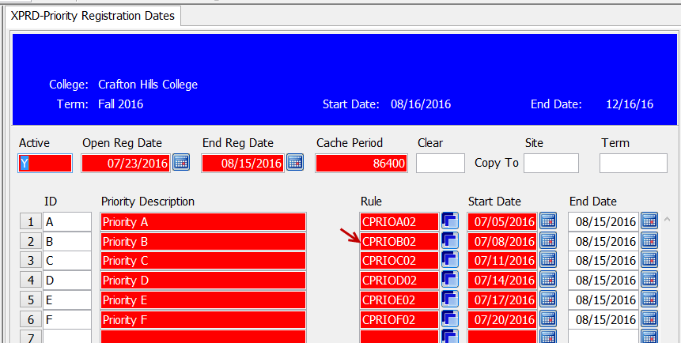

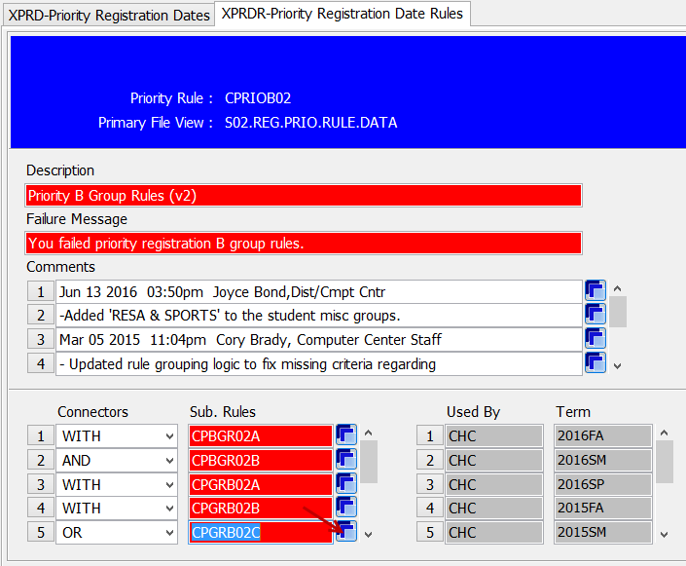

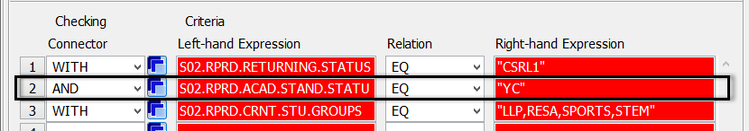

- Larry Aycock will research and submit a Help Desk Ticket to update Priority A…if a change to the rule is necessary.
- Concern: Loss of BOG (ruling) is different and more complex than Academic Standing rules.

- Valley is currently handling ‘BOG Waiver and/or Priority Registration’ manually.

DAWG “Parking Lot”
Topic | Description | Sponsor
Recruitment | Track High School Students from ‘Point of Contact’ to ‘Prospect’  Invite Vendors to show their products
Registration Time Line | Longer open registration period  Explore registration time line options  Keith Wurtz researching feasibility | Joe Cabrales /  Larry Aycock
Student Success selection for determining priority | Evaluate criteria for Comprehensive Ed Plan. | Kirsten Colvey
Drop “Reason” Codes | Waiting input from Enrollment Management Committee | Joe Cabrales
Posting Military Credit | Not posting correctly to Transcripts.  Pending Research, then bring back to DAWG. | HDO Ticket #90888
Course Auditing | Pending TESS Executive Committee Prioritization (Board Policy) | April Dale-Carter / Larry Aycock
Registration Rules Update | UNDECIDED: Implementation targeted for Spring 2017 | Need HDO Ticket  Kirsten Colvey
VETS/MILS screens | Further research - Pending comparison to MINF/XMINF | Robert Scudder
Student Group / Organization Transcript Notations | Pending feasibility study | HDO Ticket #95510  Yvette Tram

The next DAWG Committee Meeting is scheduled for Wednesday, Aug 3, 2016
(2:30 pm - 4:30 pm) in the District Annex in the TESS Training Room.

Shibboleth - https://shibboleth.net/ Explanation from Jason Brady It is a Single Sign-On system. It ties multiple applications together with one “identity” and the ability to only have to login once instead of multiple times. Using Shibboleth will allow a student to login to a state application with their username and password from our institution. The state, instead of receiving a username and password, receives information that identifies the student in their system (the CCC ID for the student).

