Meeting topics

I. EPI Steering Committee – Robert McAtee /Ailsa Aguilar-Kitibur /Andy Chang
- Updates/Concerns

II. Common Assessment Initiative (CAI) Timeline - Andy Chang / Kirsten Colvey /
James Smith / Giovanni Sosa / Ben Gamboa / Marco Cota
Updates/Issues/Concerns

  - III. User Application Process - Kristen Colvey
- Updates

  - IV. Miscellaneous

  - Next DAWG Meeting: Wednesday, Aug 10, 2016
- Cranium Cafe - Mike Bills, Presdent – Robert McAtee
- Demonstration (1 hour)
- Question/Answer
Recent Café News - From the website: http://blog.conexed.com/online-student-services-software/
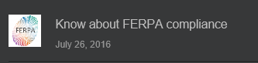 | 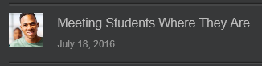
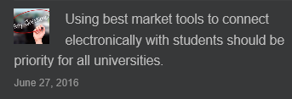
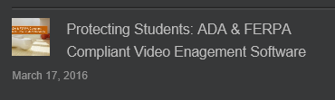

  - DAWG “Parking Lot”
Topic | Description | Sponsor
Recruitment | Track High School Students from ‘Point of Contact’ to ‘Prospect’  Invite Vendors to show their products
Registration Time Line | Longer open registration period  Explore registration time line options  Keith Wurtz researching feasibility | Joe Cabrales /  Larry Aycock
Student Success selection for determining priority | Evaluate criteria for Comprehensive Ed Plan: # Terms = 3 or more, # Units 15-30 | Kirsten Colvey
Drop “Reason” Codes | Awaiting input from Enrollment Management committee | Joe Cabrales
Posting Military Credit | Not posting correctly to Transcripts. Pending Research. Then bring back to DAWG. | HDO Ticket #90888
Course Auditing | Board Policy: Pending TESS Executive Committee Prioritization | April Dale-Carter/Larry Aycock
Registration Rules Update | Implementation targeted for Spring 2017 - For Undecided | Need HDO Ticket  Kirsten Colvey
VETS/MILS screens | Further research/pending comparison to MINF/XMINF | Robert Scudder
Student Group /Organization Transcript Notations | Pending feasibility study | HDO Ticket #95510  Yvette Tram

