The August 31, 2016 DAWG meeting was held in the Annex Training Room with the following discussions and individuals in attendance (* = via CCC Confer):
Attendance:
Crafton | Joe Cabrales, *Kristi Simonson, Kristina Heilgeist, Larry Aycock
Valley | *April Dale-Carter, *Corrina Baber, *Steven Silva, *Veada Benjamin
Annex | Andy Chang, Cyndi Gundersen, DyAnn Walter, *Jason Brady, Joanna Crisostomo, Joyce Bond, Michael Aquino, Robert (Brock) Scudder

EPI Steering Committee - Robert McAtee, Dr. Ailsa Aguilar-Kitibutr, Andy Chang
- In the process of discussing Roles Person/Positions
- Michael Aquino is working with Ferrelli to deliver the data extract file.
Recruitment – Joe Cabrales/Rebecca Warren-Marlatt
- Considering new approaches to recruiting students.
Registration Restrictions and Student Group Assignment for Athletics – Kristina Heilgeist
- How to identify Athletics for Registration Restrictions?
- Already tracking ‘Priority’ for SPORTS in the XSTM3 mnemonic.
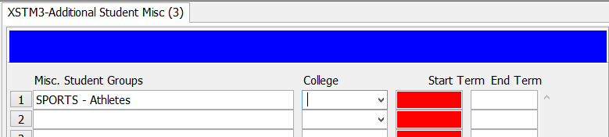

- Suggestion: Restrict access for enrolling in a section, unless the student is tagged in the Misc. Student Groups’ field…similar to HONORS.
- Current Process:
- Entered through ‘Petition’
- SBVC not currently enforcing…Not an issue
- If desired, a Help Desk Ticket will need to be created.
- Create a Registration Restriction for SPORTS
- Create a Registration Rule to be allowed into a Section.

DAWG “Parking Lot”
Topic | Description | Sponsor
- Registration Time Line | Longer Open Registration Period  Explore registration time line options  Keith Wurtz researching feasibility | - Joe Cabrales, Larry Aycock, Rebecca Warren-Marlatt
Student Success selection for determining priority | Evaluate criteria for Comprehensive Ed Plan: # Terms = 3 or more, # Units 15-30 | Kirsten Colvey
Drop “Reason” Codes | Request: Add to a joint Valley/Crafton Enrollment Management Committee (Fall Agenda). Currently only 3 reason codes. | Joe Cabrales / Rebecca Warren-Marlatt
Posting Military Credit | Transcripts: Units Attempted/Units Completed - not posting correctly.  Pending Research. | HDO Ticket #90888
Registration Rules Update | Implementation targeted for Spring 2017 - Undecided/Undeclared | Need HDO Ticket  Kirsten Colvey
VETS/MILS screens | Further research/pending comparison to MINF/XMINF | Robert Scudder
Student Group /Organization Transcript Notations | Pending feasibility study | HDO Ticket #95510  Yvette Tram
Course Auditing | Pending TESS Executive Committee Prioritization  - Board Policy may be put on HOLD | April Dale-Carter / Larry Aycock

The next DAWG Committee Meeting is scheduled for Wednesday, Sept 7, 2016
(2:30 pm - 4:30 pm) in the District Annex in the TESS Training Room.

