# Meeting topics

**I. *EPI Steering Committee*** – Robert McAtee /Ailsa Aguilar-Kitibur / Andy Chang

* Updates/Concerns

**II. *Change to MIS Student Disability Priority Registration* -** Michelle Crocfer / Dianna Jones

* Change to MIS Student Disability (SD) Priority Registration due to new disability reporting categories.

New Reporting categories highlighted below:

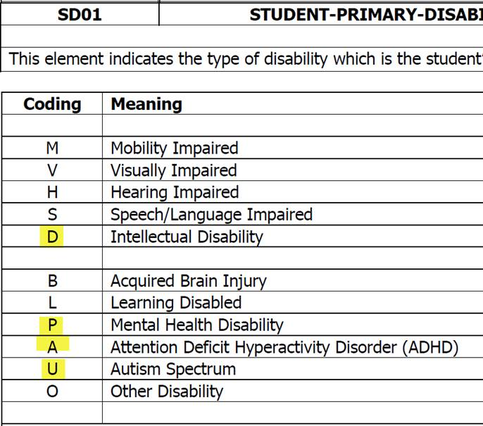

**III. *Emergency Contact” link from WebAdvisor* –** Andy Chang

**IV. *Automated Co/Pre Requisite Dropping*** – DyAnn Walter / Joyce Bond

* Update

**VI. *Capital Outlay Fee* –** April Dale-Carter

* 9/13/16 - Removed references to CITIZENSHIP from the Capital Outlay Rule.

**From:** Brady, Cory M.   
**Sent:** Friday, November 07, 2014 10:43 AM  
**Subject:** Non-Resident Rule and Captial OutLay Rule

|  |  |
| --- | --- |
| **Non-Resident Rules**   * **WITH Location Check** * WITH SCS.LOCATION LIKE ‘C…’ | Taking Classes at Crafton * WITH SCS.LOCATION LIKE ‘S…’ | Taking Classes at Valley * **AND Residency Check** * AND S02.RES.STATUS NE ‘5’ | Not California Resident * **AND AB540 Check** * EVERY S02.SCS.AB540.STATUS NE ‘YA’ | Is not a AB540 Student | **Capital Outlay Rules**   * **WITH Location Check** * WITH SCS.LOCATION LIKE ‘C…’ | Taking Classes at Crafton * WITH SCS.LOCATION LIKE ‘S…’ | Taking Classes at Valley * **AND Residency Check** * AND S02.RES.STATUS NE ‘5’ | Not California Resident * **AND Citizenship Check** * AND CITIZENSHIP NE ‘US’ | Not US Citizen * AND CITIZENSHIP NE ‘’ | Not Unknown Citizen (used because of previous bad data/missing data impacting students) * **AND AB540 Check** * EVERY S02.SCS.AB540.STATUS NE ‘YA’ | Is not a AB540 Student |

|  |  |
| --- | --- |
| **Crafton’s Non-Resident Rules** | **Crafton’s Capital Outlay Rules** |
| cid:image001.jpg@01D20D9A.5ACD14C0 | cid:image003.jpg@01D20D9A.5ACD14C0 |

|  |  |
| --- | --- |
| **Valley’s Non-Resident Rules** | **Valley’s Capital Outlay Rules** |
| cid:image002.jpg@01D20D9A.5ACD14C0 | cid:image004.jpg@01D20D9A.5ACD14C0 |

**VII. *Miscellaneous***

***Next DAWG Meeting*:** Wednesday, Sept 21, 2016

* Please send all DAWG Agenda Topics to Andy Chang for the Sept 21st and Sept 28th Meetings. I will be back for the Oct 5th Meeting. Thanks!!

***DAWG “Parking Lot*”🚘**

|  |  |  |
| --- | --- | --- |
| **Topic** | **Description** | **Sponsor** |
| **Recruitment** | Consider new approaches to recruiting. | Joe Cabrales/Rebecca Warren-Marlatt |
| **Registration Time Line** | Longer Open Registration Period  Explore registration time line options  Keith Wurtz researching feasibility | Joe Cabrales, Larry Aycock, Rebecca Warren-Marlatt |
| **Student Success selection for determining priority** | Evaluate criteria for Comprehensive Ed Plan: # Terms = 3 or more, # Units 15-30 | Kirsten Colvey |
| **Posting Military Credit** | Transcripts: Units Attempted/Units Completed - not posting correctly.  Pending Research. | HDO Ticket #90888 |
| **Registration Rules Update** | Implementation targeted for Spring 2017 - Undecided/Undeclared | Need HDO Ticket  Kirsten Colvey |
| **VETS/MILS screens** | Further research/pending comparison to MINF/XMINF | Robert Scudder |
| **Student Group /Organization Transcript Notations** | Pending feasibility study | HDO Ticket #95510  Yvette Tram |