# Meeting topics

**I. *EPI Steering Committee*** – Robert McAtee /Ailsa Aguilar-Kitibur / Andy Chang

* Updates/Concerns

**II. *Change to MIS Student Disability Priority Registration* -** Michelle Crocfer / Dianna Jones

* Change to MIS Student Disability (SD) Priority Registration due to new disability reporting categories.

New Reporting categories highlighted below:

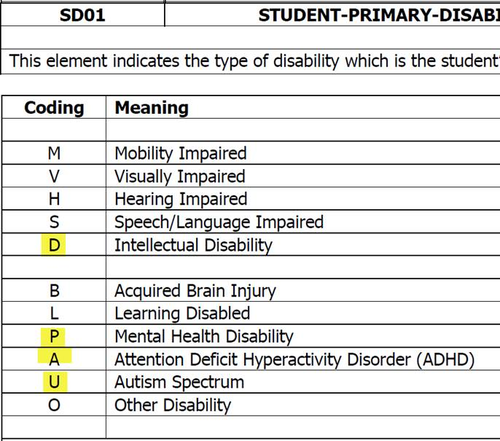

**III.** **Instructor Drops on Census Day** – Keith Wurtz and Steve Sutorus

* When Steve is doing the 320 report, he is manually removing instructor drops and according to Title 5 Ed Code, students need to be dropped by instructors prior to census

**IV. Send a Drop Message from WebAdvisor** - April Dale-Carter / Veada Benjamin

* Currently an email is sent to students when they make changes to their registration (add/drop).
* Is there a way to send a specific message when students drop their courses? This message would include the potential Financial Aid implications when dropping a course.

**V. WebAdvisor/Portal** – Andy Chang

* Rearrange the menu selections in WebAdvisor.

|  |
| --- |
|  |

**VI. Non-Drop for Non-Payment** – Glen Kuck

1. What if we go 5 or 10 days to pay?
2. Can we identify those that we know will receive some type of FA package and not drop them for non-payment or give them 5 – 10 days to pay?

**VII. Ability to Register for Fall in the Spring** – Glen Kuck

**VIII. Miscellaneous**

***Next DAWG Meeting*:** Wednesday, Oct 12, 2016

***DAWG “Parking Lot*”🚘**

|  |  |  |
| --- | --- | --- |
| **Topic** | **Description** | **Sponsor** |
| **Recruitment** | Consider new approaches to recruiting. | Joe Cabrales/Rebecca Warren-Marlatt |
| **Posting Military Credit** | Transcripts: Units Attempted/Units Completed - not posting correctly.  Pending Research. | HDO Ticket #90888 |
| **VETS/MILS screens** | Further research/pending comparison to MINF/XMINF | Robert Scudder |
| **Student Group /Organization Transcript Notations** | Pending feasibility study | HDO Ticket #95510  Yvette Tram |