The October 5, 2016 DAWG meeting was held in the Annex Training Room with the following discussions and individuals in attendance (* = via CCC Confer):
Attendance:
Crafton | Joe Cabrales, *John Muskavitch, Kirsten Colvey, Komal Bandyopadhyay, Kristina Heilgeist, Larry Aycock
Valley | *Corrina Baber, *Marco Cota, Michelle Crocfer, *Veada Benjamin, *Yancie Carter
District | Steve Sutorus
Annex | Andy Chang, Cyndi Gundersen, *Dianna Jones, DyAnn Walter, Dr. Glen Kuck, *Jason Brady, Joanna Crisostomo, Joyce Bond, *Michael Aquino, Robert (Brock) Scudder

I. EPI Steering Committee – Robert McAtee /Ailsa Aguilar-Kitibur / Andy Chang
- Oct 14, 2016 - Signoff all items; Approve Time; Approve Files
- Nov 14, 2016 - Workgroups
- Nov 18, 2016 - Training
  - II. Change to MIS Student Disability Priority Registration - Michelle Crocfer / Dianna Jones
- Moving to a ‘Primary Only’ System.
- Changes to the MIS Student Disability (SD) Priority Registration.
- New Reporting Categories
D – Intellectual Disability
P – Mental Health Disability
A – Attention Deficit Hyperactivity Disorder (ADHD)
U – Autism Spectrum
- Reporting Categories that are no longer being used.
S – Speech/Language Impaired – No longer a major category. Going away next year.
Add ‘Do Not Use’ to the description.
- DSPS data held in the PHIN Screen. Use the following fields.
- Disability
- Accommodation
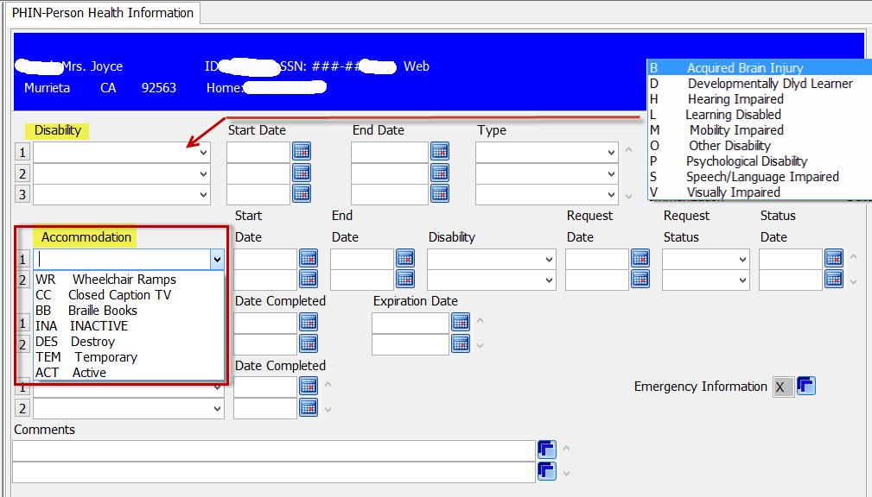
- Ways of getting Funding
  - Before : Report Contacts
Change: Priority Registration for Active DSPS Students and Contacts
  - Before : By Term
Change: DSPS Students need to come in every year
- Michelle will create a HelpDesk Ticket.
- Update the DISABILITY File.
- Change the Priority Registration Rules…checking the ‘Primary Only’ Disability.
- Determine any additional Programs and/or Reports that may be affected.
- Plus…<additional items that may be needed>
- Effective - Summer 2017

  - III. Instructor Drops on Census Day - Keith Wurtz / Steve Sutorus
When Steve Sutorus does the 320 Report, he manually removes Instructor Drops, since Title 5 Ed Code indicates that students need to be dropped by instructors prior to census.

- Student Attendance Accounting
- Steve Sutorus said the Ed Code requirements required Instructors to remove Students from the Roster if any of the following conditions exist on Census Day:
- No Shows
- Inactive Students
- Student not participating
- He also said…4-5 years ago, our auditors wanted us to back out Instructor Drops of Students, where the drop occurred on Census Day.
- The Auditors felt it was an error to drop Students on Census Day.
- As a precautionary measure, we drop Students before Census, then get the Total Student Contact Hours.
- Steve wants to ‘Automate’ a solution (i.e. Do not allow Instructors to drop on Census Day).
- Current Practice is to back out Students that have been dropped on Census. Because of this, we do not claim ‘Total Student Apportionment Contact Hours’ for those students.
- Arguments:
- Joe Cabrales said that we can’t distinguish why a Student drops…only when a Student drops.
- Instructors could have dropped the Student for other reasons.
- Drops on or after Census should be counted, since the reason may not be one of the items listed above.
- Larry read the ‘588004 California Code of Regulations’ requirements document
(Press CRTL+click to follow the link)
https://govt.westlaw.com/calregs/Document/IB328D4B0D48511DEBC02831C6D6C108E?originationContext=Search+Result&listSource=Search&viewType=FullText&navigationPath=Search%2fv3%2fsearch%2fresults%2fnavigation%2fi0ad70f760000015796e2444b36d192fa%3fstartIndex%3d1%26Nav%3dREGULATION_PUBLICVIEW%26contextData%3d(sc.Default)&rank=1&list=REGULATION_PUBLICVIEW&transitionType=SearchItem&contextData=(sc.Search)&t_T1=5&t_T2=58004&t_S1=CA+ADC+s
- Solution:
- Need to talk to our current auditors. The practice of not counting ‘Student Drop on Census Day’ may no longer be needed. Could be a legitimate reason for dropping on Census.
- Create a ‘Drop Down’ Allow the reason for dropping the section…to be entered.

- Student receives a ‘W’ grade when he is dropped on Census Date or Later.

- Provide proof by documenting that email notifications are being sent out to Instructors to drop before Census if Student is a ‘No Show’.
- Larry Aycock and April Dale-Carter will check the hand book.

  - IV. Send a Drop Message from WebAdvisor - April Dale-Carter / Veada Benjamin
Currently, an email is sent to students when they make changes to their registration (add/drop).
Is there a way to send a specific message when students drop their courses? This message would include the potential Financial Aid implications when dropping a course.

- Suggestions:
- Add a message to the email that is already being sent out.
- Regroup could be used.
- Messages could be sent once a Term. ‘Critical Deadlines’ could be put in the message.
- Target or Reminder Messages could be sent.
- A warning message could be put in the Subject Line.
i.e. Keep in mind possible consequences if you are a Financial Aid recipient…
- Update the WebAdvisor verbiage. Add to the existing red text on the page.
- Response: Already too many messages on WebAdvisior

- Send messages a week prior to registration…
i.e. If you are thinking about dropping...

- Regroup - handles notifications for ‘Late Start’ classes.

- Unrelated Suggestions:
  - Add a link to WebAdvisor for Late Start and Open Classes
- Response: A link already exist on the College websites.
  - Use Regroup to view Open Classes.
  - V. WebAdvisor/Portal – Andy Chang
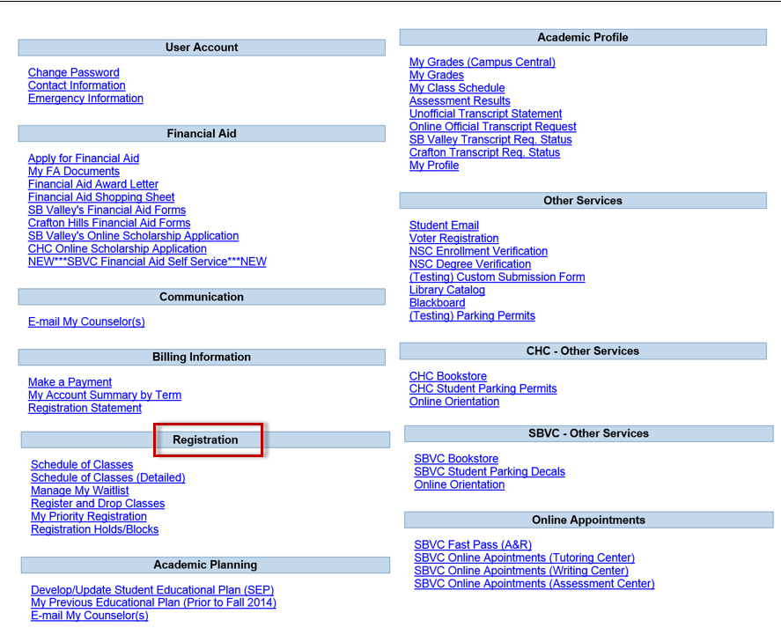

- Re-arrange the menu selections in WebAdvisor.
The landing page is not displayed to the best advantage
  - Move ‘Registration’ to the top
  - Remove some links from the screen (i.e. Items that don’t need authentication).
- Using some of the modifications listed above…Having portal will make WebAdvisor more intuitive.
- Next Step: Demo of Portal

  - VI. Non-Drop for Non-Payment / Ability to Register for Fall in the Spring – Glen Kuck
- Discussion will be held in the PDC (room 104) on Tuesday, October 29, 2016.
All members are invited to come.

Regroup (www.regroup.com) is a cloud-based mass communications platform designed to assist in maintaining continuity of business activities during a crisis, as well as on a day-to-day basis by sending notifications, emailing messages from an external email account, texting from your cell phone, etc…

