Meeting topics
I. EPI Steering Committee – Robert McAtee, Ailsa Aguilar-Kitibur, Andy Chang
- Discussion/Concerns/Issues

  - II. Pulling Fees from Financial Aid – April Dale-Carter, Larry Aycock
- Larry Aycock spoke about his previous experiences with PEL and BOG.
- Once BOG paid the enrollment fees, additional fees would be paid by the PEL Grant.
- Downside: The student received the remaining PEL amount about 10-days later, instead of the 1st week of school.
- Upside: The student would not be dropped for not being able to pay fees.
- Larry wanted to know if it was feasible to go back to that kind of system.
- Recommended by the Valley Enrollment Management Committee and some Crafton Committees.
- Questions:
- Are there any cost factors involved?
- Could be a timing issue of when PEL Funds are dispersed.
- Additional Discussion:

  - III. Student’s Emergency Contact - Robert McAtee, Larry Aycock
- Enter on Application
- Update via WebAdvisor
- Stored in EMER Screen (limited access due to sensitive nature of the data)
- Question: Should Counselors be allowed access to the information?

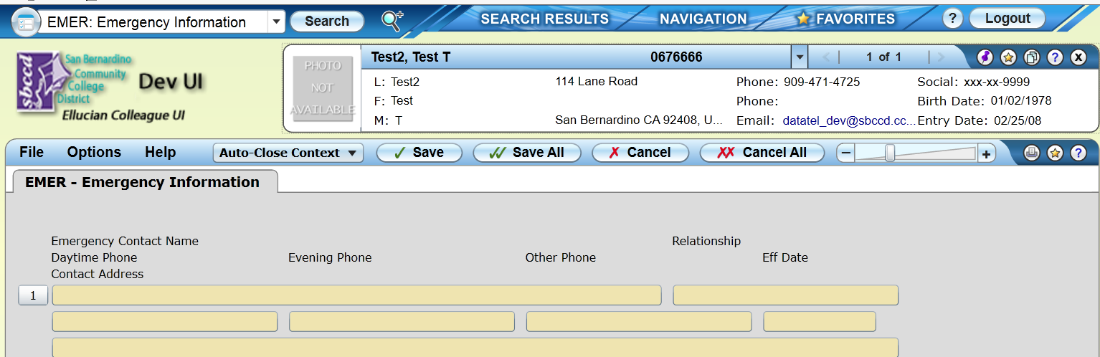
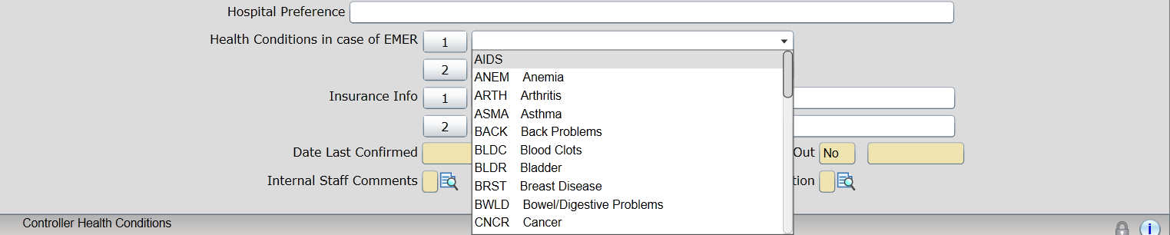

  - IV. Miscellaneous

  - Next DAWG Meeting: Wednesday, Nov 9, 2016

  - DAWG “Parking Lot”
Topic | Description | Sponsor
- Recruitment | Consider new approaches to recruiting. | - Joe Cabrales/Rebecca Warren-Marlatt
Posting Military Credit | Transcripts: Units Attempted/Units Completed not posting correctly Pending Research | HDO Ticket #90888
VETS/MILS screens | Further research/pending comparison to MINF/XMINF | Robert Scudder
Student Group /Organization Transcript Notations | Pending feasibility study | HDO Ticket #95510  Yvette Tram

