The November 2, 2016 DAWG meeting was held in the Annex Training Room with the following discussions and individuals in attendance (* = via CCC Confer):
Attendance:
Crafton | Joe Cabrales, Kirsten Colvey, *Kristi Simonson, Kristina Heilgeist, Larry Aycock,  *Robert McAtee
Valley | *April Dale-Carter, *Corrina Baber, *Steven Silva, *Veada Benjamin, *Yancie Carter
Annex | Andy Chang, DyAnn Walter, Joanna Crisostomo, Joyce Bond, *Michael Aquino,  Robert (Brock) Scudder

I. EPI Steering Committee – Robert McAtee /Ailsa Aguilar-Kitibur / Andy Chang
- Review/Project Signoff - Monday, Nov 7th (9-12pm)
- Will create a list of items that should be running by Nov 17th
- Locations for the Starfish Login and the embedded Starfish link.
- Campus Website (front page)
- WebAdvisor
- Hobson will be Training Faculty and Staff on Starfish
- Valley - Nov 17th
- Crafton – Nov 18th
- Faculty and Staff may come to either session.
- A State Representative will be at the Nov 17th Training Session.
- Extended Contract for Ferrilli 300 Hours
- 300 Hours - include following items
- Changes to correct problems found during the last review
- Early Alert
- Degree Planner – want to end up with a 1 page printout.
- We will only be charged for hours worked.
- Money covered by…
- State Sub-Grant
- SSSP Grant
- Next Steps:
- Robert McAtee will submit a HelpDesk Ticket to add Starfish to the Counselor and Faculty Menu in WebAdvisor. Starfish will replace SARSALERT on the Faculty Menu.
- Robert McAtee will create another HelpDesk Ticket to have a link put on the College’s Website (under the Login).

  - II. Pulling Fees from Financial Aid – Larry Aycock / April Dale-Carter / John Muskavitch
- Larry Aycock spoke about his previous experiences with PEL and BOG.
- Once BOG paid the enrollment fees, additional fees would be paid by the PEL Grant.
- Downside: The student received the remaining PEL amount about 10-days later.
Currently the student receives PEL Funds during the 1st week of school.
- Upside: The student would not be dropped for not being able to pay fees.
- Larry wanted to know if it is feasible to go back to that kind of system.
- Recommended by the Valley Enrollment Management Committee and some Crafton Committees.
- Questions:
- Are there any cost factors involved?
- Could be a timing issue depending on when PEL Funds are dispersed.
- This topic will be moved to the Parking Lot, until Amber Gallagher and John Muskavitch are able to attend the meeting.

  - III. Student’s Emergency Contact - Robert McAtee, Larry Aycock
- Entered on the Application
- Updated via WebAdvisor
- Stored in the EMER Screen (limited access due to sensitive nature of the data)
- Question: Should Counselors be allowed access to the information?
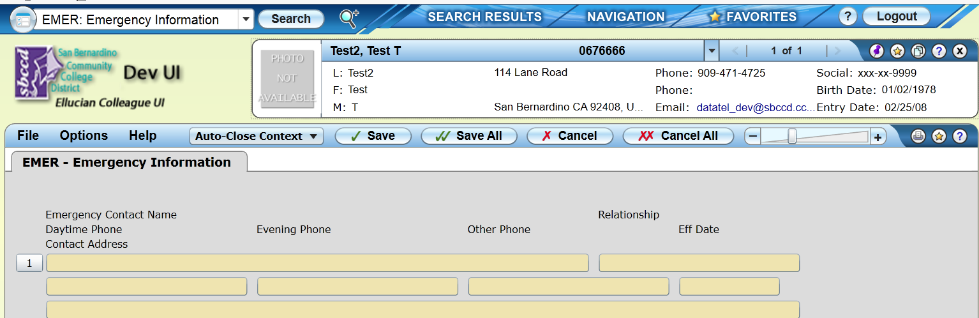
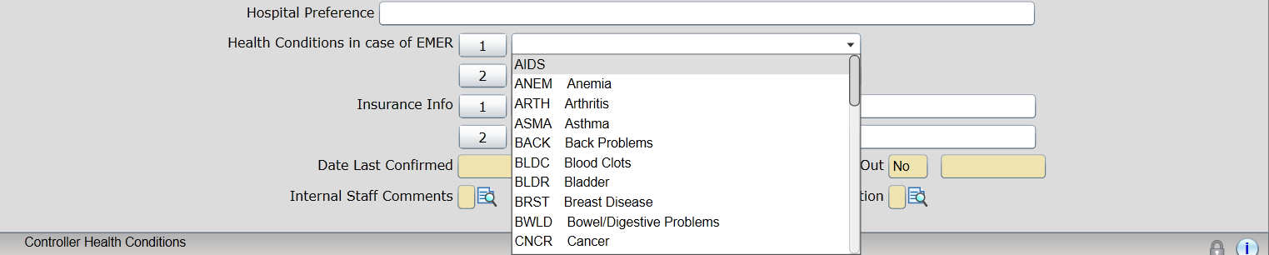

- Next Steps:
- Add the Student Emergency Information to the ‘Student In-Take Form’.
- Capture the information in the form when the Student signs up with a Counselor.
- Add : City and State to the form
- Results: 911 Emergency Services can be contacted for that City/State, if a problem arises.

