Meeting topics
I. EPI Steering Committee – Robert McAtee, Ailsa Aguilar-Kitibutr, Andy Chang
- Discussion/Concerns/Issues

I1. Students Active in Inactive Programs – Keith Wurtz, Kristina Heilgeist
- Informer Report: Inactive Academic Programs that students have active
- Inactive Program C.AS.CIS/3DCA has students registered this term and is listed as their Active program.
- Link to Report:
https://informer.sbccd.cc.ca.us:1443/?locale=en_US#action=ReportRun&reportId=371064835&launch=false

  - II1. Residency Status Coding– Keith Wurtz
- Currently, the correct residency status is not getting reported to MIS.
- The attachment summarizes the following.
- Current process of assigning residency status codes.
- Recommendation for how to assign residency status codes.

- Current Practice:
- Student is determined to be a CA. resident (these students are imported as 50000)
- Student may be a CA. resident, but further verification is required (these students are imported as 80000 until they provide proof of residency)
- Student is determined not to be a CA. resident (these students are coded as 80000)
FYI – in Colleague, the code 80000 has a description of “Unkown or not collected” which is why it has been used for both codes 2 and 3 from OpenCCC Apply.

- In MIS, Resident Status is reported in the SB09.
- The categories for resident status in MIS include the following:
- 50000 – California resident
- 600SS – US resident in a state other than California, SS is replaced with the state code.
- 6XXXX – The state is unknown
- 8XXXX – The student is from a foreign country.

Open CCCApply Data File Format

Residency Status
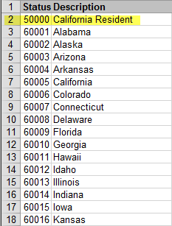
…
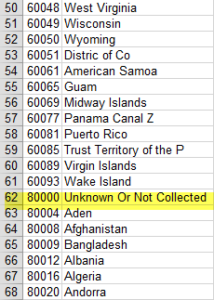
…

  - IV. Miscellaneous

  - Next DAWG Meeting: Wednesday, Jan 11, 2017

  - DAWG “Parking Lot”
Topic | Description | Sponsor
- Pulling Fees from Financial Aid | After BOG pays the enrollment fees, additional fees would be paid by the PEL Grant. | - Larry Aycock  - April Dale-Carter  - John Muskavitch
Posting Military Credit | Transcripts: Units Attempted/Units Completed not posting correctly Completed by Dianna Jones | HDO Ticket #90888
VETS/MILS screens | Further research/pending comparison to MINF/XMINF | Robert Scudder
Student Group /Organization Transcript Notations | Pending feasibility study | HDO Ticket #95510  Yvette Tram
- Recruitment | Consider new approaches to recruiting. | - Joe Cabrales  - Rebecca Warren-Marlatt

