The January 4, 2017 DAWG meeting was held in the Annex Training Room with the following discussions and individuals in attendance (* = via CCC Confer):
Attendance
Crafton | Joe Cabrales, Keith Wurtz, *Kirsten Colvey, *Kristi Simonson, Larry Aycock, Robert McAtee
Valley | *April Dale-Carter, *Corrina Baber, *Veada Benjamin, *Yancie Carter
Annex | Andy Chang, Dianna Jones, DyAnn Walter, Jason Brady, Joyce Bond

EPI Steering Committee (Robert McAtee, Ailsa Aguilar-Kitibutr, Andy Chang)
Robert McAtee indicated we are getting ready to roll out Early Alert.
- Still needs to review and signoff on everything.
- Faculty walk thru is needed before the roll out.
Kristen Colvey said that the Degree Planner has a Registration tool.
- Presenters will discuss the new tool on January 31, 2017.
- Students using Hobson can register via Ed Planning. It will be ready in June to be integrated with our Student Information System (SIS). Hobson’s API is available now, but the programming is not finished.
Phase 1 1-way approach.
Pulls information from the Shopping Cart to our SIS, so Students can see their classes.
Phase 2 2-way approach.
Should be available in June.
Meeting scheduled on June 26, 2017
- Not sure if it will work with our system. Not sure if fees are being considered.

Students Active in Inactive Programs (Keith Wurtz, Kristina Heilgeist)
In the Informer Report titled ‘Inactive Academic Programs that students have active’, the inactive program C.AS.CIS/3DCA has students registered this term, and is listed as their Active program.

Student in inactive programs will need to be referred to Counseling, so that they can be put into an active program. The problem exist because some programs were never approved by the state.

  - Residency Status Coding (Keith Wurtz)
Currently, the correct residency status is not getting reported to MIS.
The attachment summarizes the following.
- Current process of assigning residency status codes.
- Recommendation for how to assign residency status codes.

Current Practice:
- The Student is determined to be a California resident (these students are imported as 50000).
- The Student may be a California resident, but further verification is required (these students are imported as 80000 until they provide proof of residency).
- The Student is determined not to be a California resident (these students are coded as 80000).
FYI – in Colleague, the code 80000 has a description of “Unkown or not collected” which is why it has been used for both codes 2 and 3 from Open CCC Apply.
- In MIS, resident status is reported in the SB09.
- The categories for resident status in MIS include the following:
50000 – California resident
600SS – US resident in a state other than California, SS is replaced with the state code.
6XXXX – The state is unknown
8XXXX – The student is from a foreign country.

Residency Status
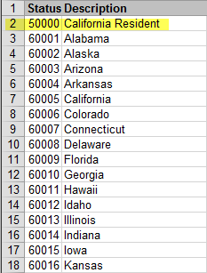
…
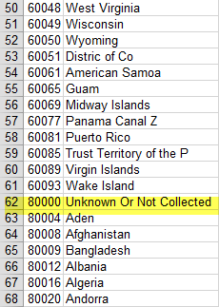

Temporary Solution:
Create a HelpDesk Ticket.
- Change the residency status from 80000 to 6xxxx when the code is 2 or 3.
- Billing rules will need to be changed

Permanent Solution:
Create a Project Request to change the import process.
- Code 2 Possible California Residents (verification needed)
- Code 3 International based on M1 Type or F1 VISA status or Non-California Resident.
- Look at other fields returned by CCC Apply to establish the status.
- Existing students will keep their 80000 code.
- AB540 Students can be 50000, 6XXXX, or 80000.
  - Miscellaneous Topic
- Yancie Carter would like to have the following changes made to the Welcome Letter.
- Add a link to new person orientation (Cynosure)
- Trigger transmission of the Welcome Letter via communication codes
HelpDesk Ticket will be created.

- It was decided that we would begin having the DAWG Meetings on the 2nd and 4th Wednesdays of the month, unless there was an important topic that could not wait until the next meeting.

Some individuals joining the meeting via phone may not be in the Attendance List.

