# Meetings TOPICS: 2ND & 4TH wEDNESDAYS

**I. *EPI Steering Committee*** – Robert McAtee, Yancie Carter, Michael Aquino

* Discussion/Concerns/Issues

**II. HelpDesk Change** – Andy Chang, Jeremy Sims

* School Dude Helpdesk Ticketing System (Helpdesk Management Software) <https://www.dudesolutions.com/industries/education/school-it-management>

**II1. Downtime for Colleague Migration to Hosting** – Andy Chang

* Ready: May 11, 2017
* Proposed Dates for migration: *Friday, May 12, 2017 6pm – Monday, May 15, 2017 12pm*

**IV. Registration Billing - Identifying International Students** – Michael Aquino

* Is the criteria to identify international students as having the student group INTERN still valid **or** should it change to use the information inputted in FINF’s Immigration Status field (see below):

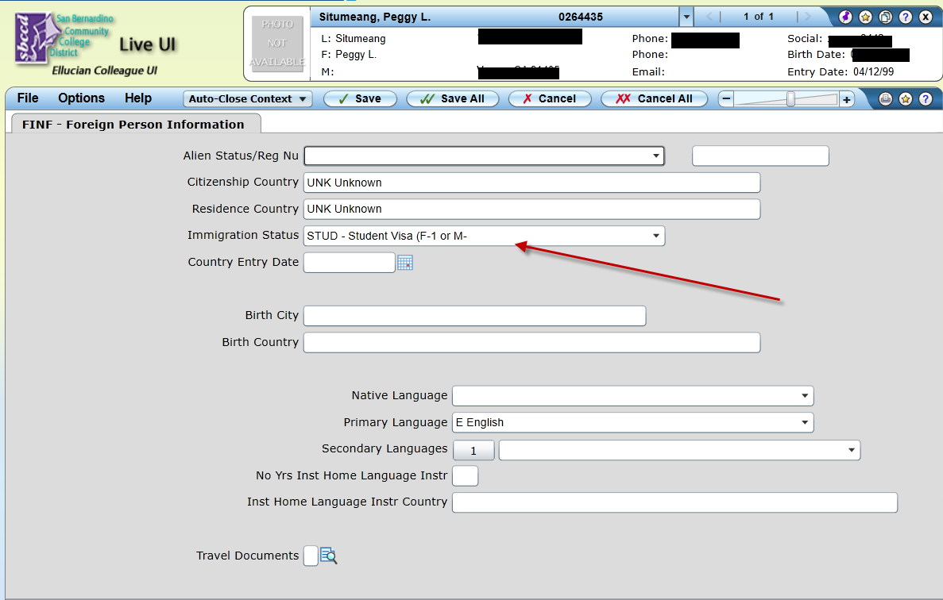

**V. Miscellaneous**

***Next DAWG Meeting*:** Wednesday, March 22, 2017

***DAWG “Parking Lot*”🚘**

|  |  |  |
| --- | --- | --- |
| **Topic** | **Description** | **Sponsor** |
| Pulling Fees from Financial Aid | After BOG pays the enrollment fees, additional fees would be paid by the PEL Grant. | Larry Aycock  April Dale-Carter  John Muskavitch |
| VETS/MILS screens | Further research/pending comparison to MINF/XMINF | Robert Scudder |
| Student Group /Organization Transcript Notations | Pending feasibility study | HDO Ticket #95510  Yvette Tram |