The March 8th DAWG meeting was held in the Annex Training Room with the following discussions and individuals in attendance (* = *via CCC Confer*):

*Attendance [1]*

|  |  |
| --- | --- |
| Crafton | Joe Cabrales, *Kristi Simonson, Kristina Heilgeist, Larry Aycock |
| Valley | *April Dale-Carter, *Veada Benjamin |
| Annex | Andy Chang, DyAnn Walter, *Jason Brady, Jeremy Sims, Joyce Bond, Michael Aquino, Robert (Brock) Scudder |

***EPI Steering Committee*** – Robert McAtee, Yancie Carter, Michael Aquino

Michael Aquino reported that…

* Valid users are not able to log into Starfish because their user accounts do not exist in Starfish. Hobson is trying to correct the issue.
* Have not started on Degree Planner. Crafton has to get the 17-18 Catalog created first.

**HelpDesk Change** – Jeremy Sims, Andy Chang

* Jeremy Sims indicated that we will be migrating to a new Helpdesk Management Ticketing System called ‘SchoolDude'.

[**https://www.dudesolutions.com/industries/education/school-it-management**](https://www.dudesolutions.com/industries/education/school-it-management)

* Canvas will handle after hours support for Canvas Issues.
* Currently, Blackboard Helpdesk handles LMS issues.
* Reset passwords: 839 calls per month; 50 students the Helpdesk could not reset.
* On July 1, 2017, we will be switching over to an in-house Helpdesk (SchoolDudes).
* Two Technicians (new hires) will handle level 1 problems.
* Students will reset their password via WebAdvisor.
* Auto attendant in cloud, then routed to a technician.
* Technicians will triage tickets and reset passwords not handled by WebAdvisor.
* Jeremy will work with Marketing on both Campuses.
* A message will be added to the Blackboard Helpdesk answering system 🡪 Effective July 1, 2017, we will no longer be resetting passwords. Then forward the student to the Helpdesk.
* WebAdvisor: What is my User Id
* Enter First Name, Last Name, and Birth Date. Then, enter last 5-digit of SSN or Colleague Id.
* Should match what is in Colleague
* Jeremy would like to have the A&R Departments at Crafton and Valley keep a tally on how many students names do not match what is in Colleague.
* This should be done between now and July 1st.
* A&R uses DRUS to re-set the temporary password.

**Downtime for Colleague Migration to Hosting** – Andy Chang

* Dates for migrating our SIS to the cloud: *Friday, May 19, 2017 6pm – Monday, May 22, 2017 12pm.*
* Want volunteers from Tess and each college work on Sunday, May 21st to test the new System.
* Overtime Pay or Comp Time will be granted.

**Registration Billing - Identifying International Students** – Michael Aquino

* Michael Aquino wanted to know if the criteria to identify international students as having the student group ‘INTERN’ still valid *or* should it use the information inputted in FINF’s Immigration Status field.

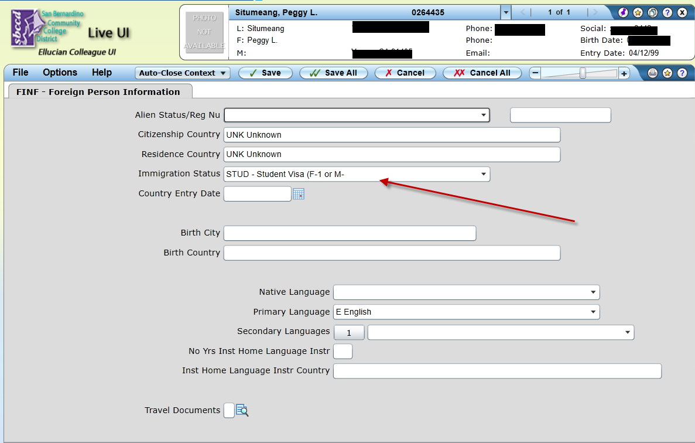

* Where do the Funds land: F-1, M-1
* Concerned about the accuracy of data
* In 2011, only 106 students had the ‘INTERN’ code on their record.
* Populated from Open CCCApply.
* Change Status: USCIS 🡪 Change not recorded.
* April Dale-Carter and Larry Aycock say it was okay to use F-1, M-1.

**Automate CCC Apply Import** – Joe Cabrales

* CCC Apply downloads 3-times per day.
* Current process 🡪 A&R manually imports Batch Files and fix errors.
* Discussed during The Enrollment Management Meeting.
* Automate the CCC Apply Import process.
* Import Batches into colleague.
* Errors get moved to a separate Batch.
* Expedite process to get students into the system and assign Colleague Ids.

1. *Some individuals joining the meeting via phone may not be in the Attendance List.*