WebAdvisor Cleanup – Brock Scudder & Joanna Crisostomo

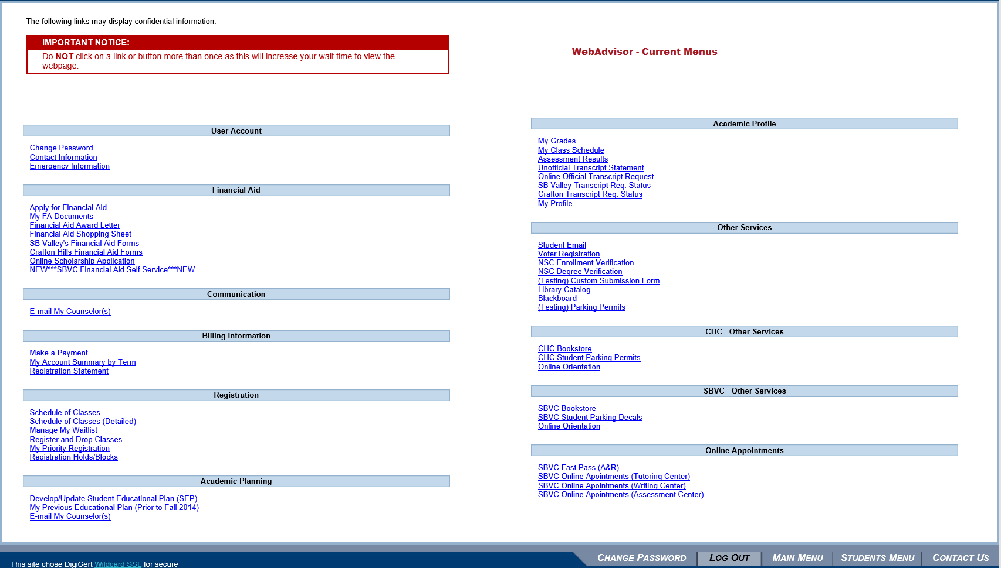 | 