# Meetings TOPICS: 2ND & 4TH wEDNESDAYS

**I. *CCC Apply International Application Online Demo & QA*** – Patty Donohue

(**2:30 pm – 3:30 pm**)

* Demo cancelled.

**II. *EPI Steering Committee*** – Robert McAtee, Yancie Carter, Michael Aquino

* Discussion/Concerns/Issues

**III. Credit Card Disclosures** – April Dale-Carter

* Are there any credit card disclosure statements when a student makes a payment, regarding the refund policy?

**IV. Instructor/Student Notifications (CRON job)** – DyAnn Walter

* Example of Cron job. The Cron shows name, schedule and what time it runs.

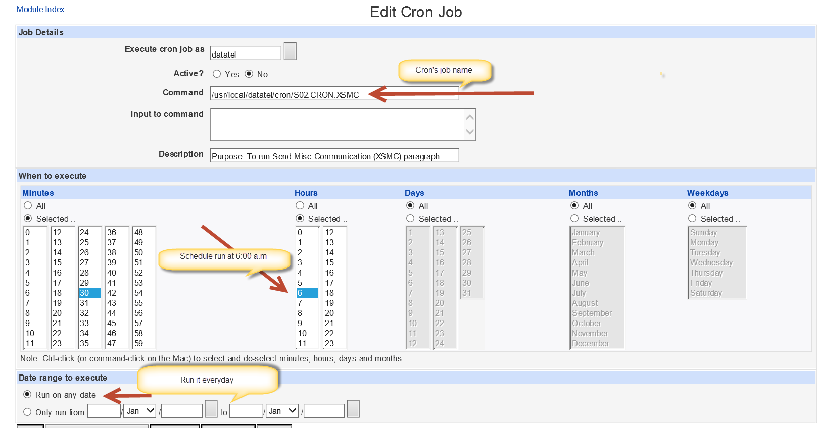

* Sample of student email output when the Cron executed.

|  |
| --- |
|  |

* Sample of faculty email output when the Cron executed.

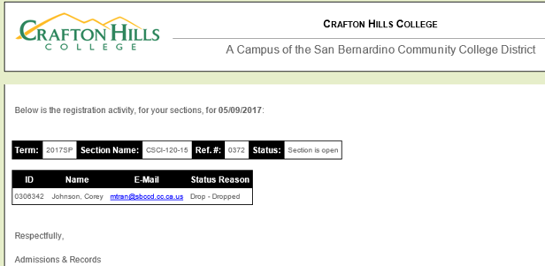

**V. Miscellaneous**

***Next DAWG Meeting*:** Wednesday, June 14, 2017

***DAWG “Parking Lot*”🚘**

|  |  |  |
| --- | --- | --- |
| **Topic** | **Description** | **Sponsor** |
| Student Group /Organization Transcript Notations | Pending feasibility study | HDO Ticket #95510  Yvette Tram |