The May 24th DAWG meeting was held in the Annex Training Room with the following discussions and individuals in attendance (*=v*ia CCC Confer*):

*Attendance [1]*

|  |  |
| --- | --- |
| Crafton | Joe Cabrales, Kirsten Colvey, *Kristi Simonson, Kristina Heilgeist,  Larry Aycock |
| Valley | *Corrina Baber, *Steven Silva, *Veada Benjamin, *Yancie Carter |
| Annex | Andy Chang, DyAnn Walter, Joanna Crisostomo, Joyce Bond,  Robert (Brock) Scudder |

***EPI Steering Committee*** – Robert McAtee, Yancie Carter, Michael Aquino

Yancie Carter said that both Crafton and Valley are finishing the Starfish Pilot. He said that we are waiting until the end of the semester to do a survey. Once the survey is completed, everyone will be focusing on Degree Planner.

**Instructor/Student Notifications (CRON job)** – DyAnn Walter

Faculty member have not been receiving notices of student Drops. DyAnn Walter said this is because the cron job (that produces the report) was deactivated.

Larry Aycock said there was an issue with emails. When the process ran, the Roster emails would not go out (and vice versus). Because the process ran intermitted, students and faculty were receiving multiple emails with incorrect notices.

April Dale-Carter and Larry Aycock approved of waiting until 2017 Fall before activating the cron.

The Cron shows name, schedule and what time it runs.

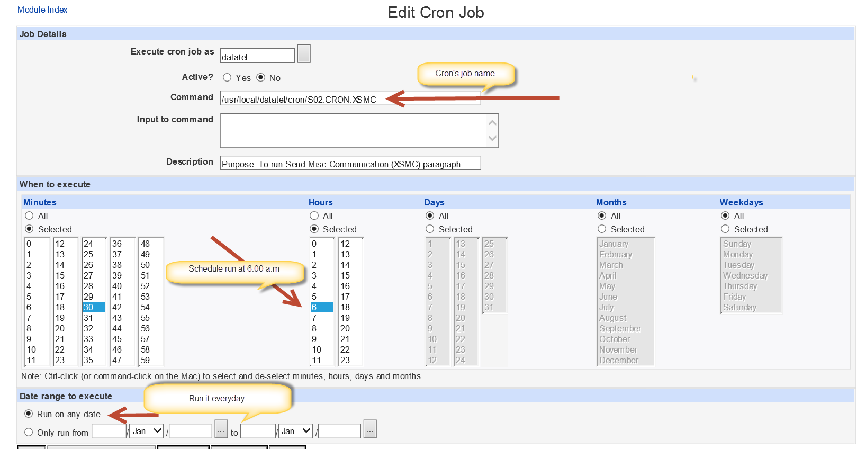

* Sample of student email output when the Cron executed.

|  |
| --- |
|  |

* Sample of faculty email output when the Cron executed.

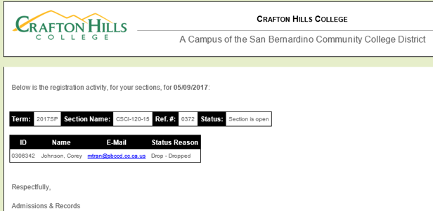

**Complaints from Students** – Joe Cabrales

* Students can’t see their grades.
* Might be because they owe an outstanding balance with the District.
* Can go to unofficial transcripts on the college’s website to see their grades.

1. *Some individuals joining the meeting via phone may not be in the Attendance List.*