Meetings TOPICS: 2ND & 4TH wEDNESDAYS
When the Online CCC Apply Demo is over, we will start the DAWG Meeting. If you do not plan to listen to the CCC Apply Demo, but would like to join the DAWG Meeting, send me an email. I will email you when the DAWG Meeting starts. Thanks.

I. CCC Apply International Application Online Demo & QA – Patty Donohue
(3:30 pm – 4:30 pm)
- Online Demo.
Patty Donohue is inviting you to a scheduled Zoom meeting.
Join from PC, Mac, Linux, iOS or Android: https://cccconfer.zoom.us/j/949964778
Or iPhone one-tap (US Toll): +14086380968,949964778# or +16465588656,949964778#
Or Telephone:
Dial: +1 408 638 0968 (US Toll) or +1 646 558 8656 (US Toll)
Meeting ID: 949 964 778
International numbers available: https://cccconfer.zoom.us/zoomconference?m=VPTqXy7XmyvrfMXURPYBApkEKv0oFwO0
Or Skype for Business (Lync):
SIP:949964778@lync.zoom.us

II. EPI Steering Committee – Robert McAtee, Yancie Carter, Michael Aquino
- Discussion/Concerns/Issues

  - III. Credit Card Disclosures – Veada Benjamin, April Dale-Carter
- Are there any credit card disclosure statements when a student makes a payment, regarding the refund policy?

  - IV. Zero Textbook Cost sections link (PDF) in WebAdvisor – Andy Chang
http://leginfo.legislature.ca.gov/faces/billNavClient.xhtml?bill_id=201520160SB1359
  - V. Posting LRC-900 Positive Attendance – Joe Cabrales, Larry Aycock
- From Larry: …We are holding off on posting the hours, but that also means they won’t be included in MIS reporting. We need to know if there is a workaround we can do to get the hours posted. Hopefully the discussion at DAWG will find a solution.

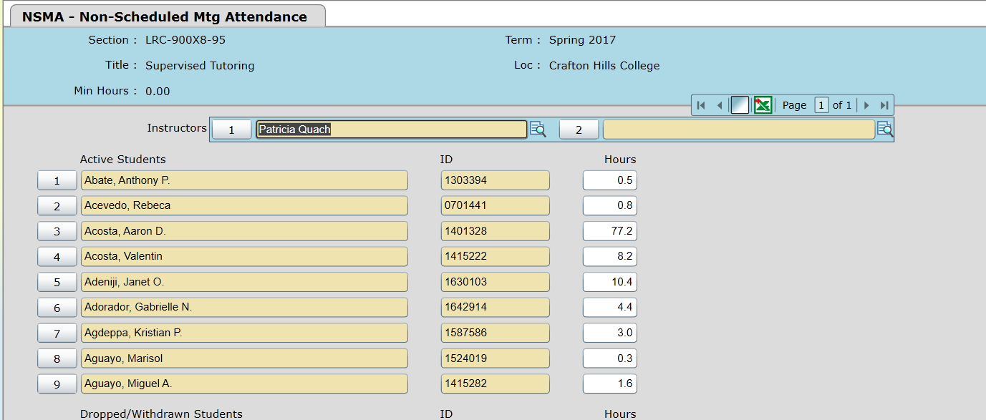

Dawn (from Ellucian) is looking into a way to have record unlocking and killing of sessions can come back to the SBCCD.

  - VI. ”Auto” Bulk Enrollment – Joe Cabrales
- Automatically registering students from waitlist.

  - VIII. Miscellaneous

  - Next DAWG Meeting: Wednesday, June 28, 2017

  - DAWG “Parking Lot”
Topic | Description | Sponsor
Student Group /Organization Transcript Notations | Pending feasibility study | HDO Ticket #95510  Yvette Tram

