# Meetings TOPICS: 2ND & 4TH wEDNESDAYS

**I. *CCCApply International Application Demo*** – Patty Donohue (3:30pm–415pm)

|  |  |  |  |  |
| --- | --- | --- | --- | --- |
| Patty Donohue is inviting you to a CCCApply International Application demo and Q&A session.  Join from PC, Mac, Linux, iOS or Android: [https://cccconfer.zoom.us/j/6770513851](https://www.google.com/url?q=https%3A%2F%2Fcccconfer.zoom.us%2Fj%2F6770513851&sa=D&usd=2&usg=AFQjCNFpzJwP3bPwY6_SHEyiv-gaEW5tIA)  Or iPhone one-tap (US Toll): +16465588656,6770513851# or +14086380968,6770513851#  Or Telephone: Dial: +1 646 558 8656 (US Toll) or +1 408 638 0968 (US Toll) Meeting ID: 677 051 3851  International numbers available: [https://cccconfer.zoom.us/zoomconference?m=IfxDvZXzzHFs7SRZfAduHnDa-roM7l4u](https://www.google.com/url?q=https%3A%2F%2Fcccconfer.zoom.us%2Fzoomconference%3Fm%3DIfxDvZXzzHFs7SRZfAduHnDa-roM7l4u&sa=D&usd=2&usg=AFQjCNE7a4fVnCRzeail4ztRmUddG_RN6w)  Or Skype for Business (Lync): [SIP:6770513851@lync.zoom.us](mailto:SIP%3A6770513851@lync.zoom.us)   |  |  | | --- | --- | | When | Wed Jul 26, 2017 3:30pm – 4:15pm Pacific Time | | Where | https://cccconfer.zoom.us/j/6770513851 ([map](https://www.google.com/url?q=https%3A%2F%2Fcccconfer.zoom.us%2Fj%2F6770513851&sa=D&usd=2&usg=AFQjCNFpzJwP3bPwY6_SHEyiv-gaEW5tIA)) | |

**Once the demo is over, our regularly scheduled DAWG Meeting will began.**

|  |
| --- |
| **Meeting Details**  Title : District Applications Workgroup (DAWG) Meeting Type : Meet & Confer  College/Group/Org: San Bernardino CCD Meeting Link **:** [**http://www.cccconfer.org/GoToMeeting?SeriesID=85e8c41b-d364-4b0a-ad31-464d39f9677a**](http://www.cccconfer.org/GoToMeeting?SeriesID=85e8c41b-d364-4b0a-ad31-464d39f9677a)  **Participant Details**  Telephone conference line: 1-913-312-3202 * * Toll free number : **1-888-886-3951** Participant passcode : **456933** |

**II. Credit Card Disclosures** – Noemi Elizalde, April Dale-Carter, Veada Benjamin

* Are there any credit card disclosure statements when a student makes a payment, regarding the refund policy?
* We are losing credit card disputes because there are no refund disclosure statements in the PayPal Payment process. Noemi Elizalde needs to finds out…
* What is actually being disputed?
* What kind of disclosure Merchant Services requires from us?

**III. *EPI Steering Committee*** – Robert McAtee, Yancie Carter, Michael Aquino

* Discussion

**IV. Pseudo courses**– Kristina Heilgeist

* Pseudo Courses may be a solution for a hurdle we have hit with degree planner.
* Preliminary work was done in July 2015 by Kristina Heilgeist, Benjamin Mudgett, and Cory Brady.

From Kristina:

The following six pseudo courses have been built in the test environment.

Please let me know if you require any additional items entered.

|  |  |
| --- | --- |
| **Purpose / When Used / Comments** | **Course** |
| Degree Applicable Transfer Totals | TRNSFR-DA |
| CHC GE Breadth Area A | OTCC-CGE/A |
| CHC GE Breadth Area C1 | OTCC-CGE/C1 |
| CHC GE Breadth Area C2 | OTCC-CGE/C2 |
| CSU GE Breadth Area A1 | OTCC-CSU/A1 |
| IGETC GE Breadth Area 1A | OTCC-IGETC/1A |

From Ben:

I have begun testing the pseudo courses in the test environment starting with OTCC-CSU/A1.  Degree Audit is not recognizing the course.  The equivalency was successfully created following general practices.  The course was entered on the student’s record through EXTS with the equivalency assigned as OTCC-CSU/A1.

We will need to evaluate the course attributes to make sure they allow the pseudo courses to be included in degree audit similar to regular courses.

1. OTCC-CSU/A1 included in degree audit syntax as an eligible course

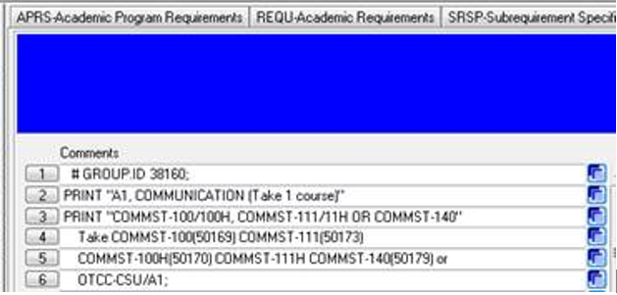

1. External course entered on student’s record

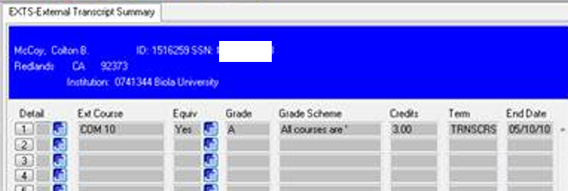

1. Equivalency assigned COM 10 from Biola University = OTCC-CSU/A1

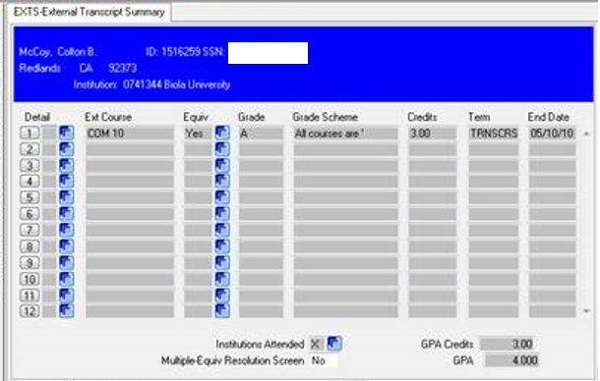

1. External course equivalency is on STAC

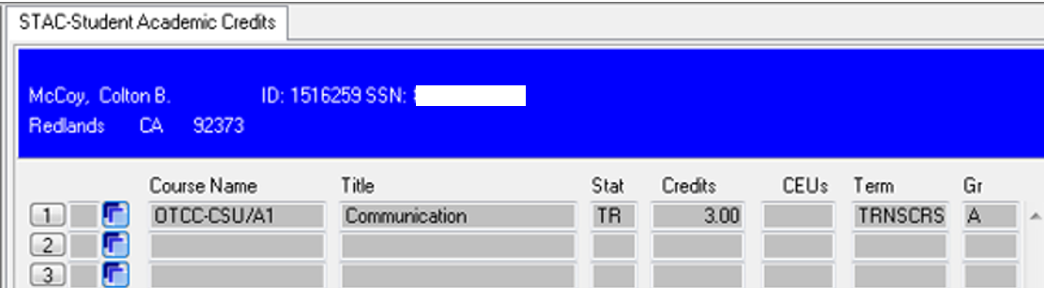

Course does not get used on EVAL

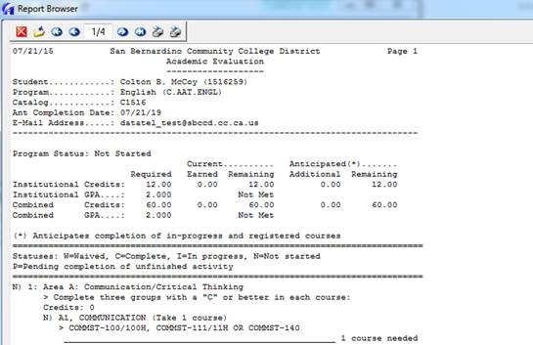

From Cory:

I’ve now updated VDA, VDAND, CDA, CDAND, DA transcript groupings to now allow records for OTCC departments to be selected, which was not previously allowed for ‘college specific’ courses that would be used in Degree Audit. That should at least allow the pseudo course to now be evaluated against the Degree Audit rules, as long as the PROG record has one of those 5 transcript groups assigned.

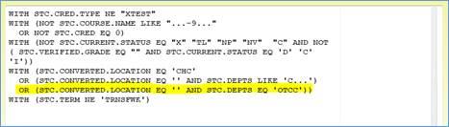

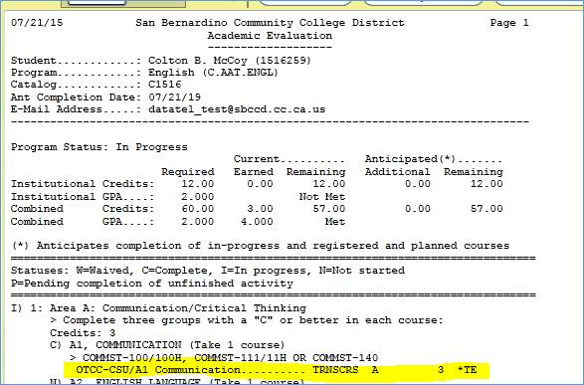

**V. Miscellaneous**

***Next DAWG Meeting*:** Wednesday, August 9, 2017 (2:30 pm – 4:30 pm)

***DAWG “Parking Lot*”🚘**

|  |  |  |
| --- | --- | --- |
| **Topic** | **Description** | **Sponsor** |
| Student Group /Organization Transcript Notations | Pending feasibility study | HDO Ticket #95510  Yvette Tram |