# Meetings TOPICS: 2ND & 4TH wEDNESDAYS

**I. *EPI Steering Committee*** – Robert McAtee, Yancie Carter, Michael Aquino

* Discussion

**II. Credit Card Disclosures** – Noemi Elizalde, April Dale-Carter, Veada Benjamin

* Resolution

**IV. Pseudo courses**– Kristina Heilgeist

* Pseudo Courses may be a solution for a hurdle we have hit with degree planner.
* Preliminary work was done in July 2015 by Kristina Heilgeist, Benjamin Mudgett, and Cory Brady.

From Kristina:

The following six pseudo courses have been built in the test environment.

Please let me know if you require any additional items entered.

|  |  |
| --- | --- |
| **Purpose / When Used / Comments** | **Course** |
| Degree Applicable Transfer Totals | TRNSFR-DA |
| CHC GE Breadth Area A | OTCC-CGE/A |
| CHC GE Breadth Area C1 | OTCC-CGE/C1 |
| CHC GE Breadth Area C2 | OTCC-CGE/C2 |
| CSU GE Breadth Area A1 | OTCC-CSU/A1 |
| IGETC GE Breadth Area 1A | OTCC-IGETC/1A |

From Ben:

I have begun testing the pseudo courses in the test environment starting with OTCC-CSU/A1.  Degree Audit is not recognizing the course.  The equivalency was successfully created following general practices.  The course was entered on the student’s record through EXTS with the equivalency assigned as OTCC-CSU/A1.

We will need to evaluate the course attributes to make sure they allow the pseudo courses to be included in degree audit similar to regular courses.

1. OTCC-CSU/A1 included in degree audit syntax as an eligible course

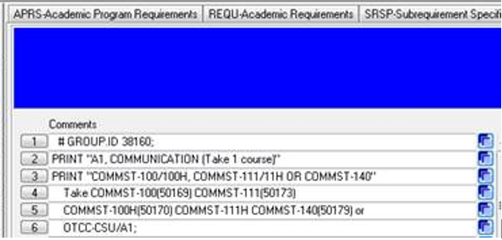

1. External course entered on student’s record

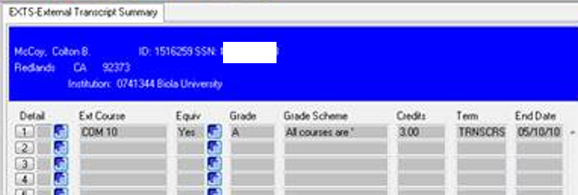

1. Equivalency assigned COM 10 from Biola University = OTCC-CSU/A1

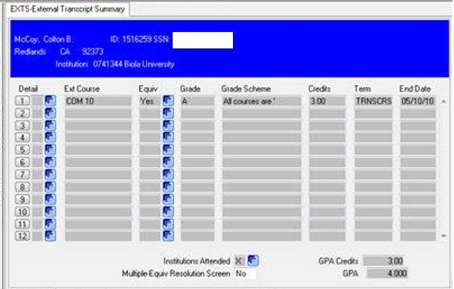

1. External course equivalency is on STAC

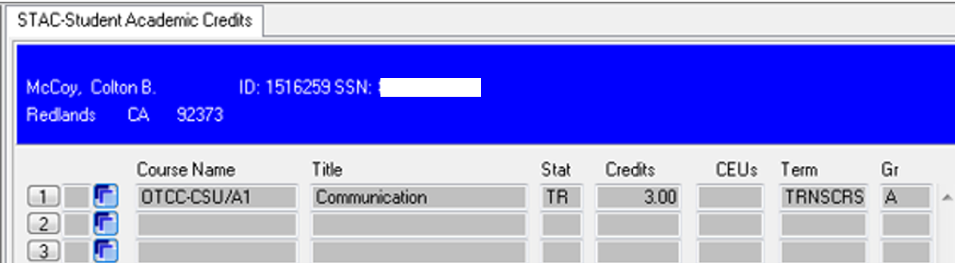

Course does not get used on EVAL

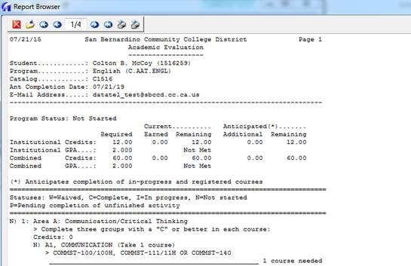

From Cory:

I’ve now updated VDA, VDAND, CDA, CDAND, DA transcript groupings to now allow records for OTCC departments to be selected, which was not previously allowed for ‘college specific’ courses that would be used in Degree Audit. That should at least allow the pseudo course to now be evaluated against the Degree Audit rules, as long as the PROG record has one of those 5 transcript groups assigned.

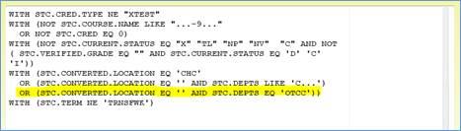

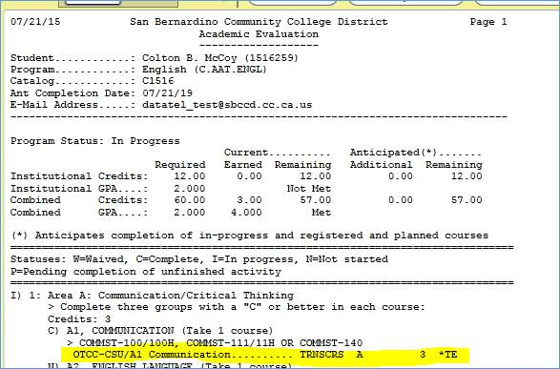

**V. Miscellaneous**

***Next DAWG Meeting*:** Wednesday, August 23, 2017 (2:30 pm – 4:30 pm)

***DAWG “Parking Lot*”🚘**

|  |  |  |
| --- | --- | --- |
| **Topic** | **Description** | **Sponsor** |
| Student Group /Organization Transcript Notations | Pending feasibility study | HDO Ticket #95510  Yvette Tram |