# Meetings TOPICS: 2ND & 4TH wEDNESDAYS

**I. *EPI Steering Committee*** – Robert McAtee, Yancie Carter, Michael Aquino

* Discussion

**II. Credit Card Disclosures** – Noemi Elizalde, April Dale-Carter, Veada Benjamin

* The District has been receiving ‘Credit Card Chargeback Rejections’ on online transactions because the refund policy was not properly disclosed.
* Noemi Elizalde contacted Citizens Business Bank (CBB) Merchant Services. She was told that the refund policy disclosure needs to be on the terms and conditions page…before a student clicks on the submit button[1].

During the course of an online payment transaction, a student will encounter two landing pages.

1. One from our system (Self Service)
2. One from PayPal (system we use to processes credit cards)

We want to know which landing page the disclosure should be displayed.

* Submitted by Michael Aquino; Proposed by Jason Brady.
* Place the refund policy disclosure statement on the payment section of self-service.
* The “Proceed to Payment” button takes you to Paypal and fits the “next to the PayPal buy or pay button” requirement.

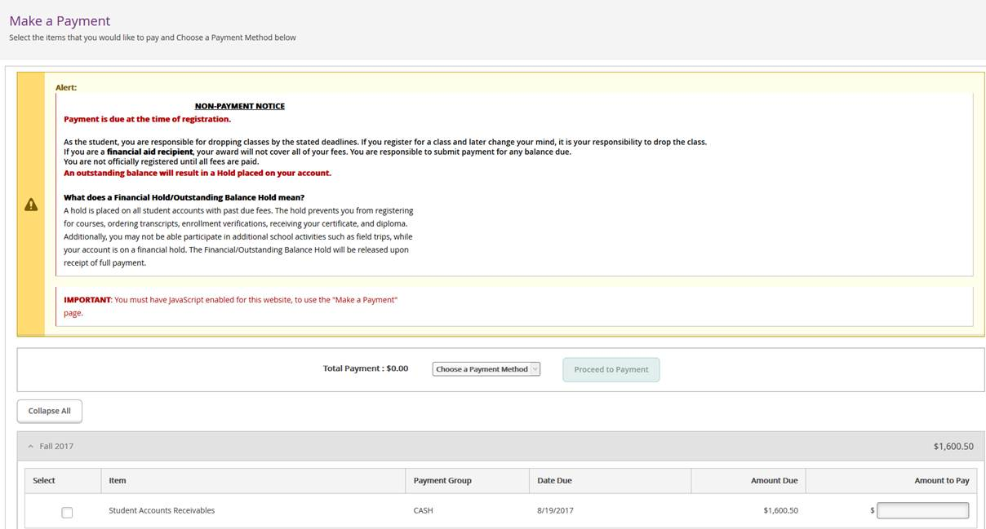

* URLs provided by Jason Brady.

https://sbccd.policystat.com/policy/3599809/latest/

http://www.craftonhills.edu/admissions-and-records/enroll/refund-policy.php

Jason

2:58 PM

https://sbccd.policystat.com/policy/3599809/latest/

https://sbccd.policystat.com/policy/3599809/latest/#autoid-0b9128a5d8de4a568c0ca6861ecfa0ca

2:59 PM

http://www.sbccd.org/Board_of_Trustees/Policies_,-a-,_Procedures

2:59 PM

http://www.craftonhills.edu/admissions-and-records/enroll/refund-policy.php

3:01 PM

* Once the online refund policy is settled, Noemi Elizalde will verify our refund policy, when cards are swiped (i.e. when in-house payment transactions are made at the colleges).
* Noemi Elizalde thinks the refund disclosure must be right above the signature line. She will confirm with Cory at Citizens what would constitute proper disclosure for these types of transactions.

**III. Non-Credit Transcripts**– Joe Cabrales

* Discussion

**IV. Pseudo courses**– Kristina Heilgeist

* Pseudo Courses may be a solution for a hurdle we have hit with degree planner.
* Preliminary work was done in July 2015 by Kristina Heilgeist, Benjamin Mudgett, and Cory Brady.

**V. Miscellaneous**

***Next DAWG Meeting*:** Wednesday, September 13, 2017 (2:30 pm – 4:30 pm)

***DAWG “Parking Lot*”🚘**

|  |  |  |
| --- | --- | --- |
| **Topic** | **Description** | **Sponsor** |
| Student Group /Organization Transcript Notations | Pending feasibility study | HDO Ticket #95510  Yvette Tram |

1. *The Refund Policy must be “prominently displayed” by the Checkout, Buy Button, or in the section where payment is collected or given.*

   *Unique laws by state about time frames (typically 30 days) can be found here:* [*http://consumer.findlaw.com/consumer-transactions/customer-returns-and-refund-laws-by-state.html*](http://consumer.findlaw.com/consumer-transactions/customer-returns-and-refund-laws-by-state.html)