The August 23rd DAWG meeting was held in the Annex Training Room with the following discussions and individuals in attendance (*=v*ia CCC Confer*):

*Attendance [1]*

|  |  |
| --- | --- |
| Crafton | Joe Cabrales, Kirsten Colvey, Kristina Heilgeist, Larry Aycock |
| Valley | *April Dale-Carter, *Corrina Baber, *Steven Silva, *Veada Benjamin |
| District | *Noemi Elizalde |
| Annex | Andy Chang, DyAnn Walter, *Jason Brady, Joanna Crisostomo, Joe Ho,  Joyce Bond, *Michael Aquino, Robert (Brock) Scudder |

***EPI Steering Committee*** - Robert McAtee, Yancie Carter,

Kristina Heilgeist, Michael Aquino

* Kristina Heilgeist said the EPI Basecamp meeting was held on Monday, August 21st. The following topics were discussed and resolved in the meeting.
* Troubleshooting Starfish
* Section records not matching
* Add new rules and flags
* Implementation
* Training Counselors on how to test Degree Planner
* Ed Plan
* Launching in Spring 2018
* Kirsten Colvey said they will be using SSSP**[2]** money to pay for additional programming.
* Want to set-up automated messages that will let the student know when they are close to graduating.
* Discussion item:
* Should SSSP money be used to ‘Register for Classes’ from the Ed Plan and to bring data back to us?
* Should we wait until the Chancellor’s Office builds a system that will provide that functionality?
* *Action Item:* Andy Chang will check with Cynthia to get a timeline for the completion of the Chancellor’s Office Glue Project**[3]**.
* Eventually, all plans (registration, assessment, etc.) will be on Glue.

**Credit Card Disclosures** - April Dale-Carter and Noemi Elizalde

* The District has been receiving ‘Credit Card Chargeback Rejections’ on online transactions because the refund policy was not properly disclosed.
* Noemi Elizalde contacted Citizens Business Bank (CBB) Merchant Services. She was told that the refund policy disclosure needed to be on the terms and conditions page…before a student clicks on the submit button**[4]**.
* During the online payment transaction process, a student will encounter two landing pages.

1. One from our system (Self Service)
2. One from PayPal (system we use to processes credit cards)

* Decision:
* Place the refund policy disclosure statement on the payment section of self-service.
* The “Proceed to Payment” button takes you to Paypal and fits the “next to the PayPal buy or pay button” requirement.
* URLs provided by Jason Brady:
* Board Policy

http://www.sbccd.org/Board_of_Trustees/Policies_,-a-,_Procedures

* + Crafton’s Website 🡪 Displays the ‘Refund Policy’

http://www.craftonhills.edu/admissions-and-records/enroll/refund-policy.php

* Using Board Refund Policy # AP5030 (Fee Refunds) as a guideline, the ‘Refund Policy’ on Crafton’s website will be updated to include three additional items.

1. *Conditions* 
   * + If a refund is requested for parking or student services card fees, the parking decal or the student services card must be attached to the refund request.
2. *Military Service Exception* 
   * + If a student who is a member of an active or reserve military service receives orders compelling a withdrawal from courses, the District shall, upon petition and a copy of received orders of the affected student, refund the entire enrollment fee unless academic credit is awarded
3. *Fees Collected in Error*
   * + Fees collected in error will be refunded in their entirety

* *Action Item:* Larry Aycock will format and update Crafton’s Refund Policy on their website, so that it included everything from SBCCD’s Board Refund Policy (AP5030).
* *Action Item:* Noemi Elizalde will create a Helpdesk Ticket to use Crafton’s re-formatted version of Refund Policy, and have the updated Non-Payment Notice placed on the Self-Service**[5]** ‘Make a Payment’ page.
* Once the online Non-Payment Notice is updated, Noemi Elizalde will determine if our in-house refund policy is sufficient (i.e. where credit cards are swiped at the colleges).

Previous Non-Payment Notice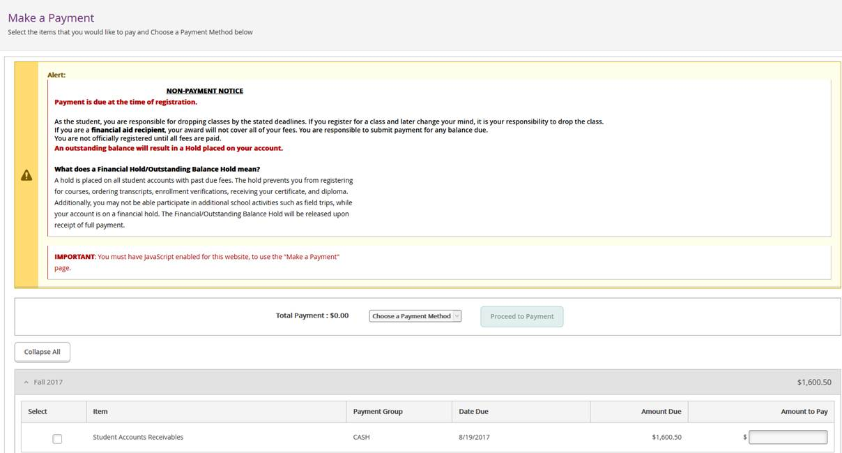

**Non-Credit Transcripts** - Joe Cabrales

* Non-credit Transcripts needed for Non-Credit Courses
* Title V - Section 55070
* These types of courses should not appear on Official Transcripts
* 72 Hour Certificated Courses (Non-credit course)
* Audit Courses are credited course and do appear on Official Transcripts
* *Action Item:* In the mnemonic ***PROG-Academic Programs***, Non-Credit Courses will be coded as ‘COMBINED Degree Audit Trans’ (i.e. Transcript Group = ‘DA’).

**Making the Waitlist Viewable** - Joe Cabrales

* Can the Wait-List be viewable to Faculty after the Wait-List closes in WebAdvisor?
* DyAnn Walter checked. Yes, the Wait-List Roster may be viewed before and after a section starts.
* Can the Wait-List be used to add students if desired?
* *Action Item*: A HelpDesk Ticket should be created to research this request.

**Automate BOG Financial Aid** - Joe Cabrales

* Student accounts need to get automatically re-billed.
* Send email to the Student letting them know that they have received a BOG.
* *Possible Solutions*:
* Set-up a cron process to run weekly.
* Create a Savedlist for the re-bill process.
* Notify Students via Comm Management.
* May be able to use regroup to schedule job and email Students.
* Re-bill only newly added BOG Students within a date range.
* Use an existing Informer Report: *Crafton BOG Students for Rebuilding.*
* Create a Savedlist from the Informer Report.
* *Action Item*: Joe Cabrales or Larry Aycock will need to submit a Project request.

1. *Some individuals joining the meeting via phone may not be in the Attendance List.*
2. SSSP is the Student Success and Support Program (formerly Matriculation)
3. Project Glue, or CCC Glue, is an integration architecture being developed by the California Community College’s Technology Center to allow disparate Student Information Systems (SIS) the ability to connect in a standardized way to system-wide technologies.
4. *The Refund Policy must be “prominently displayed” by the Checkout, Buy Button, or in the section where payment is collected or given.*

   *Unique laws by state about time frames (typically 30 days) can be found here:* [*http://consumer.findlaw.com/consumer-transactions/customer-returns-and-refund-laws-by-state.html*](http://consumer.findlaw.com/consumer-transactions/customer-returns-and-refund-laws-by-state.html)
5. WebAdvisor calls Self Service