# Meetings TOPICS: 2ND & 4TH wEDNESDAYS

1. ***EPI Steering Committee*** – Robert McAtee, Yancie Carter,

Kristina Heilgeist, Michael Aquino

* Discussion

**II. Wait List Functionality in Web Advisor** – Keith Wurtz

* Kathy Bakhit wants to make student names that are on the waitlist visible to faculty, but not to students to avoid confusion on the students’ end.
* DyAnn Walter said that the faculty does have access to view the waitlist after it’s canceled to students.
* Brandi Bailes, an instructor at Crafton, has expressed concerns about the functionality of the wait list and being able to serve students better.

1. Sometime over the weekend before the start of class, the waitlists are removed from all sections. The page that is generated when the user selects "waitlist roster" tells the user that the waitlist is empty.

* If the user has the where-with-all to select the class name anyway, they will see that the waitlist either is actually empty or has a list of students waiting.
* The user cannot tell if there is a waitlist for their class unless they select each individual section. Assuming that they knew to select the section even though the waitlist is zero.
* I attached an image to help clarify my concern.

1. Once the waitlist is removed the student only sees a message saying that the waitlist has been canceled for this section. Some students take this to mean that there is no way to get into the class.

* *Can the wording be updated to be more student friendly?*

They have no idea what that message is trying to convey.

* Students who do understand the message still have no way of knowing where they stand on the waitlist.
* Students searching for sections see that there is a class with no one on the waitlist and think that they may have a chance to add the course even though there may be 10+ students waiting to get in.

1. Once a student has been dropped or dropped the course themselves, the class shows a vacancy. The vacancy stays until a student with an add sticker actually signs into WebAdvisor and adds the course. Who knows how long that may take?

* This means that although my course is full and has 10+ students waiting to get in, a student just searching through classes sees that there are 2 or 3 empty seats and zero students on the waitlist. That student then shows up to a class that is very, very full falsely thinking that there is room.
* It’s a waste of time for the student who showed up to the class.
* It’s frustrating for the student because they have no way of knowing which classes legitimately have empty seats.

**III. Additional Biographic Information (ABIO)** – DyAnn Walter

* New screen provided by Ellucian.
* Gender Identity is not an MIS element.

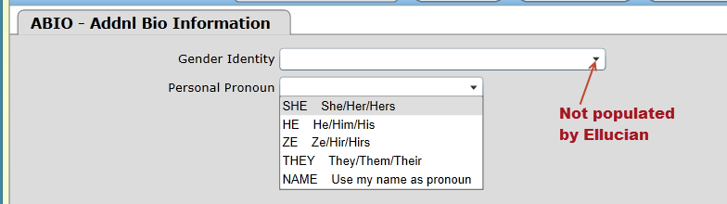

|  |
| --- |
| [**Resolution -** California Community Colleges **Chancellor's Office**](http://r.search.yahoo.com/_ylt=A0SO8xXnTahZm.cA231XNyoA;_ylu=X3oDMTEycW5kMGV0BGNvbG8DZ3ExBHBvcwMyBHZ0aWQDQjQwNzlfMQRzZWMDc3I-/RV=2/RE=1504231016/RO=10/RU=http%3a%2f%2fextranet.cccco.edu%2fPortals%2f1%2fExecutiveOffice%2fBoard%2f2017_agendas%2fJanuary%2fItem-2.3-Attachment-REVISED-Resolution.pdf/RK=1/RS=QGmZmPF9AGiq_8IIoTrQTabZGoQ-)  <http://extranet.cccco.edu/Portals/1/ExecutiveOffice/Board/2017_agendas/January/Item-2.3-Attachment-REVISED-Resolution.pdf> |

**IV. Updating XMINF-Military Information** – Arlene McGowan, Larry Aycock

* ***Problem:*** Prior to registering for classes in WebAdvisor, the student’s correct status has not been entered in XMINF for the Term being processed. This causes the student to be billed incorrectly.
* Verify both A&R Offices are on the same page on how to resolve the issues in billing when VA students are not coded on XMINF prior to registration.
* Currently, these steps required to correct the problem.
* Update XMINF (see below).

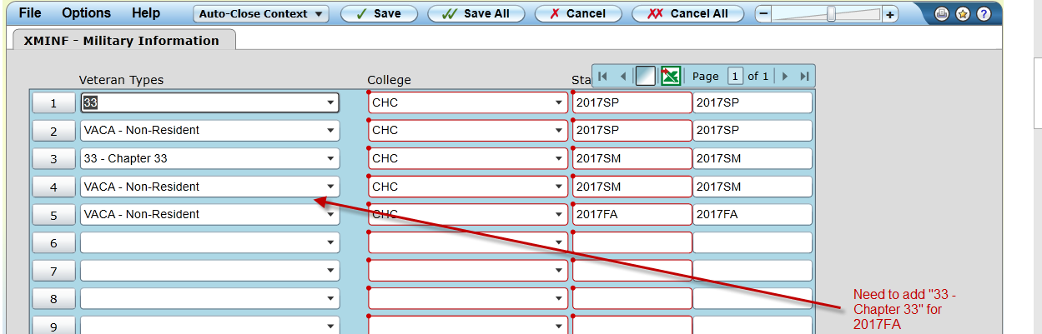

* Do the following for each of the classes the student is enrolled in.
* Using STAC/SACD, change the status from “N” or “A” to “D”.

*Do not change the date and time* of any of the classes

* Run BILL with Force= A for 2017FA. Enter the student id.
* Using STAC/SACD, change the status from “D” back to the original status.

*Do not change the date and time* of any of the classes.

* Run BILL with Force= A for 2017FA. Enter the student id.
* This should resolve the billing issue.
* Larry Aycock thinks this may be a *programming issue* with the Capital Outlay fee.
* The non-resident fees are removed when the VACA code is added, so why aren’t the Capital Outlay fees removed?
* Since this is a very common situation with our vets, we need the system to remove the Capital Outlay Fee when the code is added, even if it is after the student has registered.
* The workaround for staff to drop the student’s courses then re-add them is not acceptable as it is more work for A&R staff and creates a higher probability of human error which could result in students not being enrolled in their courses.

**V. Fall 2018 registration timeline** – Larry Aycock

**VI. Miscellaneous**

**Self Service - Student Planning** – Kristina Heilgeist

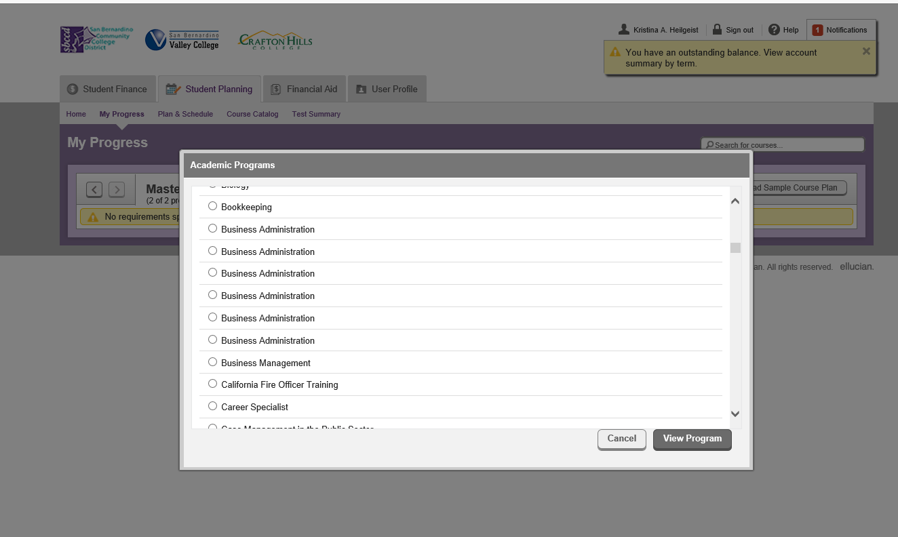<https://colss-prod.ec.sbccd.edu/Student/Planning/Programs/MyProgress#C.CERT.MT>

***Next DAWG Meeting*:** Wednesday, September 27, 2017 (2:30 pm – 4:30 pm)

***DAWG “Parking Lot*”🚘**

|  |  |  |
| --- | --- | --- |
| **Topic** | **Description** | **Sponsor** |
| Student Group /Organization Transcript Notations | Pending feasibility study | HDO Ticket #95510  Yvette Tram |
| Pseudo courses | Pseudo Courses may be a solution for a hurdle we have hit with degree planner. | Kristina Heilgeist |