The September 13th DAWG meeting was held in the Annex Training Room with the following discussions and individuals in attendance (*=v*ia CCC Confer*):

*Attendance [1]*

|  |  |
| --- | --- |
| Crafton | Joe Cabrales, Kirsten Colvey, Larry Aycock |
| Valley | *Corrina Baber, *Steven Silva |
| Annex | Andy Chang, DyAnn Walter, *Jason Brady, Joanna Crisostomo, Joe Ho,  Joyce Bond, *Michael Aquino, Robert (Brock) Scudder |

**EPI Steering Committee**

***Sponsors***: Robert McAtee, Yancie Carter, Kristina Heilgeist, Michael Aquino

Michael Aquino: Don will be transitioning his duties to Mindy Jackson in a couple of weeks.

Kirsten Colvey: Crafton is in the process of testing Degrees. The Counselors use Google Docs[2] to enter the data. They are correcting the data as errors are found. It may take a couple of months to resolve all errors.

Starfish is okay. No technical issue found…Just process issues.

Robert McAtee and Kirsten Colvey will be attended a Steering Committee Meeting in early October.

**Wait List Functionality in Web Advisor**

Sponsor: Keith Wurtz, Joe Cabrales

Kathy Bakhit wants to make student names that are on the waitlist visible to faculty, but not to students. This is necessary to avoid confusion on the students’ end.

* DyAnn Walter said that the faculty does have access to view the waitlist after it’s no longer accessible to students.

Brandi Bailes, an instructor at Crafton, has expressed concerns about the functionality of the wait list and being able to serve students better.

1. *Sometime over the weekend before the start of class, the ‘Waitlists’ are removed from all sections. The page that is generated when the user selects "Waitlist Roster" tells the user that the waitlist is empty.*

* *If the user has the where-with-all to select the class name anyway, they will see that the waitlist either is actually empty or has a list of students waiting.*
* *The user cannot tell if there is a waitlist for their class unless they select each individual section. Assuming that they knew to select the section even though the waitlist is zero.*
* *I attached an image to help clarify my concern.*

1. *Once the waitlist is removed the student only sees a message saying that the waitlist has been canceled for this section. Some students take this to mean that there is no way to get into the class.*

* *Can the wording be updated to be more student friendly?*

*They have no idea what that message is trying to convey.*

* *Students who do understand the message still have no way of knowing where they stand on the waitlist.*
* *Students searching for sections see that there is a class with no one on the waitlist and think that they may have a chance to add the course even though there may be 10+ students waiting to get in.*

1. *Once a student has been dropped or dropped the course themselves, the class shows a vacancy. The vacancy stays until a student with an add sticker actually signs into WebAdvisor and adds the course. Who knows how long that may take?*

* *This means that although my course is full and has 10+ students waiting to get in, a student just searching through classes sees that there are 2 or 3 empty seats and zero students on the waitlist. That student then shows up to a class that is very, very full…falsely thinking that there is room.*
* *It’s a waste of time for the student who showed up to the class.*
* *It’s frustrating for the student because they have no way of knowing which classes legitimately have empty seats.*

Resolution: Internal discussion needed between Faculty members to determine how the waitlist should be used once class starts.

Add Joe Cabrales to this topic.

FYI: Waitlist closes 2 days before the class starts.

**Additional Biographic Information (ABIO)**

Sponsor: DyAnn Walter

New screen provided by Ellucian.

Gender Identity is not an MIS element.

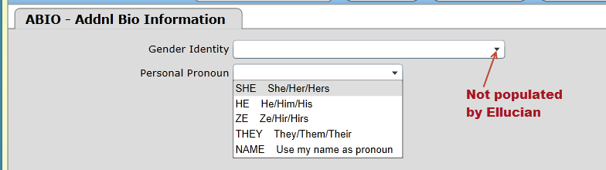

Resolution: Values not imported by CCCApply.

Do not need to populate these fields at this time.

Screen will not be used.

**Updating XMINF-Military Information**

Sponsors: Arlene McGowan, Larry Aycock

***Problem:*** Prior to registering for classes in WebAdvisor, the student’s correct status was not in XMINF for the Term being processed. This caused the student to be billed incorrectly.

Verify both A&R Offices are on the same page on how to resolve the issues in billing when VA students are not coded on XMINF prior to registration.

Currently, these steps are required to correct the problem.

* Update XMINF (see below).

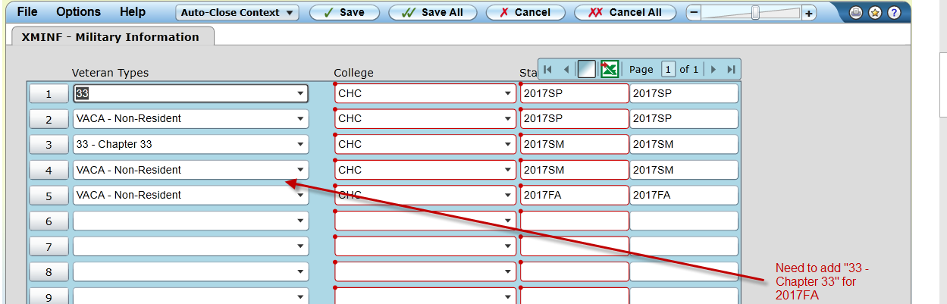

* Do the following for each of the classes the student is enrolled in.
* Using STAC/SACD, change the status from “N” or “A” to “D”.

*Do not change the date and time* of any of the classes

* Run BILL with Force= A for 2017FA. Enter the student id.
* Using STAC/SACD, change the status from “D” back to the original status.

*Do not change the date and time* of any of the classes.

* Run BILL with Force= A for 2017FA. Enter the student id.
* This should resolve the billing issue.

Larry Aycock thinks this may be a *programming issue* with the Capital Outlay fee.

* The non-resident fees are removed when the VACA code is added, so why aren’t the Capital Outlay fees removed?
* Since this is a very common situation with our vets, we need the system to remove the Capital Outlay Fee when the code is added, even if it is after the student has registered.
* The workaround for staff to drop the student’s courses then re-add them is not acceptable as it is more work for A&R staff and creates a higher probability of human error which could result in students not being enrolled in their courses.

The Capital Outlay Fee: Previously, only applied to International Students. Now, it has been changed to include Non-Resident Students.

This could be an issue if ‘Billing Rules’ are changed mid-year.

Action Item: Michael Aquino will open a ticket with Ellucian’s Action Line, since Ellucian uses a computed column that references the information on the screen.

**Fall 2018 Registration Timeline**

Sponsor: Larry Aycock

2018 Spring Registration begins on October 30, 2017

Crafton would like to have student register for fall before they leave in the spring.

New proposed registration dates:

2018SM - April 16th

2018FA - April 16th

Steven Silva said that Fall Applications begin on April 1st. The Fall Applications may need to be opened sooner to meet the new proposed registration timeline.

Partial Registration Checklist:

* 1. Curriculum
     1. Cut-off date established
     2. Sections built for the new versions of the course
  2. Catalog
  3. Scheduling
  4. Instruction needs to have the Schedule ready
  5. High School Flags have to be cleared
  6. A&R Staff
  7. Server must be able to handle additional load on the system
  8. Tess would need to know when, so that systems can be adjusted

**Miscellaneous**

**Self Service - Student Planning**

**Sponsor**: Kristina Heilgeist

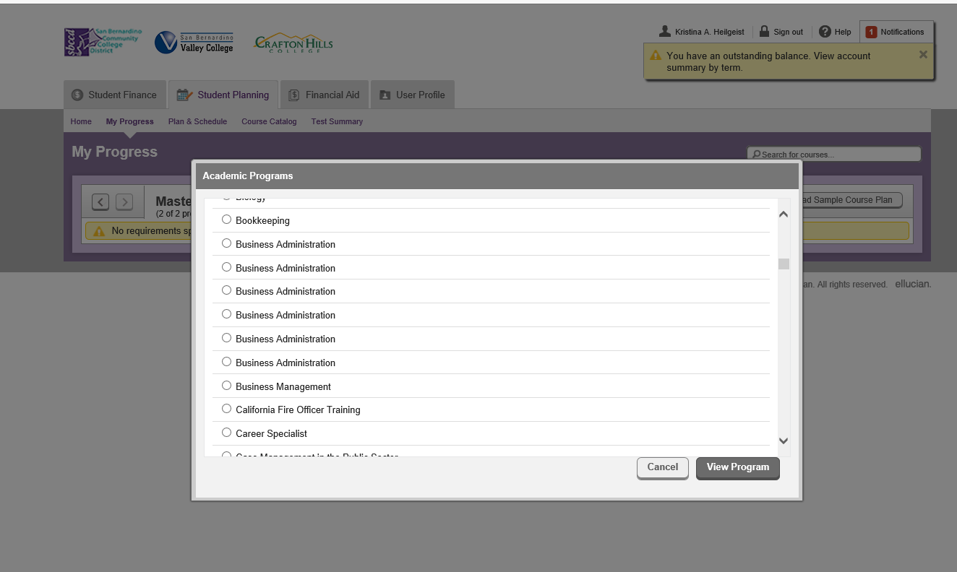

<https://colss-prod.ec.sbccd.edu/Student/Planning/Programs/MyProgress#C.CERT.MT>

The fields listed above are pulled from the Title field in the PROG Screen. This field is also displayed on the Transcript. Therefore, we would have to be cautious on name changes.

Log on: WebAdvisor

Select : Ed Plan - Plan your degree and schedule your courses

* View Your Progress
* View a New Program

*The Student’s ‘Program Title’ shows on the Transcript.*

From the Transcript:

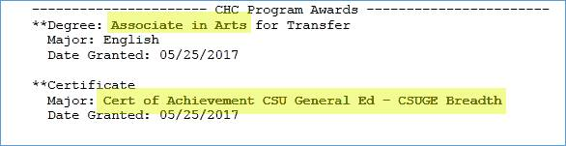

|  |  |
| --- | --- |
|  |  |

*Resolution:* Ed Plan in WebAdvisor will be phased out in 2018SM.

Moving to the Ed Plan in Hobson.

No changes necessary.

1. Disclaimer: Some individuals joining the meeting via phone may not be in the Attendance List.
2. Google Docs: Web-based word processor that allows users to create and edit files online while collaborating with other users in real-time.