Meetings TOPICS: 2ND & 4TH wEDNESDAYS
  - I. Updating XMINF-Military Information – Arlene McGowan, Larry Aycock
- Problem: Prior to registering for classes in WebAdvisor, the student’s correct status has not been entered in XMINF for the Term being processed. This causes the student to be billed incorrectly.
- Verify both A&R Offices are on the same page on how to resolve the issues in billing when VA students are not coded on XMINF prior to registration.
- Currently, these steps required to correct the problem.
- Update XMINF (see below).
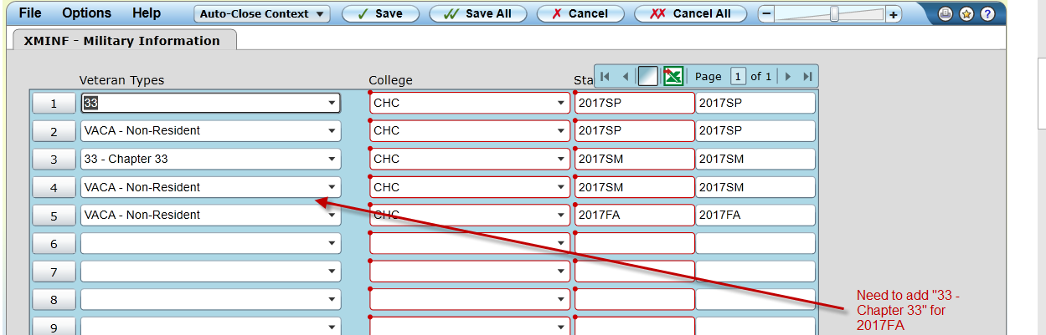
- Do the following for each of the classes the student is enrolled in.
- Using STAC/SACD, change the status from “N” or “A” to “D”.
Do not change the date and time of any of the classes
- Run BILL with Force = A and Cutoff = 12/31/17(or any date AFTER the end date of the term in question) for your student(s)/term(s) in question
- Using STAC/SACD, change the status from “D” back to the original status.
Do not change the date and time of any of the classes.
- Run BILL with Force = A and Cutoff = 12/31/17(or any date AFTER the end date of the term in question) for your student(s)/term(s) in question
- This should resolve the billing issue.
- Michael Aquino opened a ticket with Ellucian’s Action Line. Since this change is not part of Ellucian’s baseline, we would need to do one of the following.
- Execute the Workaround logic that Michael mentioned above.
- Contact Ellucian’s custom development department to make the changes.

- Larry Aycock thinks this may be a programming issue with the Capital Outlay fee.
- The non-resident fees are removed when the VACA code is added, so why aren’t the Capital Outlay fees removed?
- Since this is a very common situation with our vets, we need the system to remove the Capital Outlay Fee when the code is added, even if it is after the student has registered.
- The workaround for staff to drop the student’s courses then re-add them is not acceptable as it is more work for A&R staff and creates a higher probability of human error which could result in students not being enrolled in their courses.
- Suggestion: Submit Help Desk Ticket to determine what needs to be done to remove the Capital Outlay fee for VACA Students.

  - II. Students Enrolling in Cancelled Sections with Add Codes – Larry Aycock
- Discussion

  - III. Automate Requisites
- Ready to GoLive for 2018SP
- Problem: When Co-Requisites are found after the Section starts, the Student’s status is changed to “D’.
- BGVU calls S.VAL.GRADE
- When the student has been given a grade and the current status is ‘Drop’ or ‘Instructor Drop’, BGVU changes the grade to ‘Withdrawn’.

  - IV. Miscellaneous

  - Next DAWG Meeting: Wednesday, October 11, 2017 (2:30 pm – 4:30 pm)

  - DAWG “Parking Lot”
Topic | Description | Sponsor
EPI Steering Committee | Hobson’s Starfish Early Alert and Degree Planner | Robert McAtee, Yancie Carter, Kristina Heilgeist, Michael Aquino
Pseudo courses | Pseudo Courses may be a solution for a hurdle we have hit with degree planner. | Kristina Heilgeist

