The September 27th DAWG meeting was held in the Annex Training Room with the following discussions and individuals in attendance (*=via CCC Confer):
Attendance
Crafton | Joe Cabrales, Kirsten Colvey, Kristina Heilgeist, Larry Aycock
Valley | *April Dale-Carter, *Corrina Baber, *Jason Alvarez, *Steven Silva,  *Veada Benjamin, *Yancie Carter
Annex | Andy Chang, DyAnn Walter, *Jason Brady, Joe Ho, Joyce Bond,  *Michael Aquino, Robert (Brock) Scudder

Updating XMINF-Military Information
Sponsors: Arlene McGowan, Larry Aycock
- Problem: Prior to registering for classes in WebAdvisor, the student’s correct status was not in XMINF for the Term being processed. This caused the student to be billed incorrectly.
- Currently, these steps are required to correct the problem.
- Update XMINF (see below).
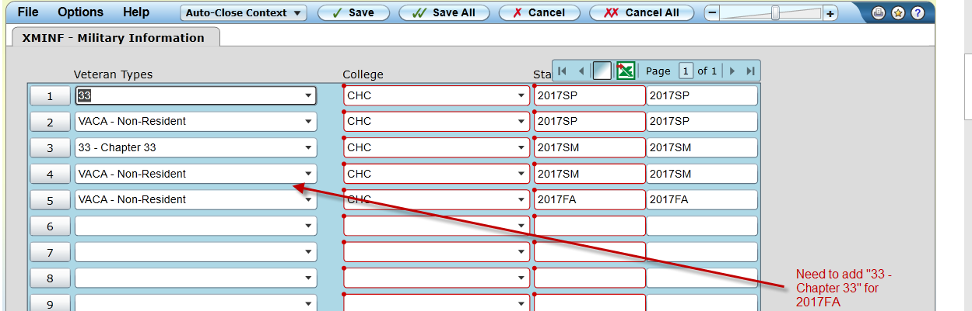
- Do the following for each of the enrolled classes.
- Run STAC/SACD. Change the status from ‘N’ or ‘A’ to ‘D’.
Do not change the date and time of any of the classes
- Run BILL for your student(s) and term in question. ‘Set Force to A’ and ‘Cutoff to 12/31/17’ (i.e. any date AFTER the end date of the term in question).
- Using STAC/SACD, change the status from ‘D’ back to the original status.
Do not change the date and time of any of the classes.
- Run BILL for your student(s) and term in question. ‘Set Force to A’ and ‘Cutoff to 12/31/17’ (i.e. any date AFTER the end date of the term in question).
- This should resolve the billing issue.
- Michael Aquino opened a ticket with the Ellucian Action Line. Ellucian replied that this change is not part of the Colleague Baseline. We would need to do one of the following to resolve the problem.
- Execute the Workaround logic mentioned by Michael (above).
- Contact Ellucian’s Custom Development Department to make the necessary changes.
- Larry Aycock thinks this may be a programming issue with the Capital Outlay fee.
- The non-resident fees are removed when the VACA code is added, so why aren’t the Capital Outlay fees removed?
- Since this is a very common situation with our vets, we need the system to remove the Capital Outlay Fee when the code is added, even if it is after the student has registered.
- The workaround for staff to drop the student’s courses then re-add them is not acceptable as it is more work for A&R staff and creates a higher probability of human error which could result in students not being enrolled in their courses.
- Resolution: The ‘2017 July-September Software Patch Cycle’ contain software changes made by Ellucian. These changes seem to have corrected the problem. Discussion has been postponed until we are sure the problem is no longer occurring.

Students Enrolling in Cancelled Sections with Add Codes
Sponsor: Larry Aycock
- Problem: An ‘Add Code’ was given the student before the class (section) was cancelled. Within the allowable add-period, the student was allowed to register for the section. The student was not notified that the section was cancelled.
- Resolution: Someone from the Instruction Office will be contacting the Instructors. Once a section is cancelled, XIRC should be run to invalidate the registration ‘Add Codes’.

Miscellaneous Topics
Misc. Topic #1: Pre-requisite and Co-requisite Sections
- Starting with the 2018 Spring Term, the nightly process of dropping students from classes (sections) that do not meet the pre-requisites and/or co-requisite requirements will be automated.
- Possible Problem: When a student does not meet the co-requisite requirement and the section has already started, the student’s status on the section changes to ‘D’ (Drop). If the dropped section contains a grade, the ‘Batch Grade Verification’ program (BGVU) will change the grade to ‘W’ (Withdrawn).
- Solution: Put a status of ‘X’ on the student’s section for all Requisite Drops.

Misc. Topic #2: 2018 Summer & Fall Priority Registration
- Joe Cabrales said that Priority Registration will began on April 16, 2017 for the Crafton’s 2018 Summer and Fall Terms.
- April Dale-Carter said that Valley has not made a decision on when the next priority registration will began for the 2018 Summer and/or Fall Terms.

Misc. Topic #3: Maxient Project
- Michael Aquino said the Input file has been created for Maxient. He is currently working with Maxient to set-up the SFTP process.

Misc. Topic #4: Non-Payment Drops
- As of 2017 Spring, students have not been dropped for non-payment.
- It was hoped that allowing the student more time to pay would improve our Full Time Equivalent (FTE) student count.
- Larry Aycock said that based on his preliminary research, most students with an outstanding balance have dropped out of class or finished with a ‘D’ or ‘F’.

Misc. Topic #5: EPI Update
- Meet once a week to resolve problems and/or concerns in Starfish.
- Yancie Carter said they were working on the set-up for Degree Planner.
- Counselors still need to review all the Degrees.
- Paying for 6 months of additional time with Ferrilli.
FYI: Ferrilli’s time is based on time actually used.
- Tess’ Responsibility
- Get training and documentation from Don (Ferrilli Consultant).
- Support the extract.
- Provide user security role access.

Misc. Topic #6: SARS Anywhere
- Kirsten Colvey will contact SARS to schedule a demo during the DAWG Meeting.

Disclaimer: Some individuals joining the meeting via phone may not be in the Attendance List.

