- Adding Additional Student Drop Reasons in WebAdvisor
To be discussed next session
Sponsor: April Dale-Carter
- In the Campus Retention Committee Meeting, we were discussing reasons students drop from a course. We were wondering if the options in WebAdvisor can be expanding upon. Can more options be added (i.e. Are you dropping all classes) or even a comment?
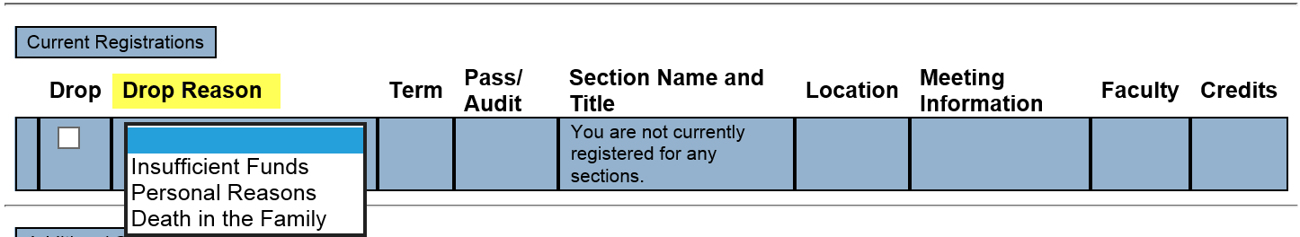

  - II. Automating Requisites for 2018SP
Sponsor: Joyce Bond
- Spring registration starts October 30, 2017.
- Must be run on quiet system. May take up to 3 hours per night.
- Students and Faculty need to be aware that WebAdvisor will be down.
- Submit SNOW Ticket for Ellucian.

  - III. Student Health and Accident Insurance Fee Increase
  - Sponsor: DyAnn Walter
- Fee Changes approved by Board of Trustees (BOT) in August

From DyAnn Walter:
A decision will need to be made. Should all 2017FA students be re-billed?

Also, what the repercussions will be that A&R will need to know when students start complaining. Not sure if that fact that the correct fee is not posted to their webpage makes a difference.
In preparation for 2017FA registration I received email from Tenille Alexander on 3/14/17 regarding the BOT approved nonresident tuition fee of $234 and capital outlay fee of $32 for the 2017-2018 fiscal year.

These fees went into effect for the 2017FA term. (Registration started 6/5/17).

From the Registration Checklist
Determine Any New or Revised Fee Changes in Board Policies that have been submitted that needs to be implemented for this registration period. Report them to DyAnn Walter. | Tenille Alexander  Completed 3/14/17 | Complete by 5/15/17  (10th business day before 1st day of registration between colleges) | Tenille Alexander  Completed 3/14/17 | Complete by 5/15/17  (10th business day before 1st day of registration between colleges)

I just received a helpdesk ticket from Elaine Akers requesting:

Please update fees in Colleague per recent board approved changes:
Student Health and Accident Insurance
$20.00 - per semester (includes $1.50 accident insurance)
$17.00 - summer session (includes $1.50 accident insurance)
$ 1.50 - accident insurance only

It looks like the Health Fee went up by $1.

Would you please confirm this fee increase, when it was approved by BOT and more importantly, when it was to go into effect.

The Health & Accident Fees are built in the billing tables, per fiscal year, not per term.

Just FYI - Neither SBVC or CHC show this increase on their website.

  - IV. Miscellaneous

  - Next DAWG Meeting: Wednesday, October 25, 2017 (2:30 pm – 4:30 pm)

  - DAWG “Parking Lot”
Topic | Description | Sponsor
EPI Steering Committee | Hobson’s Starfish Early Alert and Degree Planner | Robert McAtee, Yancie Carter, Kristina Heilgeist, Michael Aquino
Pseudo courses | Pseudo Courses may be a solution for a hurdle we have hit with degree planner. | Kristina Heilgeist

