- Adding Additional Student Drop Reasons in WebAdvisor
Sponsor: April Dale-Carter
- In the Campus Retention Committee Meeting, we were discussing reasons students drop from a course. We were wondering if the options in WebAdvisor can be expanding upon. Can more options be added (i.e. Are you dropping all classes) or even a comment?
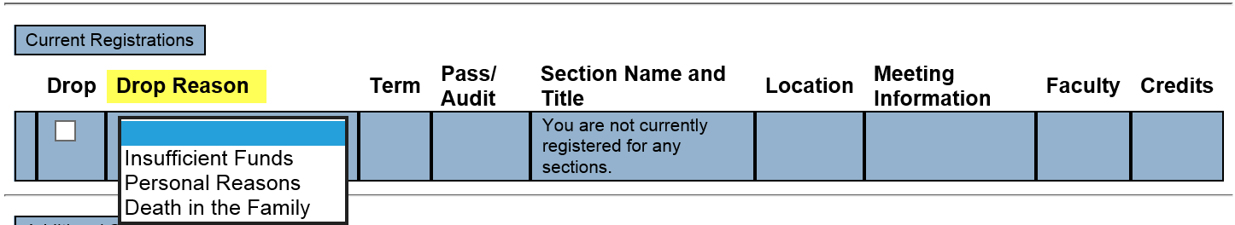

  - II. New Version of Colleague UI
  - Sponsor: Andy Chang
- Discussion

  - III. Course Registration from the Educational Plan (Using the EPI tool)
  - Sponsor: Robert McAtee
- An option is on the table to bring in a third party group (N2N associates), vetted by Hobsons and State Tech Center, to help with the integration. Robert presented the concerns to the State Tech Center and Hobsons. This included TESS staffing challenges and where we are currently with Degree Planner implementation.

- Hobsons and N2N presented the following in response:
- Phase 1 - Environment Setup
Activities - Routine items like making firewall rule changes, setting up a web server, and provisioning VPN access.
Required Staff - Network staff
Time with Normal Deployment Delays - This process usually takes about 2 weeks mostly as a function of the client's processes.
Time with no Process Delays - Usually less than 2-4 days.

- Phase 2.- Illuminate Deployment (usually runs concurrent with Phase 1)
Activities - This is provisioning of SIS access, deployment of user creation script, deployment of SIS object creation scripts (views, arrays, etc)
Required Staff - Usually a DBA or a Programmer/Analyst based on the Client organization and SIS.
Time with Normal Deployment Delays - This process typically takes 2-4 weeks depending on staff availability, environment availability and if we have to do any modifications to the scripts based on Client unique SIS attributes.
Time with no Process Delays - Usually 2-4 days.

- Phase 3 - Illuminate Configuration -
Activities - This is the UAT testing of scripts, API testing with test data, API script tweaking based on Client SIS deployment, etc. -
Required Staff - Client DBA, some institutions will involve a functional user or Registrar's office who will lead testing the registration process but some will do so just with the DBA or IT resource.
Time with Normal Deployment Delays - This process usually takes 4-6 weeks depending on staff availability.
Time with no Process Delays - Usually 6-8 days to ensure everything is working exactly correct.
Since some of the phases above can overlap, we estimate that the approximate timeframe for working with us to configure the two-way integration would be 6-9 weeks.

- Would like to know if DAWG is open to at least hearing a presentation from Hobsons and N2N on what they have that would allow students to register for courses from the Ed Plan.

  - IV. Miscellaneous

  - Next DAWG Meeting: Wednesday, November 8, 2017 (2:30 pm – 4:30 pm)

  - DAWG “Parking Lot”
Topic | Description | Sponsor
EPI Steering Committee | Hobson’s Starfish Early Alert and Degree Planner | Robert McAtee, Yancie Carter, Kristina Heilgeist, Michael Aquino
Pseudo courses | Pseudo Courses may be a solution for a hurdle we have hit with degree planner. | Kristina Heilgeist

