The October 25th DAWG meeting was held in the Annex Training Room with the following discussions and individuals in attendance (*=via CCC Confer):
Attendance
Crafton | Joe Cabrales, *Kirsten Colvey, *Kristi Simonson, Kristina Heilgeist,  Larry Aycock, *Robert McAtee
Valley | *Pavel Bratulin, *Steven Silva, *Yancie Carter
Annex | Andy Chang, DyAnn Walter, *Jason Brady, Joanna Crisostomo, Joe Ho,  Joyce Bond, *Michael Aquino, Robert (Brock) Scudder

Adding Additional Student Drop Reasons in WebAdvisor
Sponsor: April Dale-Carter, Steven Silva
The Campus Retention Committee Meeting discussed reasons students drop from a course.
The Committee would like to expand the ‘Drop Reasons’ in WebAdvisor and/or add a text box, so students are aware that there may be consequences when all their classes are dropped.
Joe Cabrales said the 1st VPs and Researchers will come up with some additional reasons. One reason that he would like to be included is ‘Transportation’.
Action Item # 1: Joe will bring up ‘Drop Reasons’ in the next Enrollment Management Meeting.
Current Drop Reasons
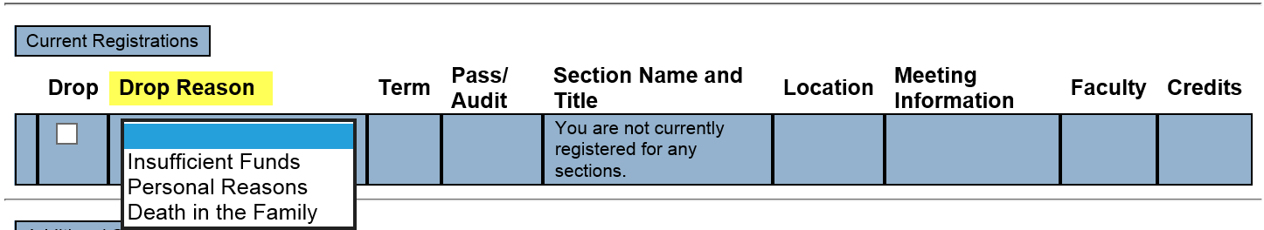

Yancie Carter wants text that would indicate the following.
… Your Financial Aid may be affected if you Withdraw from this class.
… Please meet with Financial Aid to see what implications…
Larry Aycock said that we already have pop-up for static messages in WebAdvisor, regarding Financial Aid.
Yancie wants to initiate a more proactive approach.
Suggestion: Combine Non-Payment Messages with the Drop Message.
Action Item # 2: The Register and Drop Classes’ NON-PAYMENT NOTICE text box will be changed to include a warning on the consequences of dropping classes.
Yancie Carter will submit a HelpDesk Ticket containing the verbiage that is needed.
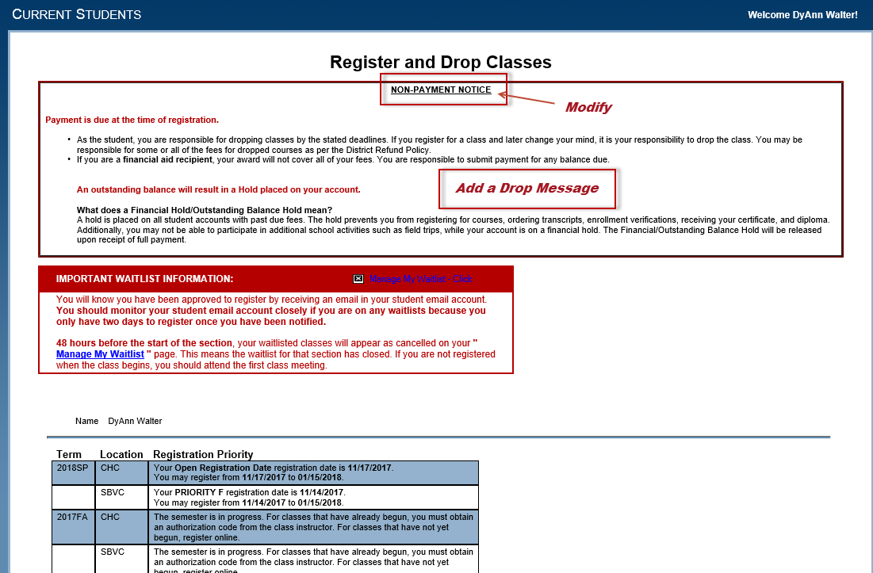

New Version of Colleague UI
  - Sponsor: Andy Chang
  - Ellucian will no longer be supporting our current version of Colleague UI 4.6 after February 2018.
  - In November, Tess will begin testing the new version of Colleague UI (5.4) in the Test Environment.
If all goes well, we will be moving to the new version in 2018. In the new version, Colleague UI will no longer be dependent on Silverlight.

Course Registration from the Educational Plan
(Using the EPI tool)
Sponsor: Robert McAtee
An option is on the table to bring in a third party group (N2N Associates), vetted by Hobsons and State Tech Center, to help with the integration.
Estimated implementation timeframe to configure the two-way integration would be 6-9 weeks.
Robert presented the concerns to the State Tech Center and Hobsons:
- TESS staffing challenges
- Current status of the Degree Planner implementation
Options:
- Developing an API Communications and SIS
- Waiting for Glue to provide 2-way communication (no timeline)
- N2N Communication is ready
- Cost - $15,000 the first year – paid by N2N
- Three Phases (see the 10/25/17 DAWG Agenda)

Objections:
- Need to address Degree Planner first
- Need communication back to Colleague
- Process would be broken when data does not come back to Colleague
- Do not want to be a N2N Beta Client
- Would like to have other Colleague Colleges use it first
- Could lose Student if they are unable to access the system
- May block students with no Ed Plan
- Hobson is supposed to be building a process to Register Student
- The product would need to handle Add Codes, Rules, and Waitlist

Andy Chang said that critical items need to be done first. We would like to get a functional base product out first, but we are willing to listen to the presentation.

Follow-up:
DAWG is open to hearing a presentation from Hobsons and N2N on allowing students to register for courses from the Ed Plan.
Robert will schedule a demo…to be held during a future DAWG Meeting.

Miscellaneous
Topic #1:
Yancie Carter would like to have an auto-generated email sent to the students when they register for online courses.

DyAnn Walter said that the student already gets a generic email with a ‘clickable link' that the student did something.

Online classes have Meeting Information that reference ‘Internet-Based’. Because of the additional wording, this may be misleading to the student.

Solution: Need to have consistence (between colleges) in coding the Sections.

Action Item # 1: Yancie Carter and Joe Cabrales will check with Corrina Baber (SVBC) and Miriam Saadeh (CHC) in Instructions.

Action Item # 2: Yancie and Joe will submit a HelpDesk Ticket to change the wording for online classes.

Topic #2:
Yancie Carter would like to know why ‘Online Orientation’ can no longer be accessed from the Guest Menu in WebAdvisor.
Reason:
It was taken off the Guest Menu because the person needs to have a Colleague Id to access the ‘Online Orientation’ process (i.e. the person needs to be able to sign into WebAdvisor…So the Colleague Id can be captured).

Disclaimer: Some individuals joining the meeting via phone may not be in the Attendance List.

