**I. High School Students with Dual Enrollment**

*Sponsors:* April Dale-Carter**,** Larry Aycock

* Possible application changes.

**II. Zero Textbook Cost PDF’s**

*Sponsors:* DyAnn Walter

* The Zero Textbook Cost **Icon** has been added to WebAdvisor and eSchedule, next to the Zero Textbook sections.
* The SECT Screen indicates which sections have Zero Cost Textbooks.

File: COURSE.SECTIONS

Field: SEC.COURSE.TYPES

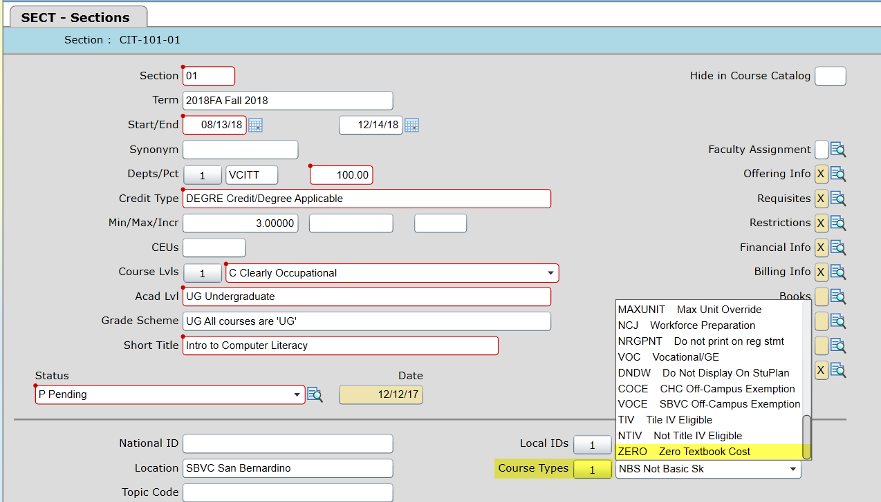

* Currently, there are links on the Students Menu in WebAdvisor of a PDF that identifies 2018 Spring Sections to add the ZERO Cost in the Course Types field.

Question: Should these links remain in WebAdvisor?

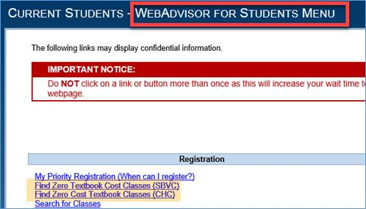

**III. EPI Steering Committee** (*Hobson’s Starfish Early Alert and Degree Planner*)

*Sponsors:* Robert McAtee**,** Yancie Carter, Kristina Heilgeist, Michael Aquino

* EPI Update.
* 2018SM Registration Checklist: DyAnn Walter would like to know when the selection criteria for the Starfish data extract files should be updated.

**V. Miscellaneous Topics**

**Next DAWG Meeting:** Wednesday, February 14, 2018 (2:30 pm – 4:30 pm)

* Location?

***DAWG “Parking Lot*”🚘**

|  |  |  |
| --- | --- | --- |
| **Topic** | **Description** | **Sponsor** |
| Building Course Equates |  | Robert McAtee |
| Pseudo courses | Pseudo Courses may be a solution for a hurdle we have hit with degree planner. | Kristina Heilgeist |
| Course Registration from EPI | Demo – To be Scheduled | Robert McAtee |