The January 24th DAWG meeting was held via CCC Confer only.

*Attendance:*

|  |  |
| --- | --- |
| Crafton | Kirsten Colvey, Kristina Heilgeist, Larry Aycock, Miriam Saadeh,  Robert McAtee |
| Valley | April Dale-Carter, Corrina Baber, Julie Ann Ulloa, Yancie Carter |
| Annex | Andy Chang, *Christopher Crew, Dianna Jones, DyAnn Walter, Jason Brady, Joanna Crisostomo, Joe Ho, Joyce Bond, Jun Xiang, Michael Aquino,  Robert (Brock) Scudder, Samantha Sarabia |

**High School Students with Dual Enrollment**

*Sponsors:* April Dale-Carter, Larry Aycock

* Concurrent Enrollment – High School Students attending college

1. High School students must submit new applications every term. It is required even though they are continuing students.
2. Initially, a HOLD is put on the student to prevent the student from enrolling. Later, the HOLD is manually removed.
3. Every term, students are required to submit paper work related to still being in high school. This would not change.

* Request

As long as the student is taking classes and remain enrolled, they should not have to fill out a new application each term. Would still need to reapply after they graduate from high school.

* Current Process

The following screens prevent high school students from re-enrolling into a class unless they reapply.

1. Student Profile Screen (SPRO)
2. Student Academic Level (STAL)
3. Student Petition Screen (STPE)

Procedurally the student is stopped by codes in SPRO and in STAL.



* *Discussion*

Change the Registration Rules to not force High School Students to submit a new application if they have not missed any terms. Students will still be limited to only those courses approved for the student.

By following the current methodology, it should work.

Tess will check to verify nothing else is involved.

Larry Aycock said he did not think the ‘High School Rule’ checks the Application’s state.

When a student misses a primary term, there is already a program that ends the student’s academic program and forces the student to reapply.

* *Action Item*

Larry Aycock will submit a Help Desk Ticket so high school students are not forced to submit new applications every term.

**Zero Textbook Cost PDFs**

*Sponsor:* DyAnn Walter

* The Zero Textbook Cost **Icon** has been added to WebAdvisor and eSchedule, next to the Zero Textbook sections.

Currently, there are links on the ‘Students Menu’ in WebAdvisor of a PDF that identifies 2018 Spring Sections to add the ZERO Cost in the Course Types field.

DyAnn Walter wanted to know if these items should remain in WebAdvisor.

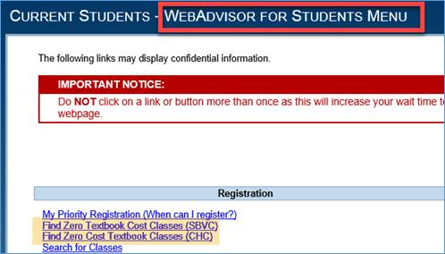

* *Discussion*

Create an Informer Report.

Use the Open Class Report to create the zero Cost textbook classes.

Automate the PDF from the report generated in Informer.

* Resolution

Leave the links in WebAdvisor.

* Action Item

Keith Wurtz and Corrina Baber will create a Help Desk Ticket to create an Informer Report and automate the creation of the PDF.

**EPI Steering Committee**

*Sponsors:* Robert McAtee**,** Yancie Carter, Kristina Heilgeist, Michael Aquino

* Discussion:

2018SM Registration Checklist

DyAnn Walter would like to know when the selection criteria for the Starfish data extract files should be updated.

April – Abbreviated Plan is due

April 16, 2018 - Summer/Fall Priority Registration

Starfish Data Extract File (Early Alert/Degree Planner)

Extract starts @ 12 midnight.

File pulled against Registered Students.

Abbreviated Ed Plan

** Needed for all students who have applied for the Term.

A ‘code’ indicating the student has completed an Abbreviated Ed Plan will need to be manually updated, since data does not come back into Colleague from Starfish yet.

Ed Plan - Rolling out the Ed Plan starts in Test. Then, Test is rolled out to Live.

Crafton: Rolling out Live from Test.

Valley : Can still be in Testing.

Both can be in production mode at same time.

Goal 🡪 2018 Fall Term

Can pilot from the Test environment.