The February 14th DAWG meeting was held in the PDC-104 with the following discussions and individuals in attendance (*=v*ia CCC Confer*):

*Attendance [1]*

|  |  |
| --- | --- |
| Crafton | Joe Cabrales, Kirsten Colvey, Kristina Heilgeist, *Kristi Simonson,  Larry Aycock, Miriam Saadeh |
| Valley | *April Dale-Carter, *Corrina Baber, *Julie Ann Ulloa, *Steven Silva,  *Veada Benjamin, *Yancie Carter |
| Annex | *Andy Chang, Dianna Jones, *DyAnn Walter, *Jason Brady,  *Joanna Crisostomo, *Joe Ho, Joyce Bond, *Michael Aquino,  *Robert (Brock) Scudder, *Samantha Sarabia |

**Registering using Add Codes**

*Sponsors:* Miriam Saadeh, Kristina Heilgeist

* Add Code

Students are being told that they need to have an Add Code to register into certain Open Entry/Open Exit Classes. Unfortunately we are not seeing any record of them registering using an Add Code…even after the initial registration deadline in Colleague.

2017FA KIN/F-970A-95 - Should never require an Add Code.

Open Entry/Open Exit Course

Positive Attendance

Does not require an Add Code

XSRGD – Add dates too long 🡪 Okay, since these type classes should be coded this way

Census Date does not matter

* Add Code required sporadically

Initially, students are asked to provide an Add Code. Later, no Add Code is requested.

* *Action Item*

Report when problems exist for Open Entry/Open Exit Classes.

Problems:

1. WebAdvisor requires an Add Code.
2. WebAdvisor no longer requires an Add Code for the same section.

**Registration Retake Policy Rules**

*Sponsors:* Miriam Saadeh, Kristina Heilgeist

* Registration Retake policy Rule

Update to incorporate time restrictions in order to eliminate the need for manual entry petitions.

* *Action Item:*

Miriam Saadeh will create a Help Desk Ticket to update the Registration Retake Policy Rule.

**eSchedule**

*Sponsors:* Miriam Saadeh, Kristina Heilgeist

* Canceled Sections

Only shows up on the eSchedule. Does not show up in WebAdvisor.

* Canceled Sections

Not easily distinguishable from other sections.

Before publication, these sections should be remove from Colleague.

* *Action Item*

Miriam Saadeh will create a Help Desk Ticket to italicize and change the wording of the Canceled Sections to red.

**EPI Steering Committee**

*Sponsors:* Robert McAtee**,** Yancie Carter, Kristina Heilgeist, Michael Aquino

* Crafton

Kirsten Colvey is looking at Themes.

Testing issues that are being corrected.

In the process of doing the following.

1. Moving Ed Plan from Ellucian to Test environment.
2. Moving Ellucian Student Planner to Degree Planner in Test.

May need to create a manual process to indicate the student has an Ed Plan.

* Valley

Starting the testing process.

Yancie Carter is working with Emma on both the Ed Plan and Degree Planner.

* Programming Changes

Ferrilli working with Hobson on changes

Exceeded 400 hours

Added another 100 hours

May need to get another Contract

**Transfer Center**

*Sponsors:* Joe Cabrales

* RCCD currently allows free transcripts based on the Student’s Id.

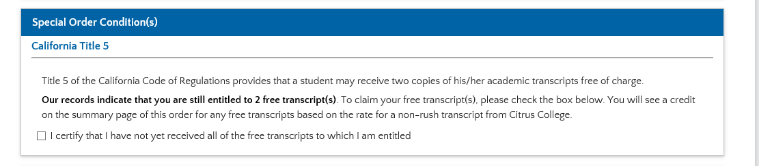

Currently, this is a manual process for us. The Transcript is sent from the College.

* *Action Item*

Larry Aycock will submit a Help Desk Ticket for Research.

1. What it would take to generate a message, similar to the one listed above.
2. Track student transcript request to Credentials via WebAdvisor.

**Non-Payment Drops**

*Sponsor:* Larry Aycock

* Running DREG (Student Deregistration) from the menu

DREG was mistakenly run from the menu without using a savedlist.

This caused students to be dropped from their classes.

Michael Aquino wrote a program to re-instate the students.

* *Action Item*

Tess will remove DREG from the Menu.

Currently, DREG is being executed from our automated processes.

1. Disclaimer: Some individuals joining the meeting via phone may not be in the Attendance List.