  - I. DE Courses in WebAdvisor
  - Sponsor: Kristina Heilgeist
- Appearance Meeting Information
- ENGL-101-70 (online class) displays the following message.
Students are expecting to be told when the class will meet.
- Kristina would like to have the wording removed.
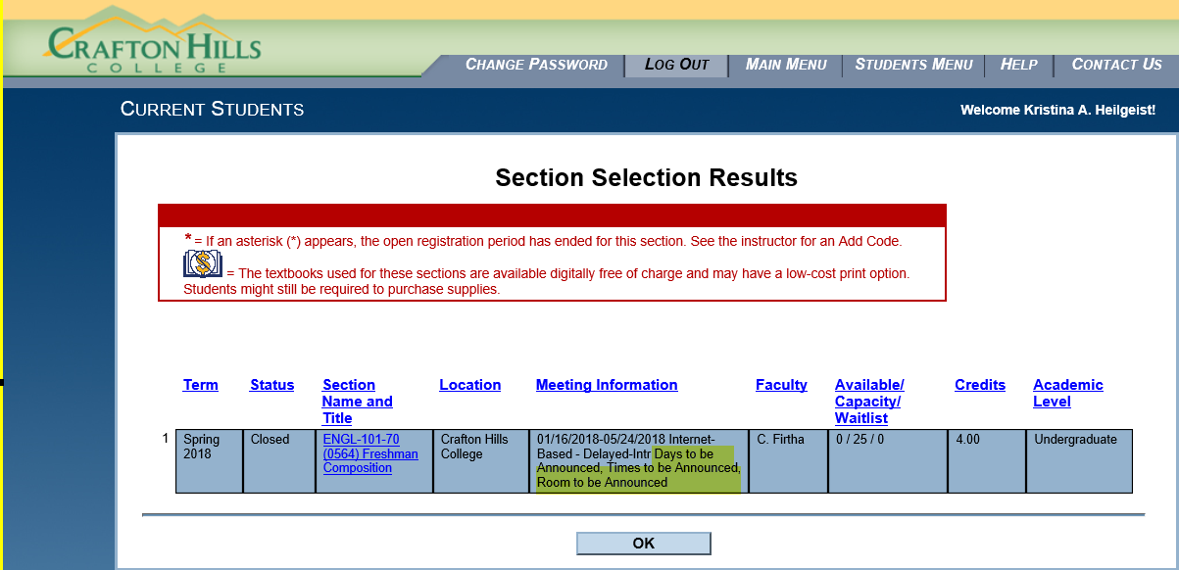

  - II. Transitioning to SARS Anywhere
  - Sponsor: Kirsten Colvey
- Both colleges need to go to SARS Anywhere. The existing SARS Grid will no longer be supported.

  - III. API for Starfish
  - Sponsor: Kirsten Colvey
- Have a quote from Ferrilli to code the API portion…$15,000.
- Kirsten will set up a meeting with Andy Chang, Don Hudson, Emily, and all other necessary individuals to discuss the scope of what needs to be done and to request of quote from Don Hudson.

  - IV. Miscellaneous Topics

  - Next DAWG Meeting: Wednesday, May 9, 2018 (2:30 pm – 4:30 pm)

  - DAWG “Parking Lot”
Topic | Description | Sponsor
Building Course Equates |  | Robert McAtee
Pseudo courses | Pseudo Courses may be a solution for a hurdle we have hit with degree planner. | Kristina Heilgeist
Course Registration from EPI | Demo – To be Scheduled | Robert McAtee

