The April 25th DAWG meeting was held in the Annex Training Room with the following discussions and individuals in attendance (*=via CCC Confer)
Attendance
Crafton | Kirsten Colvey, *Kristi Simonson, Kristina Heilgeist
Valley | *April Dale-Carter, *Christie Gabriel-Millette, *Julie Ann Ulloa,  *Steven Silva, *Veada Benjamin
Annex | Andy Chang, DyAnn Walter, *Jason Brady, Joyce Bond, *Michael Aquino, Robert (Brock) Scudder

DE Courses in WebAdvisor
Sponsor: Kristina Heilgeist
- Appearance Meeting Information
- ENGL-101-70 (online class) displays the following message. There is no date and time to meet on the line. Students are expecting to be told when the class will meet, even though it’s on online class.
- Kristina Heilgeist would like to have the wording removed.
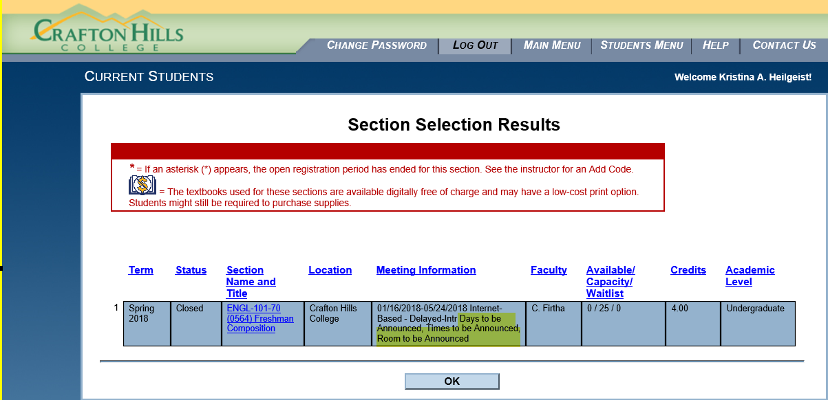

- Since the Schedule says arranged, DyAnn Walter said the ‘DAYS.OF.WEEK’ Validation Table may be updated.
- Michael Aquino suggested using a default message.
- Action Item:
- Open an Actionline Case with Ellucian to determine what’s delivered and if Ellucian has any recommendations.
- DyAnn Walter suggested that Kristina test using ‘AR’ in the ‘DAY.OF.WEEK’ field and build a section.

Transitioning to SARS Anywhere
Sponsor: Kirsten Colvey
- Both colleges need to start using SARS Anywhere. The existing SARS Grid will no longer be supported.
- Kirsten Colvey talked to Marco Cota. Since SARS will not be supporting the SARS Grid and both colleges need to go to SARS Anywhere, Kirsten wants both colleges to share the expense ($1000 each).
- Kirsten will setup a demo of SARS Anywhere during the next DAWG Meeting.
- Andy Chang said SARS Anywhere is a web layer (interface) on top the existing software.
- Kirsten wanted to know if both colleges wanted a Test Instance of SARS Anywhere. It would increase the cost to $1500...or we could just have one Test Instance, since both colleges share the database. Jason Brady thought that there might be an advantages to having separate Test Instances. It would be more portable and allow Counselors to set appointments for each other.
- Action Item
Demo of SARS Anywhere.

API for Starfish
Sponsor: Kirsten Colvey
- API allows the results of the Student’s Ed Plan (stored in Starfish) to be brought back into Colleague. This will alleviate the need to manually enter Student Ed Plans in Self Service and to manually update CASM…a screen indicating the Student has a Comprehensive Ed Plan.
- Andy Chang received a quote from Ferrilli to do the API Starfish Project for $15,000.
- Kristen will also request of quote from Don Hudson (see the Action Item below). Don previously worked for Ferrilli. He is more responsive and has diverse ideas.
- Kirsten has talked to Marco Cota about splitting the cost of the API Project.
- Complaint
DyAnn Walter said that Starfish is getting students that have registered for classes…not students who have only applied to the college. Since an Ed Plan is needed before the student registers for a class, we also need to pull students that have applied to the college.
- Kristen did not know if the system looked at CSSI (Student Success Information) or CASM (Contact and Appointment Summary) to get priority.
- Action Item
- Kirsten Colvey will set up a meeting with Andy Chang, Don Hudson, Emily, and all other essential individuals to discuss the scope of what needs to be done for the API Project.
Miscellaneous
Topic # 1
Miscellaneous Student Groups (Kristina Heilgeist)
- Need a rule to use Respiratory & Fire Academy as a group.
STPE is now used to enter a petition for each course.
- Action Item
Start with a Help Desk Ticket.

Topic # 2
Ed Plan (Kirsten Colvey)
- Research and create documentation for the following.
- How to manually enter Student Ids.
- Where to enter the Ed Plan. More screens (other than CASM) may need to be updated.
- What gets populated when an Ed Plans are created.
- Action Item
- Create Help Desk Ticket for Research and Documentation.

Topic # 3
Project Glue (Andy Chang)
- Project Glue is already out. Not sure if the API folks are looking at it.
Project Glue, or CCC Glue, is an integration architecture being developed by the California Community Colleges Technology Center to allow disparate Student Information Systems (SIS) to connect in a standardized way to system-wide technologies developed by the Technology Center or purchased by the CCC Chancellor's Office, such as the Course Exchange and Canvas course management system.
Glue provides a secure, robust framework for data exchange between these system-wide products and the colleges who use them. A key objective is to integrate all Chancellor’s Office-sponsored technology initiatives without putting additional burden on local college IT departments.

- Action Item
- Kirsten Colvey will check with Warren.

Disclaimer: Some individuals joining the meeting via phone may not be in the Attendance List.

