Comparison of SARS·GRID and SARS Anywhere
San Bernardino Community College District
May 9, 2018

Overview

- Log in via the college website
- Can authenticate users in system using a single user account
Signin – Similar to the grid

Overview of the Toolbar

- Flyout menu - Advising
- Quick Links
- Refresh
- Print – enabled, depending on which screen you are in
- Chat
- Configuration
- Help -
- User Account Information – You can specify your email and phone number

Navigation

- Flyout menu selections
-- Location – Will transfer over to SARS Anywhere
-- Date vs. Current, Future and History Data Views
-- Short Name (select one advisor or multiple advisors)
-- Specialty (select for multiple advisors only)
- Previous/Next buttons vs. F2 and F3

Tabs

- Embedded Tabs: THE GRID, MY GRID, Drop-in Screen
- Other Tab options from Tab Configuration screen

Quick Links

- Compare to Command Menu
- Options on Quick Links menu
- Divider on menu

THE GRID

- Navigation method changed
-- Location
-- Date
-- Short Name (all advisors for one date or one advisor for multiple dates)
-- Specialty
- History, Current and Future Data Views consolidated in to one view
- Previous/Next buttons vs. F2 and F3
- Focus improved

MY GRID

- Navigation method changed
-- Select one date
-- View multiple dates (Use THE GRID)
- History, Current and Future Data Views consolidated in to one view
- Previous/Next buttons vs. F2 and F3
- Comments tool tip for non-appointment allowable Schedule Codes

Drop-in Screen

- Screen layout
- Method to print the Drop-in List

Student Appointment Screen

- Select different ID format
- Generate Guest ID
- Student full name as separate fields option
- Student Contact Methods re-named Opt In Settings (Email, Phone, Text) and relocated
- Email, Print and Text Receipt renamed Confirmation Options (Email, Print, Text)
- Info Flag Alerts display
- Send email and text messages to student for moved and canceled appointment

F7 to enter guest Ids. In SARS, press the edit id.

Scheduling Actions

- Process for making and canceling appointments is the same
- Note other scheduling actions available from Quick Links menu
- Process to stop moving or copying actions

Additional Notes:
SARS Anywhere – Works with Cranium Café…but it is an add-on feature.
Replacement for the existing SARS Grid.
On the licensing side, SARS Anywhere replaces SARS Grid
Still have eSARS
Compatible with the latest version of all the major browsers
- Exception: working on, but still have issues with Edge
Waiting List Drop-in Screen: Student would get a message when it’s almost their appointment time.

SBCCD Not currently using E-Advising

When a new feature is released, it will show up in SARS E-News under ‘What’s New’.
Scott will send previous ‘What’s New’ items to Kirsten.

Waiting List – Used for Drop-ins & Waiting list
Queue: Can abbreviate the student’s name
Can show only the ticket #

Can cycle through: Show Counselor, Financial Aid, and EOPS appointment for 10 secs

Working on other options for display student info on the Waiting List – included for free

Display Web Content – allows students to see the Waiting List in a different format.

Waiting List – In the process of moving to the Web

Average Wait Time Reports: Drop-in Screen – Special Dates - Run report – Shows average wait time.

Service Time: You would need to specify the session was over…i.e. Ending time of drop-in
Requires manual interaction. Currently not visible on the screen. Not used by other colleges.

From the website:

SARS Anywhere
- SARS Anywhere is an easy-to-use appointment scheduling system for student service offices at colleges, universities and other higher education institutions.
- The scheduling component allows students to manage their own appointments and allows support service staff to make, reschedule and cancel appointments.
- It also allows academic advisors, counselors and other specialists to work with their own schedules.
- The drop-in component is used to register and track unscheduled visits.
- All of these functions are web-based and are compatible with the four major browsers.

Accessibility
- Compliant with Web Content Accessibility Guidelines (WCAG) 2.0 Level AA

Features for Scheduling
- Time slots: color-coded
- Schedule display: by date, by advisor, by specialty
- Appointment types: individual and group
- Search by student name: find the student ID if not known
- Search for availability: by days of the week, times of the day, advisor specialty
- Appointment duration: standard yet extendable
- Group appointment capacities: adjustable
- Appointment confirmations: email, printed and/or text* (* optional)
- Appointment changes: reschedule, cancel, revise details
- Advisor assignments: by last name grouping or specialty
- Attendance: mark show/no show
- Drop-ins: registration, advisor assignment, waiting time calculation
- Conflicting appointment warning: booking appointments and registering drop-ins
- Student history log: search for upcoming appointments and display historical data

Optional Text-Messaging Automated Notifications
- Return to waiting room based on position in queue
- Ready to meet
- Same-day appointment reminders up to two hours in advance

Features for Advisors
- MY GRID: configurable separate screen for advisor's own schedule
- Reports: single day detail and multiple day snapshot of own schedule
- Notepad: secured notes about students (sharable based on department determination)
- Pop-up alerts: warnings about critical information
- Instant messaging: automatic notification of appointment arrival upon check-in
- Chat: chat with individual users and send announcements to multiple users
- Additional contacts: tally and student-specific
- Additional information: store student demographics
- eAdvising: quick questions from students and answers from department
- Outlook calendars: export advisor's schedule

Features for Students
- Appointment confirmations: email, print and/or text* (* optional)
- eSARS web access: make, cancel or view own appointments.
- eAdvising: quick questions from students and answers from department
- Waiting list status: public viewer (and virtual queue, with optional text messaging)

Reporting Features
- 45 standardized reports
- Customizable reports using third-party reporting tool
- Export to alternative formats

System Administration and Set-Up Features
- Unique specifications: tailored by department
- Access security: department-controlled access to schedules and student data
- Student IDs: multiple formats supported
- SSO integration: multiple methods for single sign-on supported
- User passwords: self-recovery and change options
- Import/Export: data exchange between host system and SARS
- Interfaces: Banner®and Colleague® by Ellucian, PeopleSoft™, Microsoft®Outlook, Zoom and Cranium Cafe

SARS Anywhere Screens:
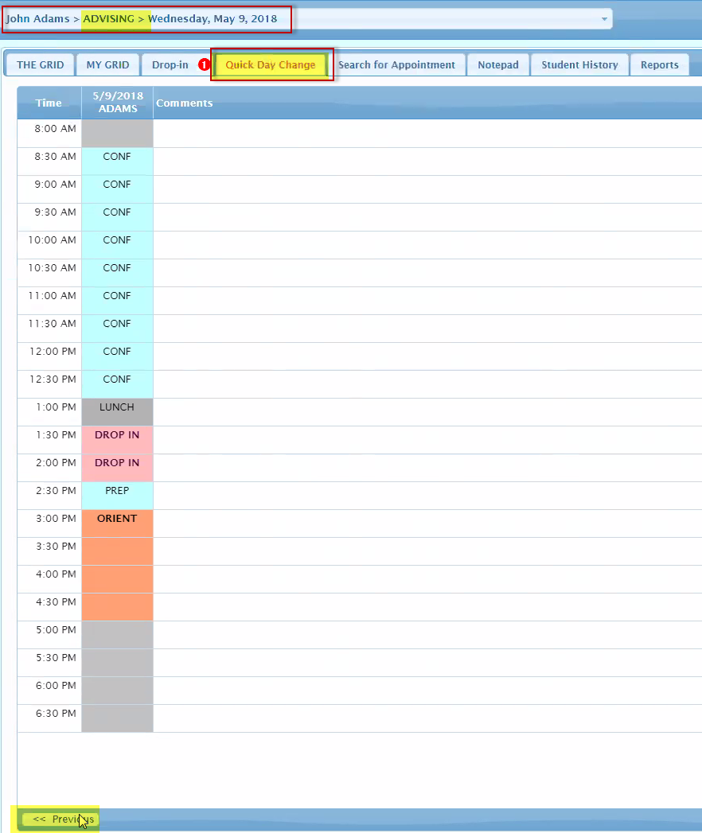

Building a Master Schedule
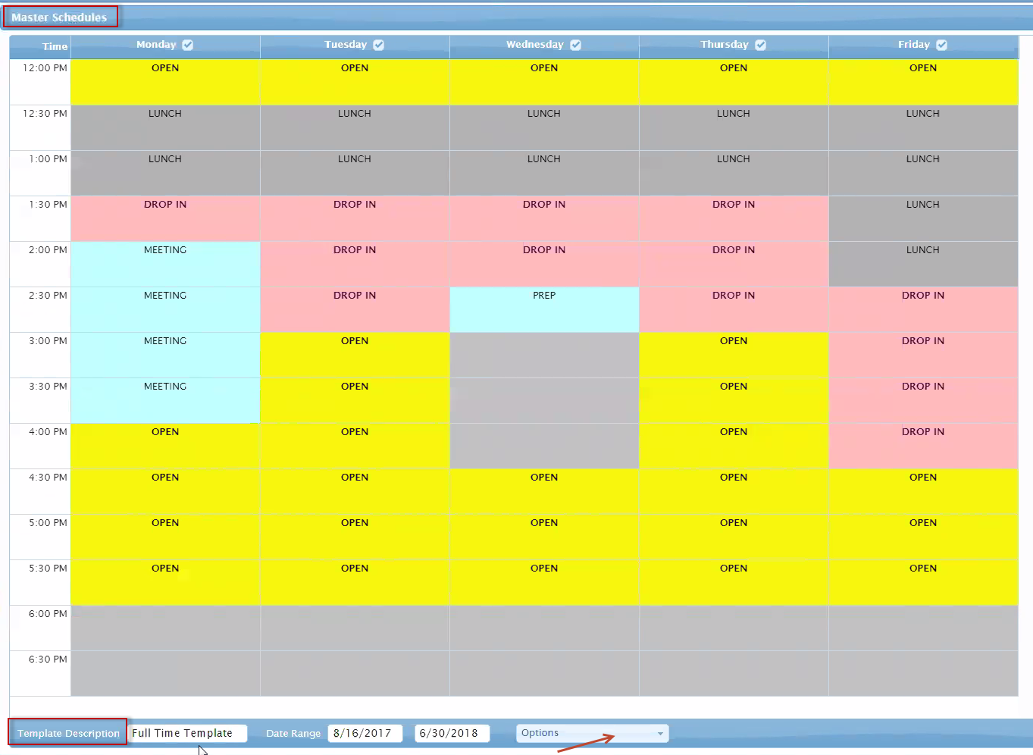

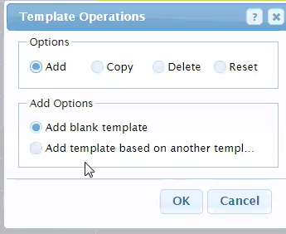 | 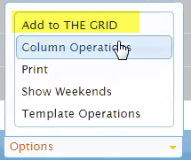

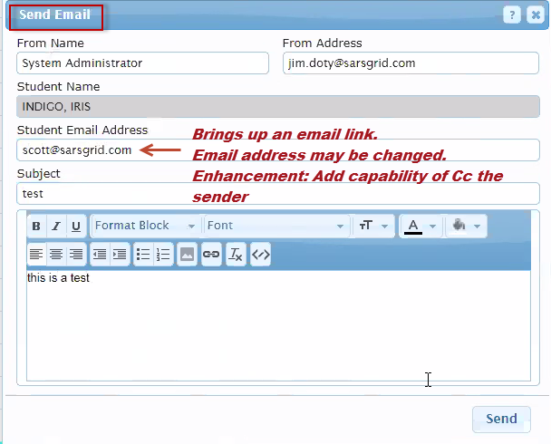 | 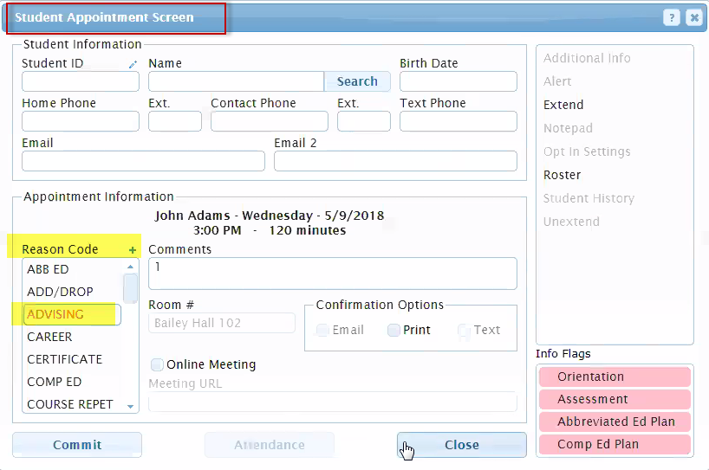

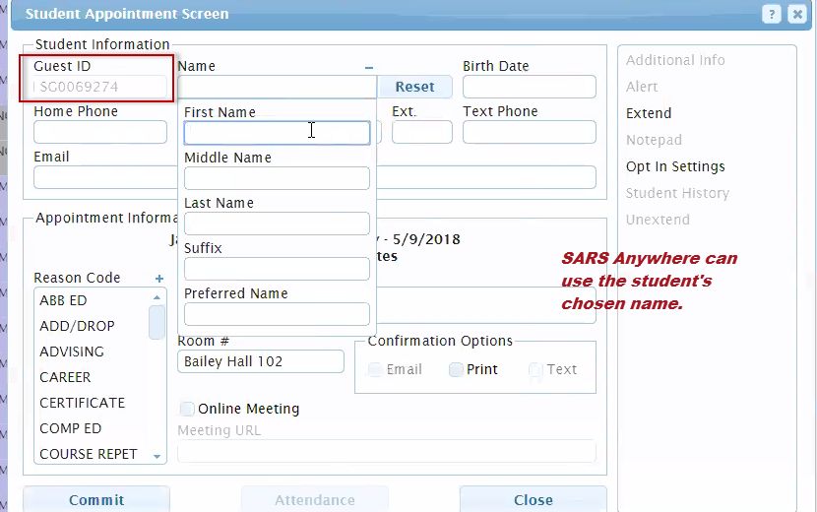

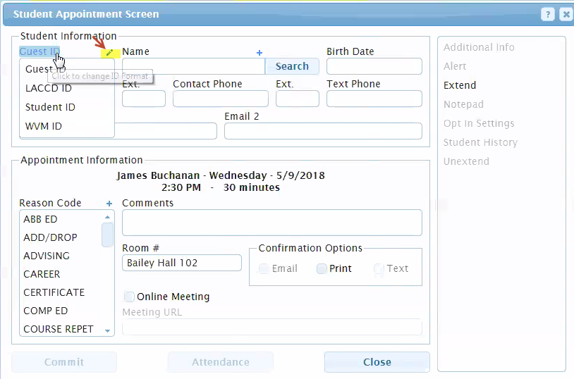

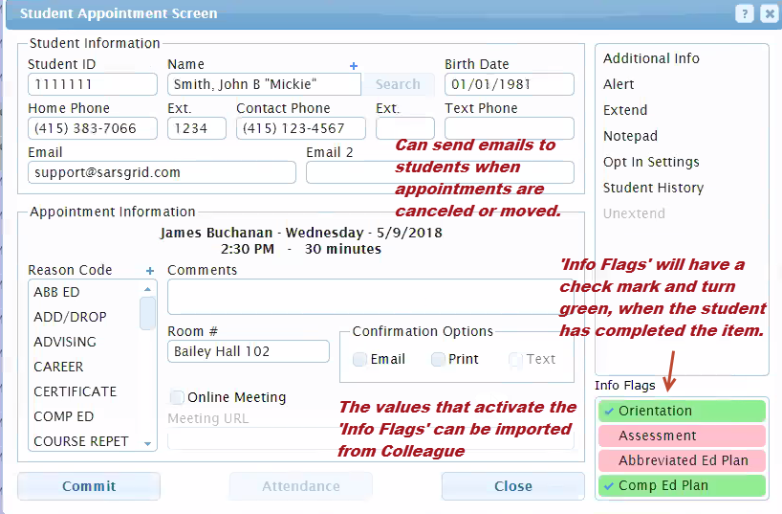

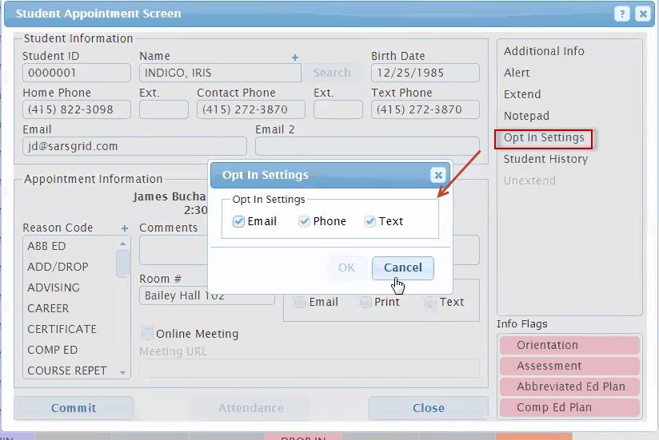

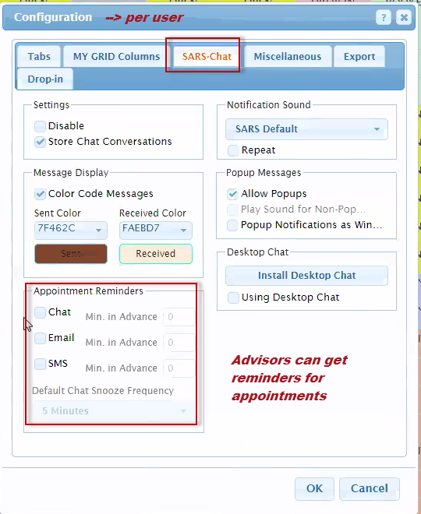 | 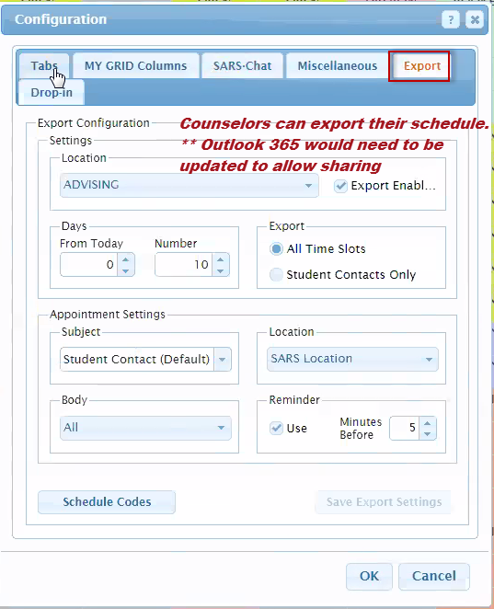

Drop-in Waiting List
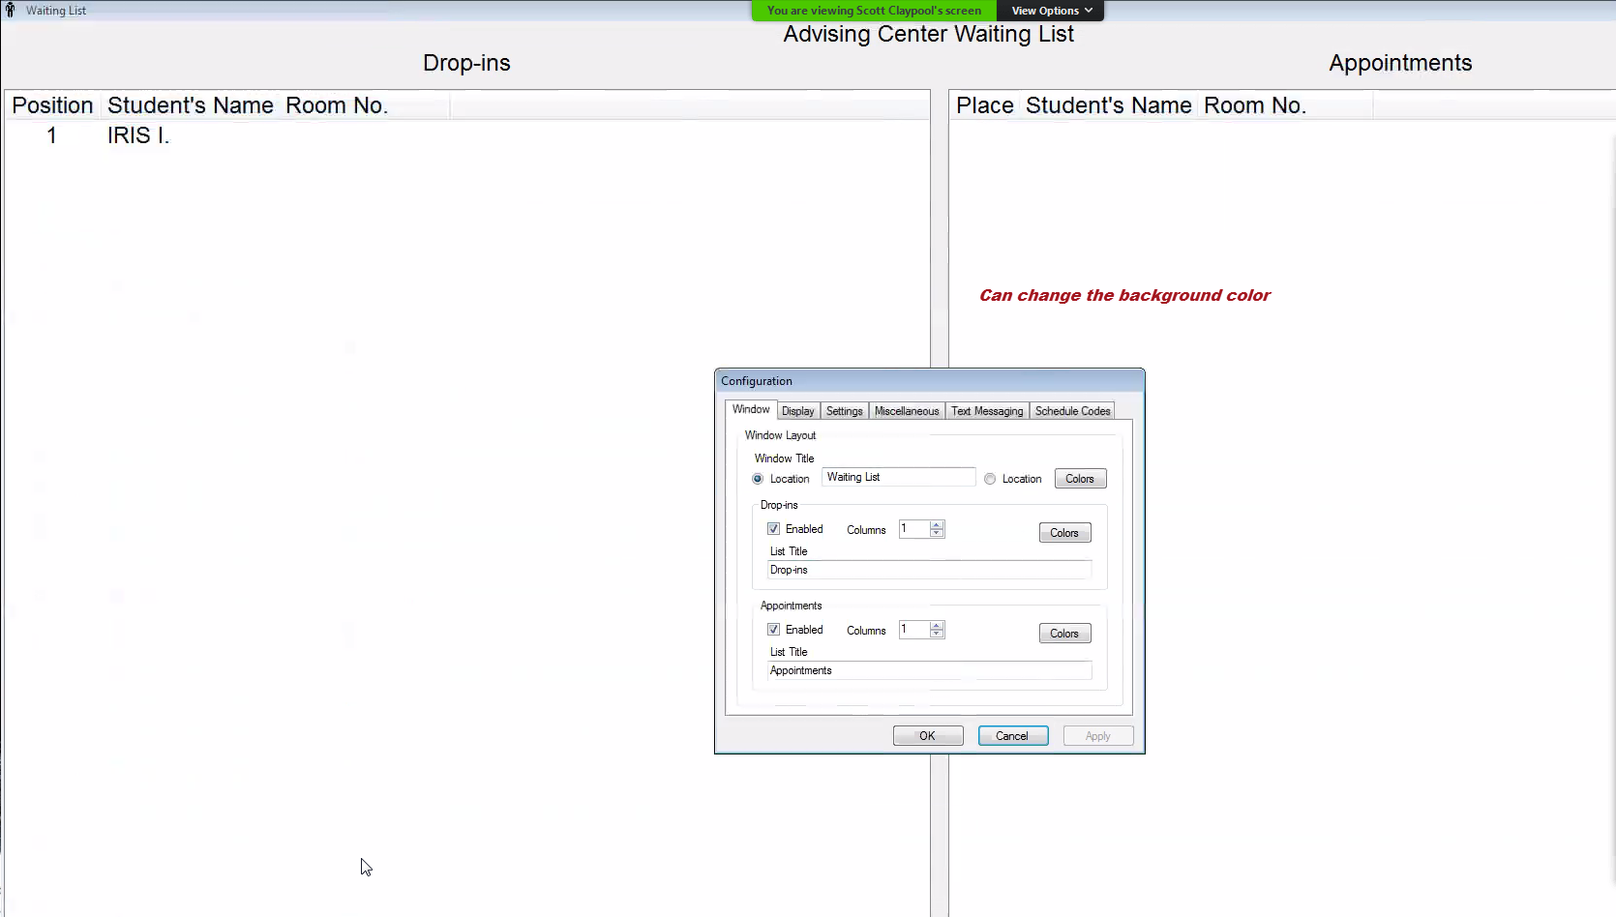

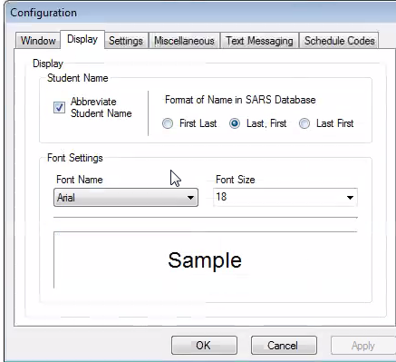 | 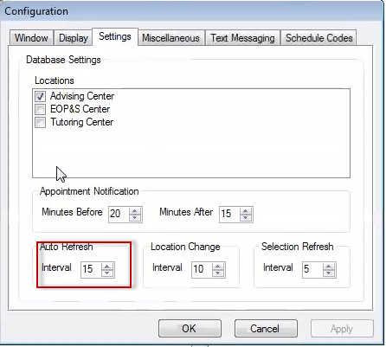

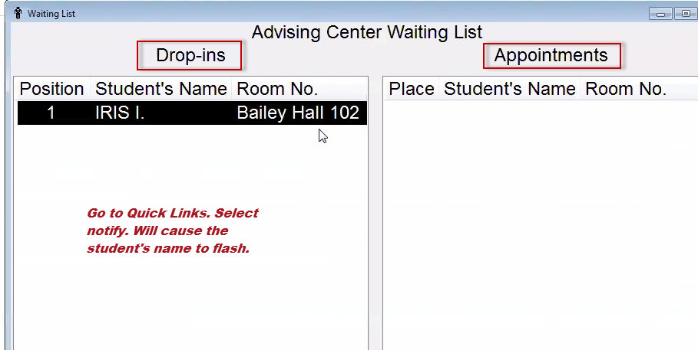

Drop-in Report contains wait times
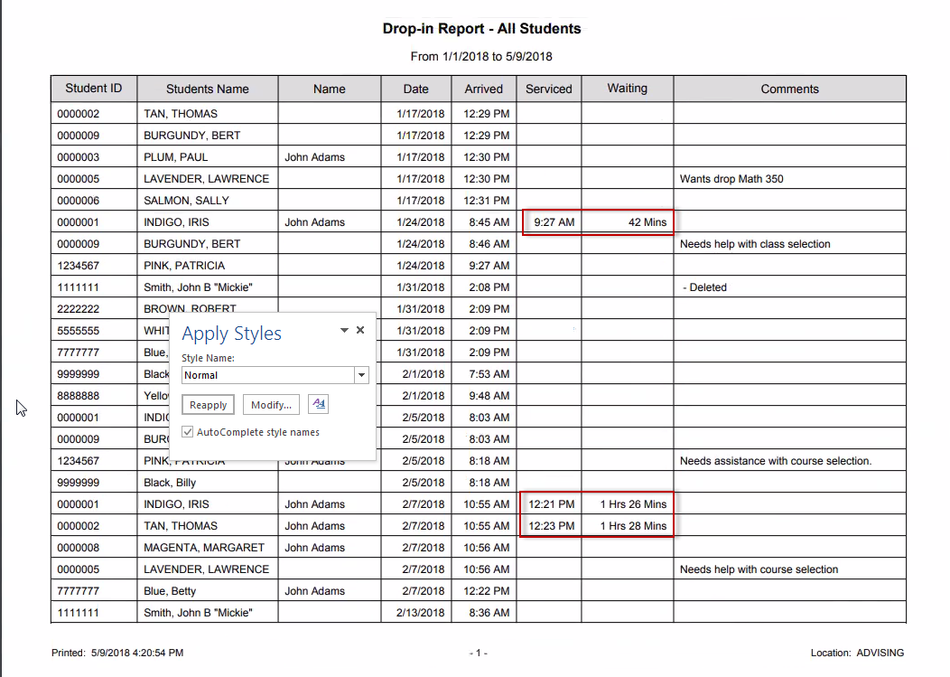

End of Drop-in Report

SARS Administration – Separate website
