The June 13th DAWG meeting was held in the Annex Training Room with the following discussions and individuals in attendance (*=v*ia CCC Confer*)

*Attendance [1]*

|  |  |
| --- | --- |
| Crafton | Kristina Heilgeist, *Kristi Simonson, Larry Aycock, *Reyna Uribe, *Steven Rush |
| Valley | *April Dale-Carter, *Corrina Baber, *Jason Alvarez, *Julie Ann Ulloa, *Kristin Garcia, *Linda Molina, *Steven Silva |
| Annex | Andy Chang, DyAnn Walter, *Jason Brady, Joanna Crisostomo, Joe Ho, Joyce Bond, *Michael Aquino, Robert (Brock) Scudder |

**New DAWG Chairperson**

*Sponsor: Joyce Bond*

Transitioning to Joe Ho, effective July 1, 2018.

**Posting through SACD and NEQV**

*Sponsor(s):* Kristina Heilgeist, DyAnn Walter, Michael Aquino

How the Data Extract from Colleague to Hobsons handle STC statuses:

* If the STAC record has a term after the 1998/1999 migration to Colleague, the record will be sent in the “course enrollment” data extract file (does not exclude any current STC status) and the “course outcome” (only if there is a grade)
* If the STAC record has a term before or equal to 1998/1999 migration to Colleague, the record will be sent in the “student transfer” data extract file (does not exclude any current STC status)
* If the STAC record has a current status of “TR” or “NC”, the record will be sent in the “student transfer” data extract file.

The above information was provided by third party vendor Ferrilli (via Michael).

Degree Planner:

Kristina Heilgeist and Larry Aycock asked if any other statuses were being used, other than “TR” and “NC” for the various credit types being selected by Hobsons in the “student transfer” data extract file.

The A&R Staff from both colleges said they were entering only “TR” and “NC” for non-traditional credit types such as Advance Placement (AP), CLEP, Credit by Exam, Military Credits, and Transfer Work.

This is good because the upload process uses the status (not term) to pull over entries into Degree Planner.

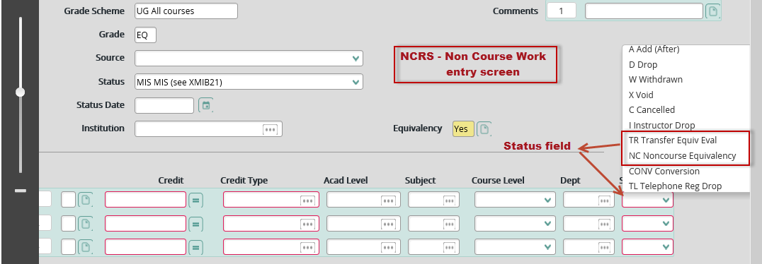

Kristina Heilgeist said that Valley attaches to an area, while Crafton attaches to a Course, which gives credit in that area.

Kristina Heilgeist recommends building pseudo courses as place holders in order to carry the Military Credit over to Degree Planner. But it was determined that pseudo courses would not be necessary since the “student transfer” data extract file pulled data based on “TR” and “NC” credit type codes.

Possibility of establishing a shared method of entry.

The colleges use different term codes to differentiate each college on purpose.

These codes are used in the custom code for each College’s Transcript.

The consensus was a shared method was not possible.

**Veteran Students Placed on Sponsorships (Ch. 33 and Ch. 31**)

*Sponsor:* Jason Alvarez

Problem: Veteran students on Sponsorships who drop courses before the refund date.

Once the student drops a course, should the refund go the student or to the VA?

Jason Alvarez is of the understanding that refunds are not always being processed efficiently, either going back to the veteran or to the VA, and we may be sitting on funds that are supposed to be returned from past academic years.

Currently, the SPII Sponsor Invoice Inquiry Screen shows the money is credited to the Sponsorship (0760709 – Department of Veterans Affairs).

Unfortunately, the Sponsorship goes after the student for payment.

Where does the refund go?

VA pays the District directly through EFT.

When the student drops the course, the money goes to the District.

The VA goes after the student, but should be going after the District.

The District is keeping the money.

Possible Solutions

Review the ‘Sponsor Billing Refund Informer Report’ to determine which Sponsorships need to be reimbursed.

View ARAI or ARIQ to access the Sponsorships. Credits will be detailed on the screen for each account.

*Action Item*

Larry Aycock and Jason Alvarez will sit with Kristin Raisch to review the Informer Report.

**Removing a Section from WebAdvisor**

*Sponsor:* DyAnn Walter

Is it time to remove “Student Educational Plans (Prior to Fall 2014)” from WebAdvisor?

The parameters of the old Ed Plan are not being maintained, causing confusion when used by counselors.

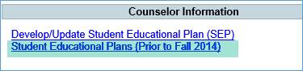

Decision:

The question needs to be directed to the Counselors.

Marco Cota and Kirsten Colvey will be back in July.

Leave on agenda until the 1st meeting in July.

**Miscellaneous**

***Positive Attendance Report***

April Dale-Carter said students auditing courses are appearing on the Positive Attendance Rosters. April wanted to know if the Instructors should be including hours the students attended, if they are auditing the course.

Larry Aycock said those students should not be counted. The Instructor should mark the Roster with a 0 for students auditing the course.

*Action Item*

April will create a HelpDesk Ticket to have the system add and populate the column with the ‘Audit Status’ on the Positive Attendance Roster. This would allow A&R to identify Auditing Students.

1. Disclaimer: Some individuals joining the meeting via phone may not be in the Attendance List.