**I.** **Removing Section from WebAdvisor**

Sponsor: DyAnn Walter

* Is it time to remove “Student Educational Plans (Prior to Fall 2014)” from WebAdvisor?

The parameters of the old Ed Plan are not being maintained, causing confusion when counselors use it.

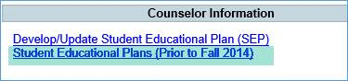

***Next DAWG Meeting*:** Wednesday, July 25, 2018 (3:30 pm – 5:30 pm)

***DAWG “Parking Lot*”🚘**

|  |  |  |
| --- | --- | --- |
| **Topic** | **Description** | **Sponsor** |
| Building Course Equates |  | Robert McAtee |
| Pseudo courses | Pseudo Courses may be a solution for a hurdle we have hit with degree planner. | Kristina Heilgeist |
| Course Registration from EPI | Demo – To be Scheduled | Robert McAtee |