**I.** **SARS Anywhere implementation schedule**

Sponsor: Kirsten Colvey, Marco Cota

* The contract should be approved at the September 13 meeting
* Schedule and receive a 60-minute demonstration of SARS Anywhere.
* Then, sign up for the next available "sandbox" (practice) session for a two-week period (optional).
* (For college IT) Schedule and attend a 20-minute meeting with SARS to review the technical system requirements and installation logistics.

**II. Uniformed, data-driven calculation**

Sponsor: Gio Sosa, Kristina Heilgeist

* Applying a uniformed, data-driven calculation to compute estimated program completion times, that will be consistent across Colleague, PPA, catalog, etc.

**III. Changing the eschedule for online classes**

Sponsor: Miriam Saadeh

* Currently, the eschedule shows online classes this way:

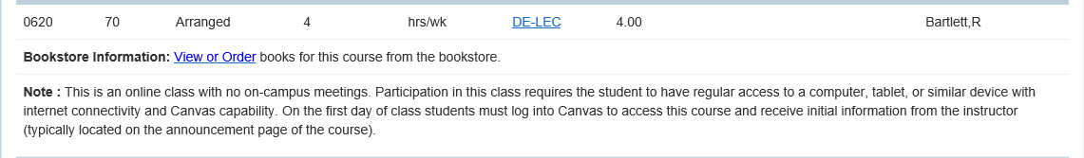

* Under start, it says 4. Under end, it says hrs/wk.
* We would like to discuss changing this and adding dates to the sections as well.

**IV. XRGD Calculation Error**

Sponsor: Larry Aycock

* XRGD is incorrectly calculating the late add period for short term sections, and does not align with District’s corresponding AP. This appears to go back several years.

**V. Hobson’s Update**

Sponsor: Robert McAtee, Kristina Heilgeist

* Kristina will provide updates based on some decisions made during the functional call this week.

**VI.** Miscellaneous

1. Interactive Committee Software – request from Rebeccah
2. Chosen Name + Put Roster updates in Production
   1. Spread the word: Steps to inform student of this option
   2. Discussion: How will A&R handle this request?
   3. [Demo] XRST and HTML rosters
3. Student’s personal email not being updated
   1. When student changes their CCC Apply email and submits a new application, the students email address on file is not updated to the new one.
   2. Discussion: How should this be handled?
4. Reminder about the proposed tickets from our last DAWG meeting

***Next DAWG Meeting*:** Wednesday, September 12th, 2018 (2:30 pm – 4:30 pm)

***DAWG “Parking Lot*”🚘**

|  |  |  |
| --- | --- | --- |
| **Topic** | **Description** | **Sponsor** |
| Building Course Equates |  | Robert McAtee |
| Pseudo courses | Pseudo Courses may be a solution for a hurdle we have hit with degree planner. | Kristina Heilgeist |
| Course Registration from EPI | Demo – To be Scheduled | Robert McAtee |