The August 22nd DAWG meeting was held in the Annex Training Room with the following discussions and individuals in attendance (*=via CCCConferZoom)
Attendance
Crafton | Kristina Heilgeist, Kirsten Colvey, Larry Aycock, Joe Cabrales, *Miriam Saadeh, Robert McAtee, *Gio Sosa
Valley | *April Dale-Carter, *Julie Ann Ulloa, *Steven Silva, *Veada Benjamin
Annex | Andy Chang, *Corrina Baber, DyAnn Walter, Joe Ho, *Michael Aquino, Jason Brady

I. SARS Anywhere implementation schedule
  - Sponsor: Kirsten Colvey, Marco Cota
- Kirsten said she has been in touch with Joann Dodi, regarding SARS implementation. They need to wait until Virginia sends their paperwork to them.
- They apparently have gotten the PO. Kirsten asked her if there's some prep stuff that we can do.
- A list was given to Kirsten, which includes a 60-minute demo, a sandbox for us to play in it. They also want to speak to IT, to talk about the technical pieces.
- Kirsten asked if we can hold a Zoom meeting for each campus, she thinks that will be easier for everyone involved, to minimize travel.
- Kirsten recommend that we take them up on their offer and do two 60 minutes demonstrations for each campus. But Kirsten needs to know who to contact at Valley.
- Kirsten said she will talk to Marco about it. Kirsten also would like to know who they should contact at TESS for the technical meeting, DyAnn suggest that Kirsten talk to Andy about it.
- Kirsten asked Andy who she should direct Joann (SARS Group) to, Andy wanted to know when this meeting will be. Kirsten said Andy can setup a time that’s best for TESS and the contract should be approved on the 9/13 board meeting. Kirsten also mentioned that SARS group already got their PO.
- Andy asked if it will be sometime after 9/13? Kirsten said that SARS group is willing to have the meeting before 9/13. Kirsten is planning to get the demo and other meetings before then, she wants this to move as fast as possible.
- Andy said that he will figure out who he will assign to this. Kirsten said that Joann Dodi is one of the owners of the project and she needs to know who the TESS contact person will be.
- Robert ask if it is set to be approved on 9/13, Kirsten confirmed that they’ve already received the PO from both colleges. Joe asked if it will be the entire suite, Kirsten said it will be the entire SARS Anywhere, except the premium integration, that’s a separate purchase.
- Andy wants to know if all the components are spelled out in the contract, Kirsten said that the outlook integration is available right now, they just don’t use that function now.
- Andy said from what he remembered, there is probably no programming involved, he will find someone to support both colleges. Both Joe and Kirsten agree that each college should schedule their own demo and meetings.
- Andy points out that since this will be switched to web based, users should be given enough warning that their desktop version will not work anymore. Need to make sure both colleges are ready before the switch.
- Kirsten agrees. She wants to have this move forward as soon as possible.
- Robert asked if CHC can be switched on first, Kirsten said she does not know. But she said it looks like there is only one server, one instance, and both colleges are sharing it. Andy think any changes will be a global change and affect both colleges.
- Kirsten said that we should propose some rollover dates and find one that’s agreeable for both colleges. She also points out that there are some very “webbie” things that’s in the new version, but all of the reason codes, schedule codes will stay the same.

II. Uniformed, data-driven calculation
  - Sponsor: Gio Sosa, Kristina Heilgeist
- Gio said that we have Program Participation Agreements that we file with the Department of Education. The PPA allows us as a college to participate in their financial aid program.
- As part of the PPA, we are asked to identify how long it would take a student to complete our programs.
- Kristina looked at what we’ve submitted in the past for our CTE programs and found an inconsistency between what we have identified in our agreements and what we have listed in Colleague.
- Gio took some time to investigate this. He was not able to find the underline logic for where those numbers are coming from in Colleague. Gio is assuming that has to do with required units and the length of a semester.
- In talking with Keith, Gio thinks that they have calculations that we can possibly use, that can be applied to any program across the district.
- Gio has not talk to James or anyone at Valley yet, the goal is to develop a process that can be applied to different programs as unit requirements change. As opposed to just relying on an obscure number in Colleague that we can't really explain.
- Kristina points out that there are some programs that are 12 units, but shows it will take 4 semesters to finish, or 86 units and can be done in 2 semesters. These are the perfect examples of this calculation error.
- Kristina used the formula provided by Gio and was able to fill out her PPA audit form. The logic seems to be sound across the board.
- Gio want to get everyone involved and possibly develop a calculated field in either Informer or Colleague, to have a standardized approach, even across the district, to calculate how long it will take to complete a program.
- DyAnn pointed out that on the program screen, there is a field called “month to complete”, Kristina said that they are aware of that field, but they can’t find the logic behind how the number is derived. She also said that this topic was discussed in DAWG meeting about two years ago. DyAnn thought this is related to completion date on SPRO, around the time when they implemented degree audit in Colleague and Self Service.
- DyAnn suggested some test methods with complete date. Work with SPRO, PROG.
- Kristina suggest that CHC will get started and will loop in SBVC for uniformity.
- Gio said that can create own calculated fields in Informer. Kristina said that she has some calculations done already in excel. Gio said that having it in informer has its benefits for future development.
- Gio suggest approaching James Smith and/or Christie Gabriel at SBVC.

III. Changing the eschedule for online classes
  - Sponsor: Miriam Saadeh
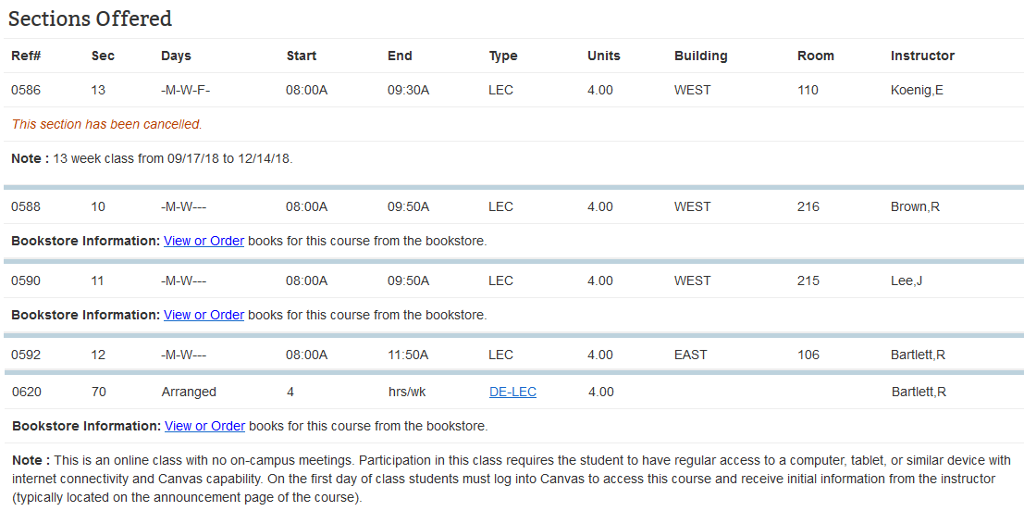
- Miriam pointed out that current eschedule information displays are not sufficient when showing information for online classes.
- Keith and Miriam both think that this does not look at its best. Keith would like to add dates showing exactly when the classes are. Miriam is looking for input on how to make this better.
- DyAnn asked where the dates should go, Miriam said anywhere that it could go. She said, looking at the current schedule, the online classes just show a “4” under START (see above diagram, circled), the 4 represents four hours per week, but it is not clear. Miriam is hoping that there will be a better way to show this to the students.
- Joe navigated to eschedule on the CHC website. (showing the above diagram). Class English 101.
- Jason pointed out there are some explanation at the top regarding “arranged”, it is separated, and it’s not easy to read.
- Miriam pointed out that if there are no dates, as a scheduler, she knows this is a 18 week course, but she thinks it will be nicer if this can be pointed out to the students. She wants to know if there is a place where dates or “18 week” or “full term” can be added.
- Kristina suggest adding a note at the top to say, “unless otherwise noted, all courses are 18 weeks”. Miriam like the idea, it will provide better info for the students.
- Jason points out that section Start, and End date fields are available, and can be add to the display, however this change will affect both colleges, DyAnn suggest that this should be reviewed and approved together from SBVC and CHC. SBVC contact person is Terri Long.
- Joe suggests that an email can be circulated and ask for approval from both colleges, then use that to generate a ticket to add the extra information to the eshcedule display.

IV. XRGD Calculation Error
  - Sponsor: Larry Aycock
- Larry said that they’ve noticed that end dates for short term classes are being calculated incorrectly. This goes back many years.
- This came about because there were some questions about the start courses as to why the add periods are calculated so shortly.
- While figuring this out, they realized that short term classes are giving 20% minus one day as of the late add period, but it should’ve been 10%
- Example: 16 week course, 16 x 7 day = 112 days, 10% = 11.2 which per student AP should be rounded to 11 days as the add period, in the system, it is being calculated as 20% which is census minus 1 day, which gives student 21 days to add.
- Since all the dates are calculated by a program in Colleague, Larry thinks this is affecting SBVC as well, all the way back to 2015, if not longer.
- The AP says, students may add courses during the first two weeks for full term course or the first 10% for the short-term course, it is now being calculated at 20% minus one day.
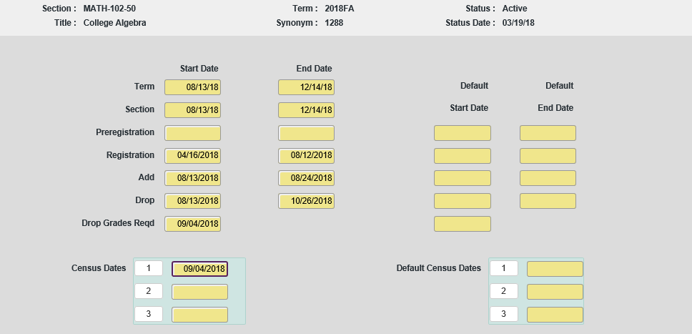
FULL-TERM CLASS

- This is an example of a full-term course, term starts on 8/13/18, you have the first two weeks, which ends 8/24/2018. Census is on 9/4, so there is a week between that where students cannot add, this is when late add petitions, to make exceptions etc. Census is calculated at 20% which is the Monday of the fourth week.

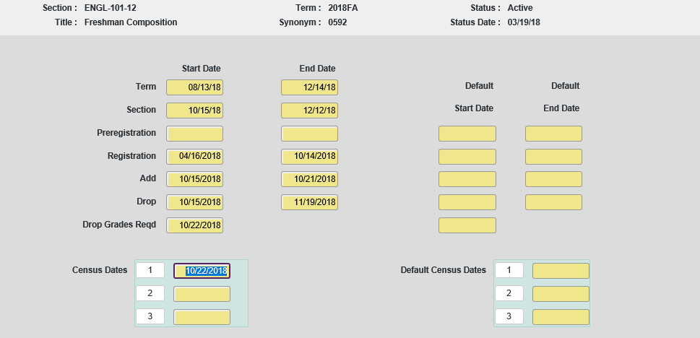
SHORT-TERM CLASS

- This is a short-term class, census is 10/22/18, which is 20%. The last add date is calculated as 10/21/2018, which is not correct, it must be 10% per board policy.
- Larry said that he will submit a ticket and work with April so both colleges, faculties needs to be made aware of this change, don’t go with the past dates.
- Kirsten asked why not 15%? Larry pointed out that Title 5 states the regulations, it is related to refund date.
- DyAnn pointed out that there are some documentations related to this in the document library. DyAnn said that in the related document, it says “Sections that are not primary term sections, the last day to add is the day before census date of the section”
- Larry points out that this document is wrong, because the board policy AP 5075 states 10% (see diagram below). Larry is sure that this policy has not changed. (https://sbccd.policystat.com/policy/3958120/latest/)
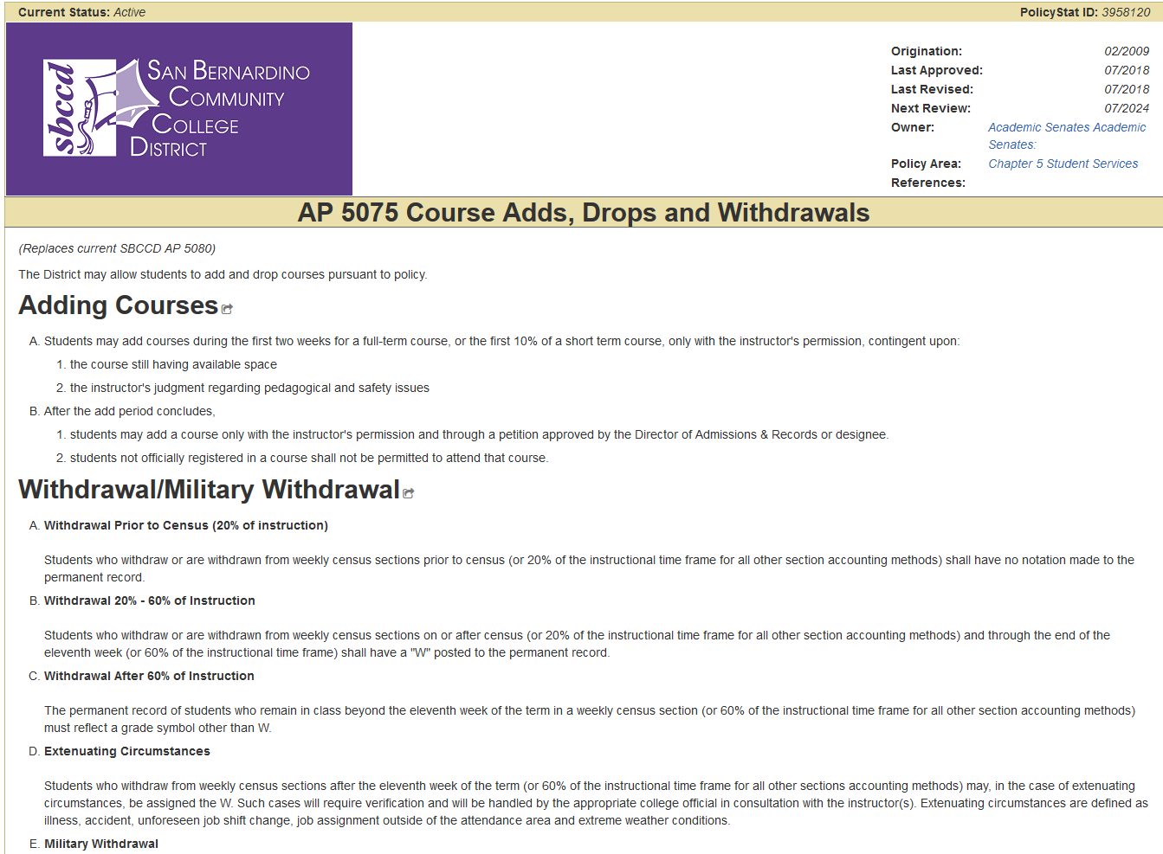

V. Hobson’s Update
  - Sponsor: Robert McAtee, Kristina Heilgeist
- Robert said that we are getting closer to going live. Hobson’s team wants a go live date, so they can push their programmers to address the issues that’s going on in the testing.
- Decided on a couple dates, 8/30/2018 – complete 2017, 2018 edits and rollover to 2018 – 2019 catalog.
- On 10/15/2018 – Both CHC and SBVC will be completed with their program edit and testing, so can prepare to move those to production on October 15.
- Hoping at CHC to use live on Nov 1st. Test out on CHC’s NSA group. Doing ed plans live on Nov 1.
- SBVC will follow through but will watch and see what happens at CHC.
- Two issues about pre-requisites needs to be addressed:
  - Adding up degree units, will be addressed with the new patch.
  - (Robert did not mention the 2nd issue)
- Kirsten brought up some concerns regarding contract approval time and the contractor commencement time.
- Andy pointed out that the contractor will not get access until board approval, but we can set up the user first.
- Robert said that Brianna uploads are functioning at CHC with early alerts and she is busy working over at SBVC, making good progress.

Miscellaneous DISCUSSIONS

Interactive Committee Software (Joe Cabrales)
- Rebeccah from CHC is looking for a software / app / website solution to house committee information.
- This fancier version of the “brochure” will have detailed committee information and allow sign up.
- Instead of doing handouts, emailing and asking others to sign up, person to person, users should be able to come to this one place, browse through and sign-up
- Jason points out that on the district website, there is a section for the committee information, question is how often these committees update their information. Sign ups are not handled by the committees directly.
- Joe said that he did find some third-party software, but Rebeccah is looking for something immediately available.
- Andy and Joe will keep an eye open for any software out there.

Chosen Name + Put Roster updates in Production (Joe Ho, DyAnn Walter)
- Joe pointed out that the new rosters which includes the chosen name, has yet to be installed in Production environment, because the semester just started, and we want to make sure all the instructors have their roster. The old roster is in Microsoft Word format. The new roster is in HTML format.
- Joe asked if anything was decided about how to inform the students about the chosen name option, no process is in place yet.
- April from Valley did mention that a request did come in from a student.
- Joe showed that users can enter the chosen name under BIO -> Chosen Name.
- Joe also demonstrated how to generate roster using XRST and asked the users to do test in the TEST environment.
- Larry asked why the template was changed from Microsoft Word to HTML. Joe pointed out with the new changes, the new information was not going to fit in the old template, without going to HTML format.
- Joe Cabrales pointed out that if the Chosen Name was entered into the system at the middle of the semester, the instructor will need to get a new roster.
- DyAnn and Joe pointed out that because the rosters are now in HTML format, some formatting in the browser will be required before printing, it is a one-time setup. Instructions will be provided to the users and also to the helpdesk.
- The positive attendance roster now includes the audit code.
- Larry asked about if the audit code AU will show up in transcripts, but both Joe and Larry don’t remember the exact details, so will investigate this later.

Student’s personal emails not being updated (Joe Ho, DyAnn Walter)
- When a student applies for a new term and change their personal email address on CCC Apply, currently this email address is not updated in Colleague, and the welcome email will get sent to their old email address.
- Joe and DyAnn previously discussed this with Larry and Larry agreed that this should be changed, the new email address should overwrite the previous email address. April agrees.
- This email address is indicated by the type “I” under NAE screen, in Colleague.

Reminder about the proposed tickets from our last DAWG meeting (Joe Ho, DyAnn Walter)
- Kristina said that she is still collecting more data before she will submit the ticket.
- DyAnn would like to remind Marco about submitting a ticket regarding “removing section from WebAdvisor” which was discussed during the July 25th DAWG meeting.

Online Forms - LDAP and/or SSO (Larry Aycock)
- CHC has been working with a company called Laser Fish, to create online forms. They would like to link the system to our Active Directory. Larry needs more information about how to proceed.
- Andy wanted to know how many people will be using the system, and Jason was wondering if this is for employees or students as well.
- Kirsten said that CHC will have about 36 stations and probably have 40-50 employees.
- Larry said that this is for employees to access the system, not for students. Students will be able to submit certain forms. One of the licenses will be used for them to submit online, that does not require Active Directory.
- Jason said if it talks directly to Active Directory, then it will require working with IT to set up that integration. If they use Single Sign-On (SSO) or Security Assertion Markup Language (SAML), then Jason can help. Jason suggest that CHC should talk to Wayne and Jeremy Sims
- Kristina asked about using SSO with the E Catalog software, Jason said if they are using SAML, then it won’t be very difficult to integrate.

Instructors Posting Positive Attendance Online (April Dale-Carter)
- April would like to know, when will the function be available for instructors to post the positive attendance hours, themselves.
- Andy said that, we think Ellucian is coming out with something in the Self-Service module, which will allow instructors to enter positive attendance via self-service. They are hoping to have this feature out by end of the year. They’ve confirmed as recently as last month that they still plan on this out before end of the year.
- Larry asked if this is something that we’ve already purchased, all we have to do, once it’s released, is to implement it? Andy concurs.
- Andy said, once we get it, it will be installed in the TEST Environment, and the users can test it.

Cannot Send Email to An Active Student (April Dale-Carter)
- Trying to send an email to a student but getting a “no application exists”
- This student has been attending and enrolled continuously since 2009.
- Larry asked if this student has recently graduated, because they run into this when someone graduates and don’t have an active program. April said when she tries to pull this student out on NAE, it says this student does not have an application for her.
- April said a ticket was submitted for this issue

Disclaimer: Some individuals joining the meeting via phone may not be in the Attendance List.

