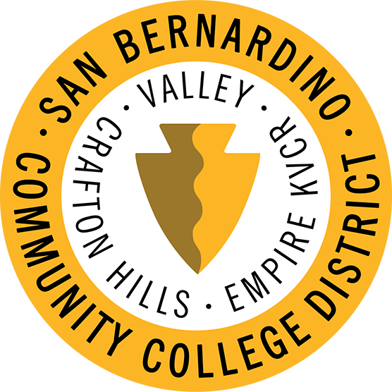 | San Bernardino Community College District  Distance Education Coordination Council  AGENDA  April 10, 2023 12:30 pm
The distance education coordination council (DECC) has the charge to develop guidelines and recommendations to the colleges regarding distance education issues. This committee shall have the added responsibility of coordinating district support for distance education offered at Valley college and Crafton hills college. All programs offered in the district through distance learning shall be a part of one of the two colleges with the appropriate review and evaluation by the academic senate and the discipline being offered.

Members | Cherishea Coats, Kay Weiss, Brandice Mello, Cynthia Hamlett, TL Brink, Andy Chang, Margaret Worsley, Rania Hamdy, Davena Burns-Peters, Stephanie Lewis, Kashaunda Harris
Agenda Approval

Crafton Hills Updates
TOPIC | DISCUSSION

Valley College Updates
TOPIC | DISCUSSION

District Distance Education Updates
TOPIC | DISCUSSION
 | - Turnitin Demo
Upcoming Tool Needs | - Turnitin  - Honorlock  - Labster
Bookstore | - Willo Transition
Canvas LTI update | - Pearson
Canvas Releases | - Submit on behalf  - Sortable Name

Discussion Topics
TOPIC | DISCUSSION
 | - Canvas Outcomes

Next Meeting:
May 08, 2023

